**Stratton Playgroup**

New Road, Stratton, Bude, Cornwall EX23 9AP

**Telephone:** 01288 356135 **E-mail:**  strattonplaygroup@hotmail.co.uk

**Website:** www.strattonplaygroup.uk **Ofsted No.:** 102959 **Registered Charity No.:** 1038250



**Term Dates**

Start of Summer Term 2024 Tues 22nd April

School Starters group and individual photos Thurs 24th May

Bank Holiday Mon 5th May

Half-Term Mon 26th May – Fri 30th May

Last Day Tues 15th July

Leavers Party Weds 16th July

**In this month’s Newsletter**

What are we learning this half term……

Learning intentions this half term

Our role play

Some photos of the children

Summer clothing

Sun cream

Lending library news

Staff training updates

This half term we are learning all about story books. Each week we will have a story focus, we have a’' variety of learning and activities based about the book.

We will begin by listening to the story **‘oi frog’.** The children will learn about life cycles and animal habitats. The children will make craft frogs with blower tongues using cups and party blowers. We will incorporate number songs such as ‘5 little speckled frogs’. The children will move like frogs in the garden. We will use the iPad to look at life cycles, learning the names of the different stages of the frog’s development: frogspawn, tadpoles, froglet, frogs.

Next, the children will listen to the story **‘The very lazy ladybird’.** The children will use expressive language and gestures; and move to the story. We will model what the animals do: sleep, hop, roar, swish, etc. Outside, the children will go on bug hunts. The children will make shape ladybirds, talking about the qualities of different shapes (how many lines and corners each shape has).

**Learning intentions for this half term:**

**Communication and language**

* Listen to simple stories and understand what is happening with the help of the pictures.
* Enjoys listening to longer stories and can remember much of what happens.
* Learn and use a wider range of vocabulary.

**Personal, social and emotional development**

* Be increasingly able to talk about and manage their emotions.
* Talk about feelings and gradually be able to understand how others may be feeling.

**Literacy**

* Enjoys sharing books with an adult.
* Repeats words and phrases from familiar stories, asks questions about the book.
* Extend conversations about stories, learning new vocabulary.

**Understanding the world**

* Understand the key features of a life cycle.
* Plant seeds and care for growing plants.

**Fairy-tale castle role play**

Gemma and her daughters Lily and Layla have made a fairy-tale castle for our role play area.

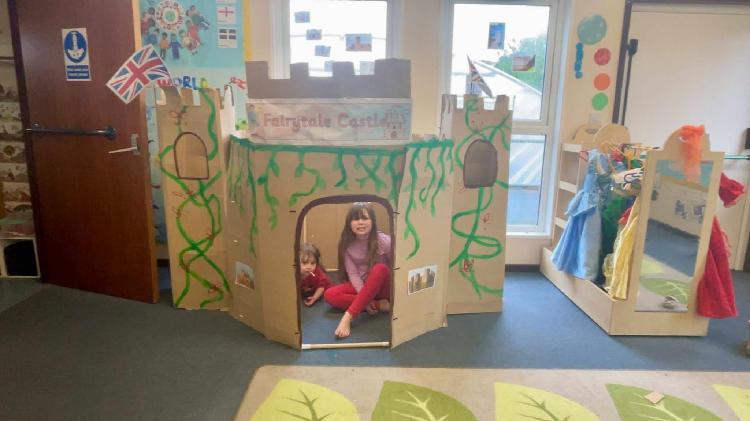

**Some photos of last half term**

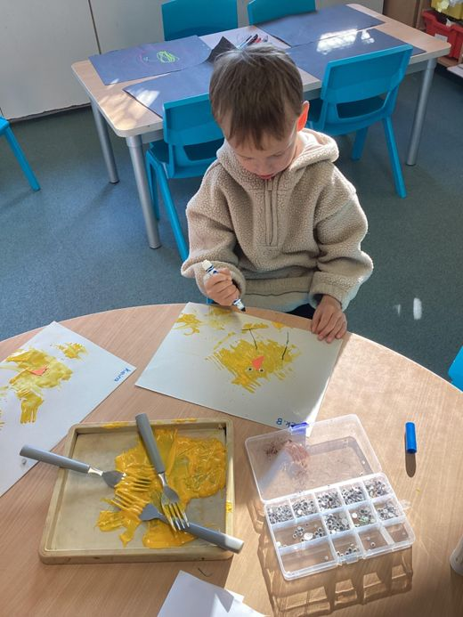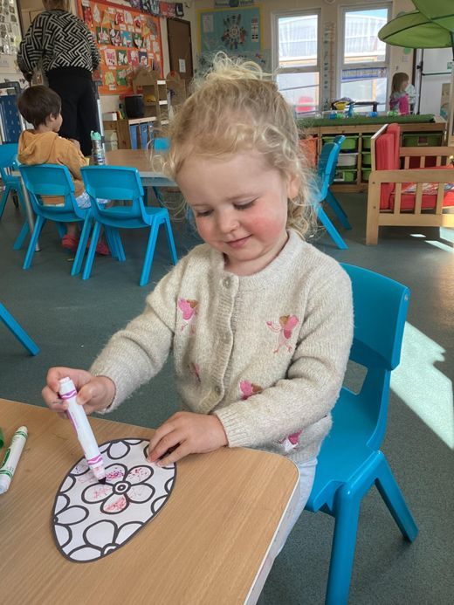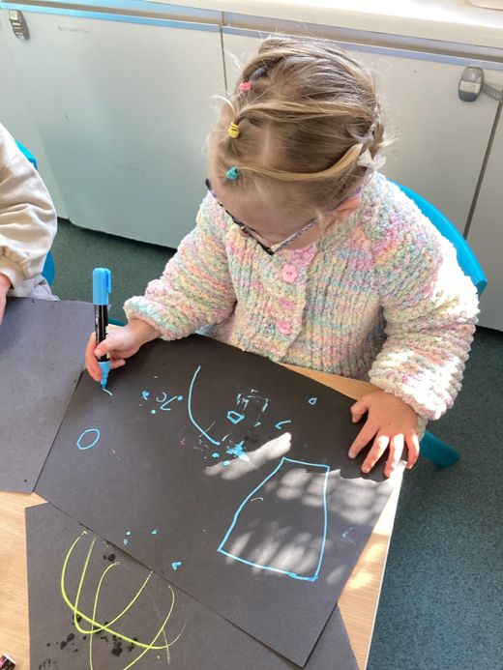

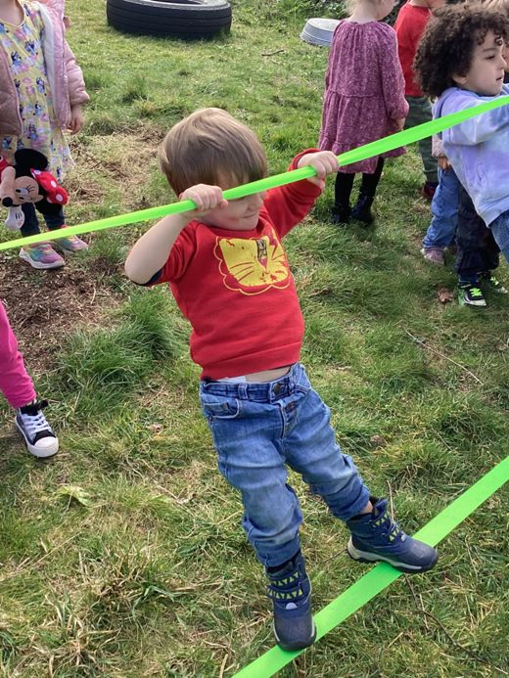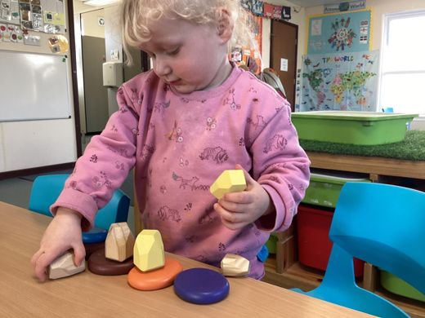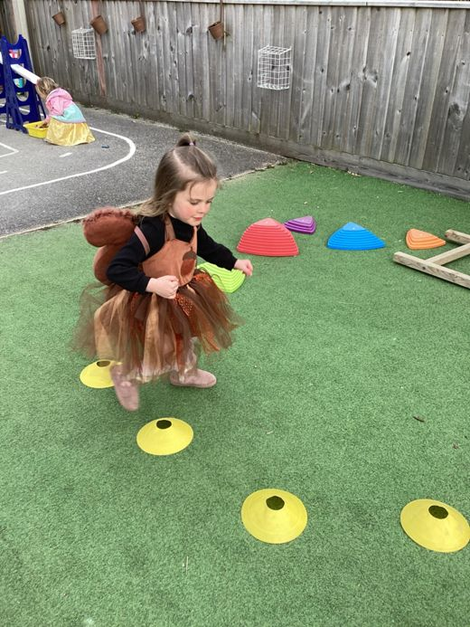

**Summer Clothing**

We are hoping for warmer/sunnier weather over the next term.

Please can we ask the children wear shoes with a secure back (sensible shoes for running and playing).

Where possible can children’s shoulders be covered.

Please can children please ensure there bring a spare change of clothes.

**Sun cream**

Please check the weather forecast before your child comes to their session. If hot sunny weather is forecast, please apply sun cream.

If you child is here all day we will reapply.

We do supply sun cream at playgroup but we do ask for a £1 contribution.

Alternately please send in a labelled bottle of sun cream which we will use for your child.

**NHS Recommendations**

* a sun protection factor (SPF) of at least 30 to protect against UVB
* at least 4-star UVA protection

**Lending library news**

10 book award goes to Elodie

15 book awards go to Amaya, Keira and Harper

20 book awards go to Molly

30 book awards go to Grace, Felicity and Ky.

**Staff Training Updates**

**Kelly has completed/ attended:**

Early Years Managers Network meeting

Operation Encompass – Key Audit Briefing

**Liv has completed:**

Learning Through Play

Creating Communication Friendly and Language Rich Environments

The Safer Food Level 2 Food Hygiene

Allergy Awareness in Early Years Level 2 Certificate

**Anna has attended:**

Early Years SENDCO Network meeting

**Gemma Marshall has completed:**

The Safer Food Level 2 Food Hygiene

Thank you for your time in reading **this newsletter**, if you have any questions please speak to a member of staff.

Kelly and all the team 😊

 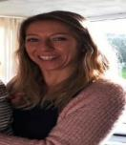 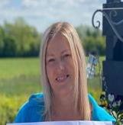 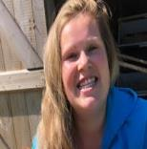 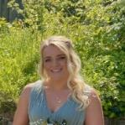  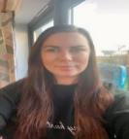

Kelly Anna Sam Harri Roxy Kayleigh Gemma

Liv Edwina