Stratton Playgroup
New Road, Stratton, Bude, Cornwall EX23 9AP
Telephone: 01288 356135 E-mail: strattonplaygroup@hotmail.co.uk
Website: www.strattonplaygroup.uk Ofsted No.: 102959 Registered Charity No.: 1038250

Easy Ways to Support Stratton Playgroup
We are a charity run non-profit community group. We rely on families supporting us throughout their children’s time with us; and sometimes beyond….

For all the nicer things that we have at Playgroup, we fundraise to provide them for your children.

This is done in several ways, some are no effort at all, you just need to remember when shopping online.

Other ways to support us, are to come along to one of our fundraising events. These are always great fun, so please try to help out if you can.

My School Fund
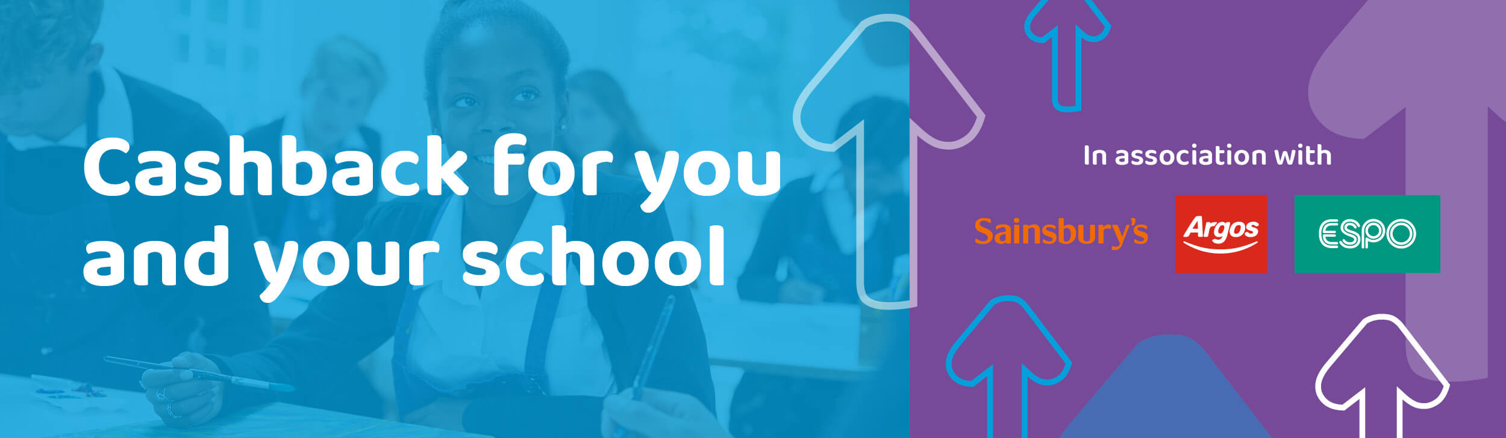

This is a NEW fundraiser for us, for relatively little effort & you will earn money too!!!
All you need to do is to go to https://www.myschoolfund.org/#/cms/about-us to register. Then you link your usual payment card to your account.

Easyfundraising
This is a brilliant fundraiser for us, for again, relatively little effort.
All you need to do is to go to https://www.easyfundraising.org.uk/causes/strattonpgbude/ to register. Then you can download the Donation Reminder for your toolbar or an App for your mobile device, so that you don’t miss any donations.



Bag2School
We have 2 collections each year – November & June.
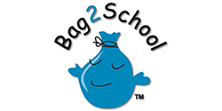
Visit https://bag2school.com/ for further information.
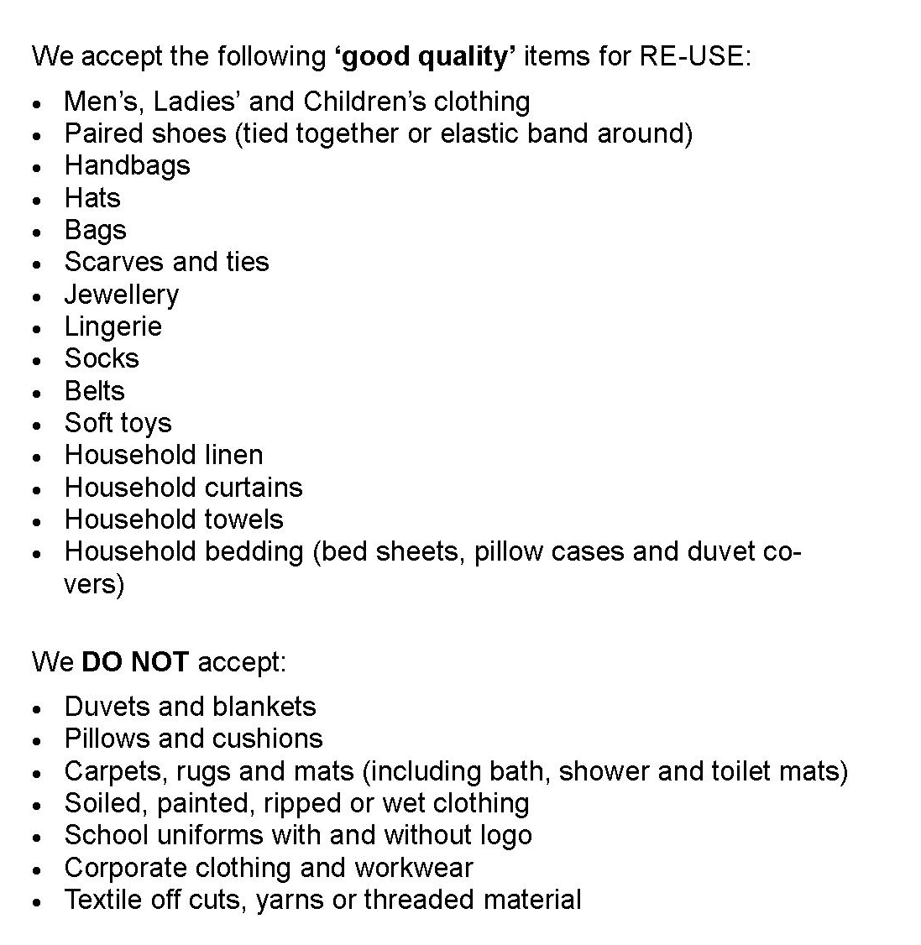

Other Fundraising Events
Each year we hold various events for you to support the playgroup; such as Christmas Fayre, Quiz Night, Bingo, Raffles, Donation Week. We welcome any support you can give, whether it is to help run an event, by donating prizes, or just coming along and having a fun time, we are always extremely grateful.

Many thanks for your continued support
From the Staff & Committee of Stratton Playgroup

