**Stratton Playgroup**

New Road, Stratton, Bude, Cornwall EX23 9AP

**Telephone:** 01288 356135 **E-mail:**  strattonplaygroup@hotmail.co.uk

**Website:** www.strattonplaygroup.uk **Ofsted No.:** 102959 **Registered Charity No.:** 1038250



**Next week the 9th June - Old clothes**

We have some large-scale painting and messy activities planned.

Please ensure children come to playgroup wearing clothes that you do not mind getting messy.

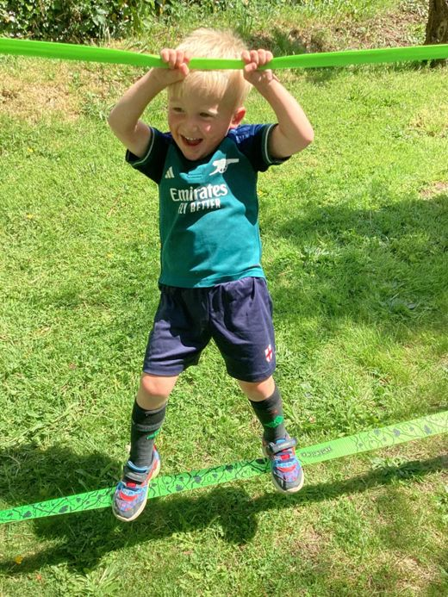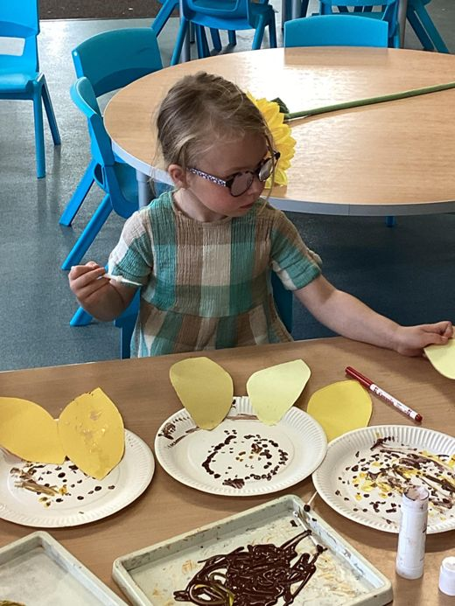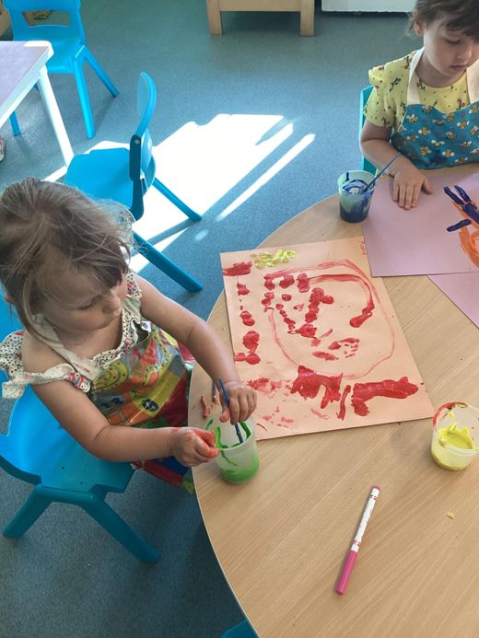Please also ensure they have a change of clothes with them.

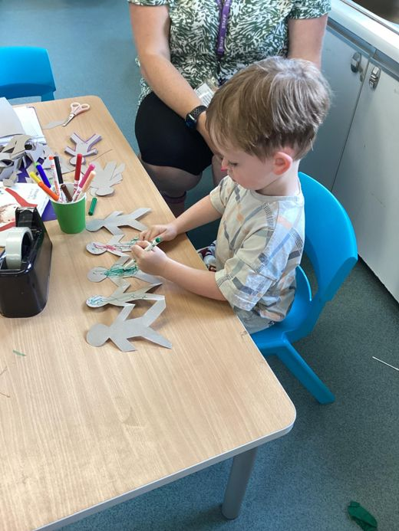

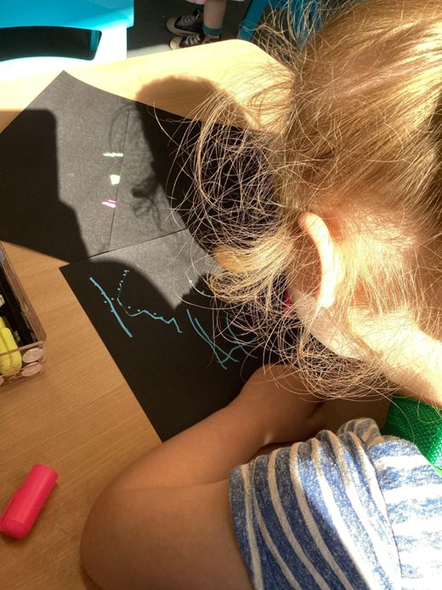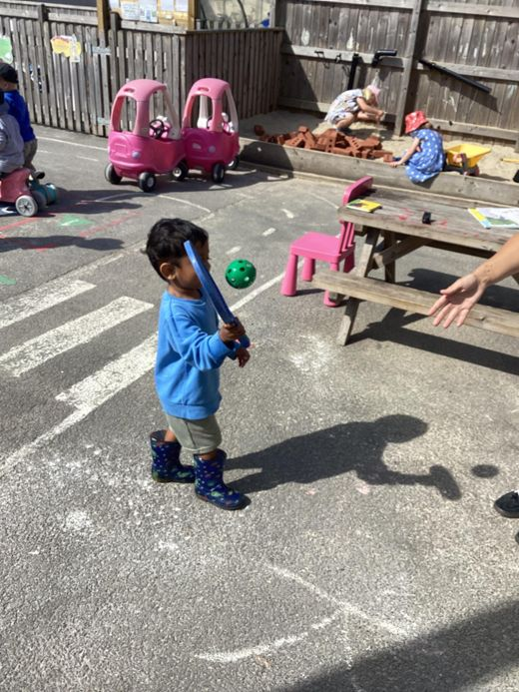

**Term Dates**

Bags for school’s collection DATE CHANGE Thurs 10thJULY @Playgroup AM

Last **full** day Tues 15h July

Playgroup **AM** Session and School Starters Party **PM** Weds 16th July

**In this month’s Newsletter**

What are we learning about this half term

Our Learning Intentions

What Is “Bag2School”?

Sports day success

Important Dates information

Key Person Meetings

Lending Library News

Cutting up foods

Summer clothing

Sun cream

Operation Encompass

Bringing items into playgroup

Wearing Jewellery

Jewellery at playgroup

School Starters Party

**What are we learning about this half term**

We are now in our final half term of this academic year. Our topic is **‘around the world’.** Each week we be learning about a different country, the countries are Germany, Italy, Australia, Brazil, India and the Czech Republic.

The first country we are learning about is Germany. The children will learn to say hello in German. The main activity will be painting to music by German composers, they will use different tools for large scale painting outside. The children can use different texture in the paint such as sand, clay and ice. The children will explore the different patterns and colours in the German flag.

We will be moving on to learn about Italy. The children will learn to say hello in Italian. The children will also use iPads to look at and learn about landmarks in Italy such as the leaning tower of Pisa and the colosseum.

Next, we will be learning about Australia. The children will use cardboard tubes and different coloured paint to make and decorate didgeridoos. The children will listen to and learn about different Australian music and dance. We will learn about Australian animals and make animal movements and animal craft. We will explore Australian facts through the use of story books.

**Our Learning intentions for Summer term**

**Communication and language**

· Use a wider range of vocabulary based on different countries and cultures

· Listen to different stories and understand what is happening

· Learn that different countries speak different languages

**Mathematics**

· Talk about 2 D and 3 D shapes and use informal mathematical language such as sides, corners, lines, flat, round.

· Discuss routes and locations

· Combine shapes to make bigger ones

· Notice and make their own patterns

**Understanding the world**

· Talk about what they see and use a wider vocabulary

· Know there are different countries in the world and talk about the differences they have experienced or seen in photos.

· Expressive arts and design

· Explore different materials freely

· Respond to what they have heard expressing their own thoughts and feelings – music from all over the world

· Move and dance to music – exploring movement to different types of music

|  |
| --- |
| *C:\Users\User\AppData\Local\Microsoft\Windows\INetCache\Content.MSO\EDB36EE6.tmp*  Bag2School is a **free eco-friendly fundraising scheme** that helps schools, businesses, community groups, local councils, and charities **raise funds through textile recycling** as well as spreading textile recycling awareness.  **Date of Collection** Thursday 10th JULY @Playgroup AM  Please Bring your bags to playgroup on this morning (we can store bags before if needed)  **Items collected are:**  **Clothes**  **Paired shoes**  **Handbags**  **Hats**  **Bags**  **Scarves and ties**  **Bras**  **Jewellery**  **Socks**  **Belts** |

|  |
| --- |
| C:\Users\User\AppData\Local\Microsoft\Windows\INetCache\Content.MSO\9F06D1C2.tmp  **SUCCESS**  What a lovely sports day we had 😊  The children were amazing!!  Thank you to everyone who came along and enjoyed the afternoon with us. |
| **Important Date Information**  **Tuesday 15th July** is playgroup’s last **FULL** day  **Wednesday 16th July**  Our Wednesday playgroup session is open until **1PM** (if you child is not starting school in September they will need to be collected at 1PM) Bring lunch as normal.  1:30PM – 3:30 PM *School Starters party* @playgroup (more information to follow)  Note: If your child is a school starter and they normally attend all day they still can. |

**Key Person Meetings**

Your child’s key person will be approaching parents over the next couple of weeks to arrange key person meetings.

**Lending Library News**

5 books award goes to Ilya

10 books award goes to Maeva

15 books award goes to Luke and Jenson

20 books award goes to Katelyn

30 books award goes to Jackson

**Cutting up foods.**

Can I please remind everyone that it is playgroups policy that foods such as grapes, blueberries and cherry tomatoes are all cut in half lengthways.

Foods such as sausages, cocktail sausages and scotch eggs should also be cut in half.

REMINDERS

**Summer Clothing**

Please can we ask the children wear shoes with a secure back (sensible shoes for running and playing).

Please can we ask that children’s shoulders are covered.

Please can children ensure they bring a spare change of clothes.

**Sun cream**

Please check the weather forecast before your child comes to their session. If hot sunny weather is forecast, please apply sun cream.

If you child is here all day, we will reapply.

Please send your child to playgroup with a labelled bottle of sun cream which we will use for your child. **NHS Recommendations -** a sun protection factor (SPF) of at least 30, to protect against UVB at least 4-star UVA protection

**Bringing items into playgroup**

Please can we ask that children do not bring in too many unnecessary items to playgroup, especially anything very precious or very small. Unfortunately, these items can get lost or broken which results in upset children.

**Jewellery at playgroup**

For health and safety reasons can we ask that children do not wear lots of unnecessary jewellery at playgroup.

Thank you for taking the time to read our newsletter. If you have any questions please speak to a member of staff.

**Operation Encompass**

We are now an operation Encompass setting

Operation Encompass is a unique police and education early intervention safeguarding partnership that notifies schools before the start of the next school day when a child has been exposed to, or involved in, any domestic violence incident. This early notification enables us to offer immediate support to these children, helping them feel safe and listened to.

 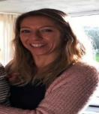 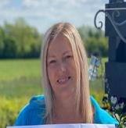 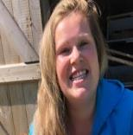 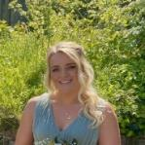 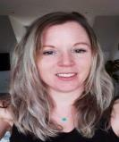 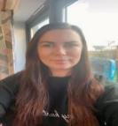

Kelly Anna Sam Harri Roxy Kayleigh Gemma

Liv Edwina