**Stratton Playgroup**

New Road, Stratton, Bude, Cornwall EX23 9AP

**Telephone:** 01288 356135 **E-mail:**  strattonplaygroup@hotmail.co.uk

**Website:** www.strattonplaygroup.uk **Ofsted No.:** 102959 **Registered Charity No.:** 1038250



*Just like that we only have a couple of weeks left at playgroup for this academic year. Therefore, I would like to take this opportunity to say thank you to you* ***all*** *for being part of our playgroup community. A Special mention to our parents who are on our committee.*

*Good luck to all our children starting school in September. We will miss you but we are excited for you all as you start this next chapter in your educational journey.*

*I would like to say a* ***BIG*** *thank you to our staff team for their continued dedication to playgroup.*

*I hope everyone has a lovely summer (hopefully with some sunny weather), we look forward to seeing our returning children and their families in September, as well as welcoming lots of new families.*

**Term Dates**

Bags for school’s collection DATE CHANGE Thurs 10thJULY @ Playgroup AM

Last **full** day Tues 15h July

Playgroup **AM** Session and School Starters Party **PM** Weds 16th July

Pre-placements days for new children Thurs 4th and Fri 5th Sept

Back to Playgroup Mon 8th Sept

**In this month’s Newsletter**

Next couple of weeks

What Is “Bag2School”?

Staff training updates

Children returning in September

Lending Library News

School Starters Party

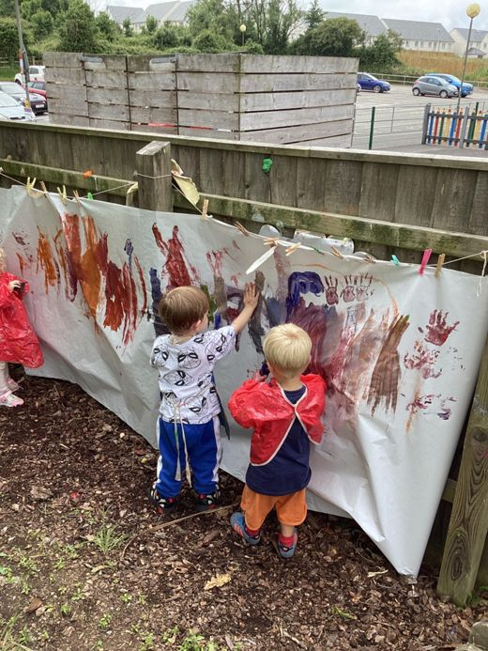 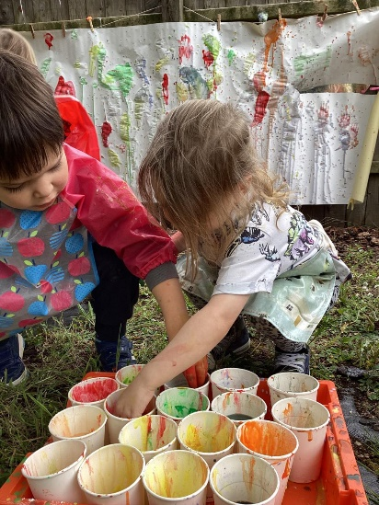 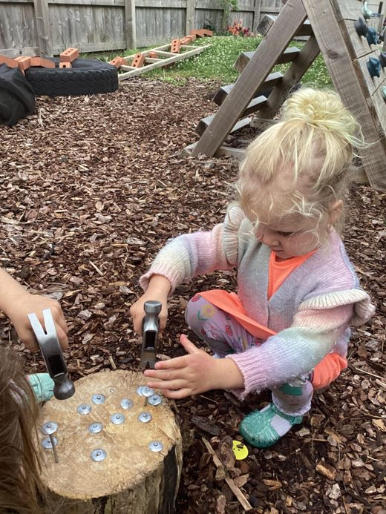



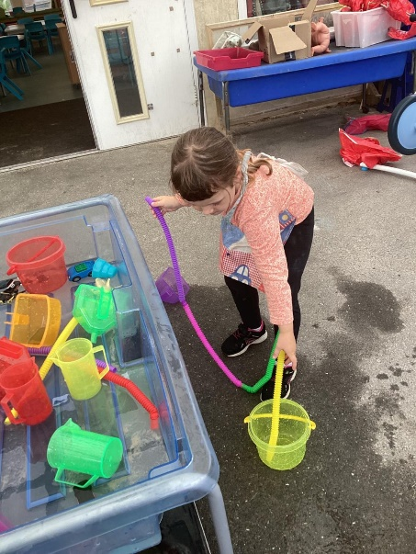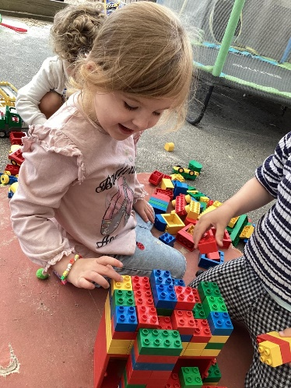

**Next couple of weeks**

Next week the children will learn about India. The children will make Rangoli patterns using coloured sand, chalk, lentils and rice. The children will use their fine motor skills to pick up small objects for their patterns. The children will look at other patterns such as henna hand tattoos, Indian flag and fabric collages. The children will try different Indian tastes such as poppadum’s, onion bhajis, naan bread.

During our last week the children will learn about the Czech Republic. We will look at the Prague castle. We will look at maps of where places are. The children will use shapes to make pictures of castles. We will listen to fairy tales and learn traditional dances. We will say goodbye to the children starting school and have a party on Wednesday afternoon.

|  |
| --- |
| *C:\Users\User\AppData\Local\Microsoft\Windows\INetCache\Content.MSO\EDB36EE6.tmp*  Bag2School is a **free eco-friendly fundraising scheme** that helps schools, businesses, community groups, local councils, and charities **raise funds through textile recycling** as well as spreading textile recycling awareness.  **Date of Collection** Thursday 10th JULY @Playgroup AM  Please Bring your bags to playgroup on this morning (we can store bags before if needed)  **Items collected are:**  **Clothes**  **Paired shoes**  **Handbags**  **Hats**  **Bags**  **Scarves and ties**  **Bras**  **Jewellery**  **Socks**  **Belts** |

**Staff training updates**

**Harri, Roxy and Liv** have renewed their paediatric first aid

**Kelly** has attended a manager’s network meeting

**Anna** has attended a SENCO network meeting

**Sam** has renewed her understanding and supporting behaviour, safeguarding and the prevent duty.

**Gemma** has attended Makaton training

**Roxy** has attended Learning through play and Promoting effective speech and language skills

**Children returning in September**

You have been sent an email this week clarifying the sessions your child will be attending and who your child’s key person will be (this may have changed due to the days your child is attending and the days staff work).

**Lending Library News**

**‘WOW’** 50 books award goes to Ky

10 book award goes to Mason

**Fees & Funding** – Information for returning families

Our Fees from April 2025 are £24.00 per child per session; with the Early Start and Lunch Club at £4.00 per child each.

There is a concessionary rate available for families with more than 1 fee paying (unfunded) child attending at one time, please ask a member of staff for details.

Some children may be entitled to 2-year-old “disadvantaged families” funding; applications need to be made via Cornwall Council’s Family Information Service, they will then approve up to 15 hours of funded childcare per week, if you or your child meet the criteria.

The term after your child turns 3 years old, they are entitled to Early Years Education Funding, which covers fees up to 15 hours per week for 38 weeks of every academic year. This must be taken over a minimum of 2 days in sessions no longer than 10 hours in any one day, and taken between a maximum of 2 childcare providers.

We ask that all 2-year-olds attend a minimum of TWO 3-hour sessions per week; and the term after the child turns 3, that they attend a minimum of THREE 3-hour sessions per week.

This is to ensure that the child settles, and benefits as much as possible from their time with us.

We may be able to claim up to an approx. £570 per year for Early Years Pupil Premium (EYPP) for some children that are claiming EYEF with us; this additional money could make a significant difference to your child’s learning outcomes. Any parent who thinks their child may be eligible, can have the appropriate details checked by Cornwall Council’s Early Years Finance Team, by simply informing us of your date of birth and national insurance number.

Under the flexible entitlement, parents with funded children can use the Early Start and Lunch Club as part of their funded hours and therefore not have to pay for them. But if you intend to use your full entitlement of funding on normal playgroup sessions, or your child is not government funded, the fee for the Early Start and/or Lunch Club will be payable.

**Note –** The government has confirmed that from September 2025, all eligible working parents of 9-month-old+ children will be able to access funding for 30 hours per week of education and care - certain criteria must be met, further details can be found at [www.childcarechoices.gov.uk/](http://www.childcarechoices.gov.uk/)

At the same time, some parents can also apply for a Tax-Free Childcare account: <https://www.gov.uk/childcare-calculator>

The parents or carers will need to earn at least the equivalent of 16 hours at the minimum or living wage but no more than £100,000. This applies to each parent in dual-parent households, though there are exceptions where one parent is in receipt of Incapacity Benefit, Severe Disablement Allowance, Carer’s Allowance, Limited Capability for Work Benefit or contribution-based Employment and Support Allowance and their partner is working.

You will need to apply for this extra funding and provide us with your child’s eligibility code.

Thank you for taking the time to read our final newsletter of this academic year.

Kelly and all the team 😊

      

Kelly Anna Sam Harri Roxy Kayleigh Gemma

Liv Edwina