Stratton Playgroup
New Road, Stratton, Bude, Cornwall EX23 9AP
Telephone: 01288 356135 E-mail: strattonplaygroup@hotmail.co.uk
Website: www.strattonplaygroup.uk Ofsted No.: 102959 Registered Charity No.: 1038250

Newsletter – January 2026


In this months newsletter
Our learning this half term
Our learning intenetions
Meet the team - Kayleigh and Liv
Sessions avaliabilty
Lending Library news
School applications
Commiittee members
Reminder of session times
Our updates
Term dates

Our learning this half term
To begin our learning children will share their news from the Christmas break. We will start to learn our new topic – Space and Science. We will learn about the night sky and learn about stars. We will look at star shapes and make shooting star wands.
The children will listen to the story ‘how to catch a star’

Then, we will explore different shapes and make shape rockets. The children will look at their names and older children will make name rockets by sticking the correct amount of shapes to match their sounds in their names.
The children will listen to the story ‘whatever next’

We will then be moving on to learn about the different planets in the solar system. We will talk about the size of the planets and take part in size ordering activities.
We will learn about the planet we live on and what it looks like from space.
The children will take part in astronaut craft.

Towards the end of the month the children will learn about the moon. The children will use the iPad with adult supervision to research the moon. They will look at people landing on the moon and take part in experiments about gravity. We will make and play with moon dough.
The children will use foil to create moon paintings.
The children will take part in movement activities, fast and slow. What it’s like to move in space.

Our Learning intentions……….
Communication and language:

- Learning new vocabulary
- Listening to new stories
- Looking at information books and learning new things

Personal, social and emotional development
- Children’s mental health week – Talk about emotions

Understanding the world
- Learning about the world around us
- Experiments – learning how and why things work

Mathematics
- Use number language – shapes, big small, size ordering planets
Counting planets
- Flying rockets measuring how far they fly.

Meet the team
This month is Kayleigh and Liv

Kayleigh


Role and Responsibilities
Early Years Practitioner

How long have you worked at playgroup?
5 years

Qualifications
Foundation degree in early childhood studies.

What is your favourite thing about working in early years?
I love being part of and working with a team to provide care and look after children.

A little bit more about Kayleigh
I am a farmer’s wife with two daughters 15 and 11. I like to spend most of my free time taxiing between Rugby matches and horse-riding activities.

How would you like to see playgroup grow and develop?
I would like playgroup to venture out on more activities and do some more outings in the community.

Liv


Role and Responsibilities
Early Years Practitioner

How long have you worked at playgroup?
18 months

Qualifications
Level 3 Diploma for the Early Years Practitioner (Early Years Educator)

What is your favourite thing about working in early years?
Planning exciting activities to support children’s individual learning and development needs that matches their energy and enthusiasm.

A little bit more about Liv
I love to be outdoors exploring the coast. I recently brought my first home with my partner, so, we are both enjoying settling in and putting our own stamp on this.

How would you like to see playgroup grow and develop?
As we come into spring and warmer times ahead I would love to help develop more sports and outdoor activities.

Staff updates
Tracy will be joining our team this month. Over the coming weeks we will introduce Tracey and tell you more about her tole within our team.

We would like to wish Roxy a very happy 30th Birthday!

Space/session availability
We are currently full for this academic year and have a waiting list for spaces.
Spaces are already filling up from September 2026 so if you or someone you know would like to reserve a space please:
Visit our website: strattonplaygroup.co.uk
OR
Email: strattonplaygroup@hotmail.co.uk

Lending library News
We look forward to sharing more book awards throughout the year.

School applications
If your child was born between 1 September 2021 and 31 August 2022, you will need to apply for a school place for September 2026. The deadline for applications is 15 January 2026.
https://www.cornwall.gov.uk/education-and-learning/schools-and-colleges/school-admissions/

Committee Members
We held our AGM on 5th December. The consensus was that we will proceed with the conversion to a CIO, as it is becoming increasingly difficult each year to achieve the numbers needed for the charity constitution we currently follow. This will go ahead as soon as the new committee members have been registered with Ofsted.

Chair: Kerrianne Inch
Secretary & Ofsted Nominated Person: Edwina Williams
Treasurer: Angela Hawkes
Committee Members: Roxy Wilkinson-Hardy, Kelly Swatton, Gemma Marshall, Amy Wise & Olivia James

Reminder of Session Times
Early Start – drop off can be from 8.15am but no later than 8.30am.
Morning Session – drop off 9:00am.
End of morning session / lunch time - pickups or drop offs (12.00 or 12.30).
Afternoon pick up – from 3:15pm until 3.30pm.
Late fee charge of £8 per hour (minimum of £4) if you are later than 10 minutes collecting.

Updates
We are very proud of our website, where we display all our information; this will also be updated regularly with events and dates. This is available at: www.strattonplaygroup.uk.

We also have Facebook and Instagram - please find us as “Stratton Playgroup Bude”.
Monthly newsletters – these will be emailed to you each month.
At the end of each session a small description of the session will be written on the easel, outside – weather dependent.
Term Dates
School Applications deadline Thurs 15th Jan
Half-Term Mon 16th Feb – Fri 20th Feb
Last Day Thurs 2nd April
Start of Summer Term 2024 Mon 20th April
Bank Holiday Mon 4th May
Half-Term Mon 25th May – Fri 29th May
Bags to school collection Tuesday 9th June
Last Day TBC
Leavers Party TBC

Other dates throughout the year will come up such as celebrations and events days.

Thank you for your time in reading this newsletter, if you have any questions please speak to a member of staff.

Kelly and all the team

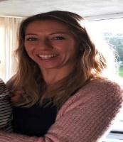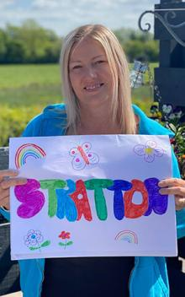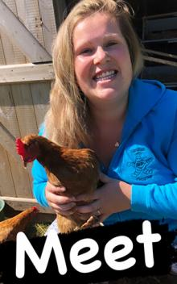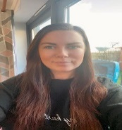
Kelly Anna Sam Harri Roxy Kayleigh Gemma
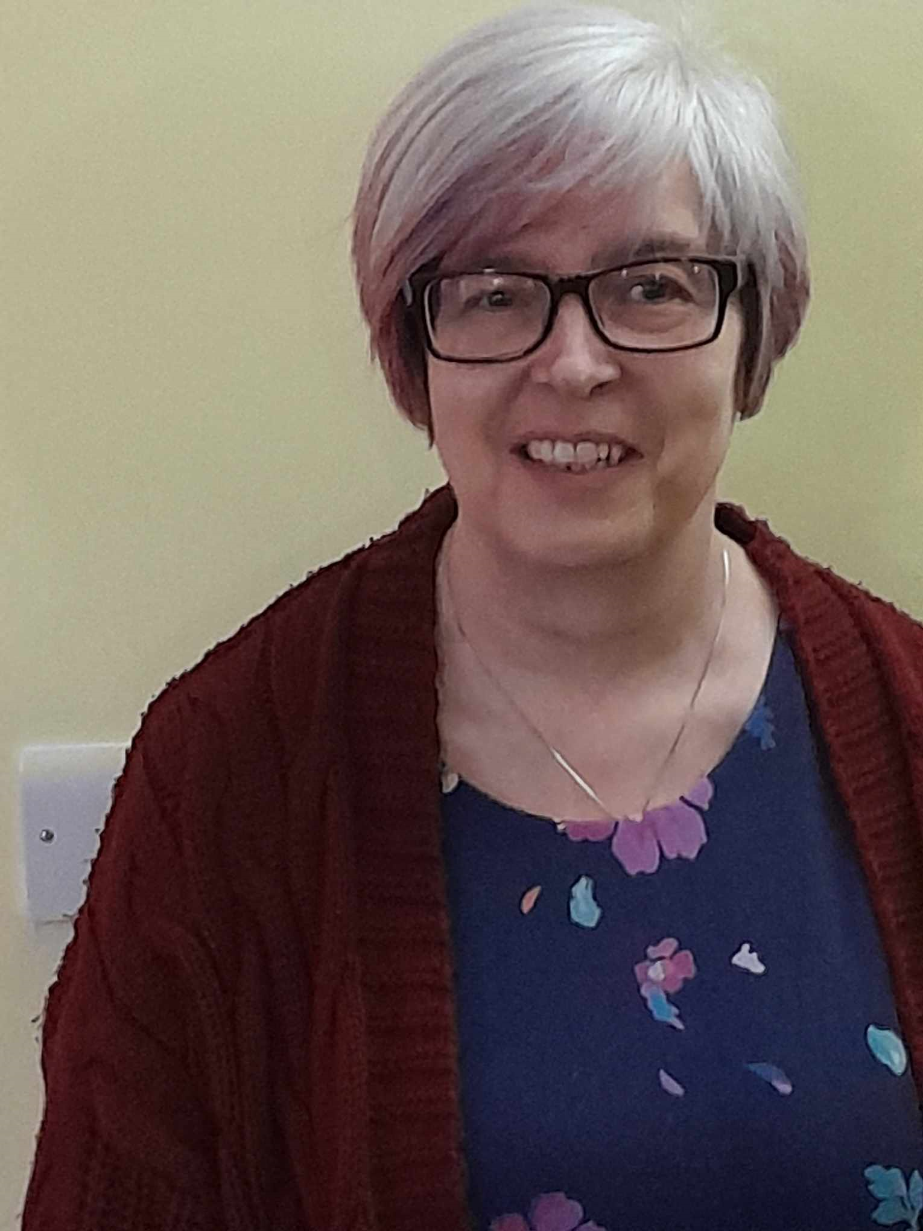
Liv Edwina

