**Stratton Playgroup**

New Road, Stratton, Bude, Cornwall EX23 9AP

**Telephone:** 01288 356135 **E-mail:**  strattonplaygroup@hotmail.co.uk

**Website:** www.strattonplaygroup.uk **Ofsted No.:** 102959 **Registered Charity No.:** 1038250

**Newsletter – October 2025**

****

**Looking forward to the rest of this half term**

The children have been settled well.

They have been taking part in lots of different learning.

Next week the children will create name craft. They will choose what shape their craft is e.g. name rockets/flowers. We will count how many sounds each child has and older children will listen to the syllables in their names. The children will use writing tools to practice writing the letters or tracing the letters in their names. We will use various craft resources to decorate them.

Next, we will do leaf painting, talking about the size and colour of different leaves we find. We will also make nature wands and paint with different natural objects such as corn and pine cones. We will listen to the story ‘Owl babies’

During our last week before half term we will celebrate harvest festival. We will talk about things that we grow. The children will listen to the story ‘little red hen’. The children will talk about being kind and sharing; and have a go at making their own bread rolls by using their physical skills to mix and knead the dough.

**Returning Parents – Reconfirm contact details.**

You have been emailed a form to reconfirm all your contacts details.

Please ensure you reply promptly.

Paper forms are also available.

It is really important we have all your up to date details.

**Key Person Meetings**

We will be inviting you to have a meeting with your child’s key person.

These meetings will be offered during the weeks of **13th and 20th October**.

Your Key person will arrange a convenient time with you.

These meetings are really beneficial to discuss your child’s progress.

**Meet the team.**

Each month we will introduce two of our team members.

This month is **Kelly and Anna.**

|  |
| --- |
| **Kelly**  C:\Users\User\Pictures\166452553_10159000526760675_4805057017291548122_n.jpg  **Roles and Responsibilities**  Manager and Designated Safeguarding Lead (DSL)  **How long have you worked at playgroup?**  Since September 2011.  **Qualifications**  Kelly has 1st Class BA Hons Degree in Children, Schools and Families. Kelly also has a level 3 qualification in Leadership and Management.  **What is your favourite thing about working in early years?**  I really enjoy watching children grow and develop from their first day to their last. Each child’s journey is different and I always feel very proud seeing them on their last day of preschool ready for the next part of their educational journey.  **A little bit more about Kelly**  I have four children two sons, Harrison and Otto and two daughters, Tilly and Lottie.  I love being active and going to the gym, setting myself goals and challenges.  I spend my weekends watching my children take part in their favourite things, Gymnastics, Football and Rugby.  I absolutely love exploring the world and visiting lots of different countries.  **How would you like see playgroup grow and develop?**  I am really keen to develop our outdoor space further. This would include having a reading/literacy shed/area.  **Anna**  C:\Users\User\Pictures\423472062_419769053941267_912508108087475725_n.jpg  **Role and Responsibilities**  Deputy Manager and Special Educational Needs Co-Ordinator (SENCO)  **How long have you worked at playgroup?**  Since September 2011.  **Qualifications**  NVQ level 3 in early years care and education CACHE level 3 special educational needs coordinator award for early years settings.  **What is your favourite thing about working in early years?**  I enjoy the role of supporting children and families to reach their full potential. I enjoy seeing how children grow and develop over their time at playgroup. I enjoy watching the children’s interactions between themselves and how their relationships with their peers develop. I love hearing funny things they say. Every day is different and its never boring.  **A little bit more about Anna**  I have two grown up daughters; Holly and Sophie and a son, Ben. I enjoy running, swimming, cycling and taking part in different challenges/events  **How would you like to see playgroup grow and develop?**  I work hard to ensure playgroup is a fully inclusive setting for all but would like us to develop and extend this further with more staff training around special educational needs and disabilities.  Outside, I would like to plant some fruit trees to grow our own snack. |

**Staff recruitment**

We are currently in the process of recruiting to **add** to our team.

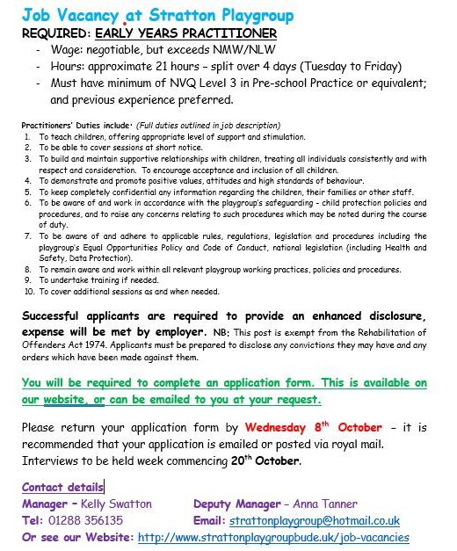

**Space/session availability**

We are currently full for this academic year and have a waiting list for spaces.

Spaces are already filling up from September 2026 so if you or someone you know would like to reserve a space please:

Visit our website strattonplaygroupbude@co.uk

OR

Email strattonplaygroup@hotmail.co.uk

**Lending library News**

30 books award go to Myles

**Labelled Belongings**

Please can we ask that children bring a coat and bag to playgroup each day they attend. To include -spare clothes, weather dependent clothing e.g. gloves, hats – **a labelled water bottle,** and for children that require toileting accessories; nappies, wipes and any other items needed. We suggest that children have a pair of wellies to leave at playgroup. **Please can all children’s belongings be clearly labelled.**

**Children bringing items into playgroup**.

We don’t encourage children to bring in items from home as these can become lost or damaged, and cause upset to the children. If your child has something special that they would like to share, could you please speak to your child’s key person before the session.

**Lunch items**

Please ensure that items in your child’s lunch box such as, grapes, cocktail sausages, large blueberries, cherry tomatoes are cut in at least lengthways, or smaller.

**Attendance**

Please ring/message and let us know if your child will not be attending playgroup for any reason; otherwise, as part of our attendance policy we will have to contact you.

Please remember that children should not attend playgroup if they have a stomach bug and may not return until 48 hours have passed after the last loose movement or vomit.

Please only send your child to playgroup if they are well enough. Children should not be attending playgroup if they need Calpol before- unless this is for a specific reason such as immunisations.

Attached is our full attendance policy.

**Medicine**

It is essential that we are informed if your child has had medicine before attending playgroup. If your child needs to have medicine while at playgroup you will be required to fill in a medicine form, the medicine will be checked by a staff member, and it needs to state clearly - the child’s, name, dose and date. Your child should not attend playgroup for the first 24 hours on a new medication.

**Individual Photos**

On **Thursday 9th October**, Jayne Poole Photography will be in playgroup to take individual photos of the children; siblings/group photos can also be taken. If you child does not attend on this day but you would like to have a photo slot, your child’s key person will speak to you nearer the time to arrange a time slot.

**For children starting school in September 2026**

Stratton school open sessions

**Head Teacher School Tours**

Tuesday 7th October 9:30-10:00

Thursday 16th October 1:30-2:00

Tuesday 4th November 2:00-2:30

Wednesday 19th November 11:15-11:45

Tuesday 9th December 9:30-10:00

Come and see our incredible reception area and have a play with your child using our wonderful resources.

**Stay and Play**

Tuesday 7th October 4:00-4:30pm Tuesday 14th October 4:00-4:30pm

**School applications**

If your child was born between 1 September 2021 and 31 August 2022, you will need to apply for a school place for September 2026. **The deadline for applications is 15 January 2026.**

<https://www.cornwall.gov.uk/education-and-learning/schools-and-colleges/school-admissions/>

**Bags to school Collection**

*This is a fund raiser for playgroup.*

  
***Collection date -***Thursday 13th November 9:00am

*We are collecting good quality items for RE-USE:*

**Men’s, ladies’ & children’s clothing, paired shoes, handbags, belts & accessories.**

**Please see the full list of items collected:**

*Clothes, Paired shoes, Handbags, Hats, Bags, Scarves and ties, Bras, Jewellery, Socks* and *Belts*

If needed Bags can be stored here a couple of weeks before

**Reminder of Session Times**

**Early Start** – drop off can be from 8.15am but no later than 8.30am.

**Morning Session** – drop off 9:00am.

**End of morning session / lunch time** - pickups or drop offs (12.00 or 12.30).

**Afternoon pick up** – from 3:15pm until 3.30pm.

**Late fee charge** of £8 per hour (minimum of £4) if you are later than 10 minutes collecting.

**Updates**

We are very proud of our website, where we display all our information; this will also be updated regularly with events and dates. This is available at: www.strattonplaygroup.uk.

We also have Facebook and Instagram - please find us as **“Stratton Playgroup Bude”.**

Monthly newsletters – these will be emailed to you each month.

At the end of each session a small description of the session will be written on the easel, outside – weather dependent.

**Term Dates**

Individual photos Thurs 9th October

Key person meetings During weeks 13th and 20th October.

Half-Term Mon 27th- Fri 31st October

Bags to school collection Thursday 13th November

Committee AGM Thursday 20th Nov (further details to follow)

Last Day Thurs 18th Dec

Christmas Party Fri 19th Dec (further details to follow)

Start of Spring Term 2024 Mon 5th Jan

School Applications deadline Thurs 15th Jan

Half-Term Mon 16th Feb – Fri 20th Feb

Last Day Thurs 2nd April

Start of Summer Term 2024 Mon 20th April

Bank Holiday Mon 4th May

Half-Term Mon 25th May – Fri 29th May

Bags to school collection Tuesday 9th June

Last Day TBC

Leavers Party TBC

Other dates throughout the year will come up such as celebrations and events days.

Thank you for your time in reading **this very lengthy newsletter**, if you have any questions please speak to a member of staff.

Kelly and all the team 😊

 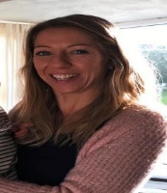 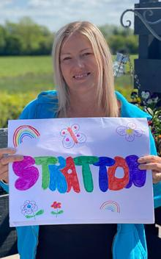 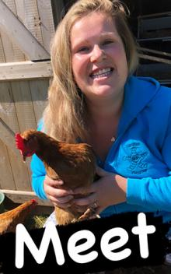   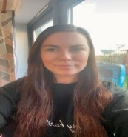

Kelly Anna Sam Harri Roxy Kayleigh Gemma

Liv Edwina