Stratton Playgroup
New Road, Stratton, Bude, Cornwall EX23 9AP
Telephone: 01288 356135 E-mail: strattonplaygroup@hotmail.co.uk
Website: www.strattonplaygroup.uk Ofsted No.: 102959 Registered Charity No.: 1038250

Newsletter – December 2025


I would like take take this opportunity to wish everyone a very Merry Christmas.
I hope you all have a wonderful christmas break. I look forward to seeing everyone back at playgroup in the new year.

Playgroup’s last day is Thursday 18th December
ALL children are invited to our Christmas party on Friday 19th December 9am-12noon

In this months newsletter
Looking forward to the last couple of weeks
Meet the team Gemma and Roxy
Fund Raisers – Christmas hampaer and Christmas raffle.
Bags 2 School
Playgroup’s Christmas Party
Sessions avaliabilty
Lending Library news
Stratton School head teacher tours
School applications
Reminder of sessions times
Polite reminder of collecting promptly at collection times
Our updates
Terms dates

Looking forward to the last couple of weeks….
We now have a couple of weeks left at playgroup before we break up for Christmas.
Over the next couple of weeks, the children will learn all about penguins. They will make penguin decorations. We will find out all about penguins’ habitats and their life cycle.
We will use the iPads to research penguins and listen to stories about arctic animals.
On Wednesday 10th December, we will be visiting Stratton Church.
This week at playgroup we will enjoy a range of different Christmas crafts and activities. The children will make Christmas hats ready for our Christmas party on Friday.
We will use the iPads to look at how different cultures celebrate Christmas around the world. We will have our Christmas party on the Friday morning.

Meet the team
This month is Gemma and Roxy

Gemma


Role and Responsibilities
Early years practitioner and deputy SENCO.

How long have you worked at playgroup?
7 and half years

Qualifications
Level 3 Diploma for the Children and Young People's Workforce (Early Learning and Childcare); and is working towards her Early Childhood Foundation Degree.

What is your favourite thing about working in early years?
The best thing about working with children in early years is being a part of each child’s journey. No day is ever the same.

A little bit more about Gemma
In my spare time I like to spend time with my family and crafting with my girls. I have two daughters called Lily and Layla. I have worked in childcare for 15 years and currently in my second to last year of my degree in early childhood studies.

How would you like to see playgroup grow and develop?
I would like to get more interactive group board games for the children to challenge them. I would also like to see out outdoor area develop with more resources and equipment.

Roxy


Role and Responsibilities
Early years practitioner

How long have you worked at playgroup?
8 years

Qualifications
Level 3 Diploma for the Children’s Workforce (Early Years Educator).

What is your favourite thing about working in early years?
I find working in early years so rewarding, I love watching the children discover who they are and develop their own characters, it’s amazing to be part of that journey.

A little bit more about Roxy
I am also Mummy to Elodie, together we love to go on adventures with our friends and creating lots of memories. Our favourite things to do are go to the beach, the park, lots of different crafts activities and feeding the ducks. We love exploring new places and going on holidays and mini breaks away.

How would you like to see playgroup grow and develop?
Playgroup is constantly growing and developing in the best interest of our children. We have a lot of children who love to be outside and climbing so being able to develop this even further would be amazing.

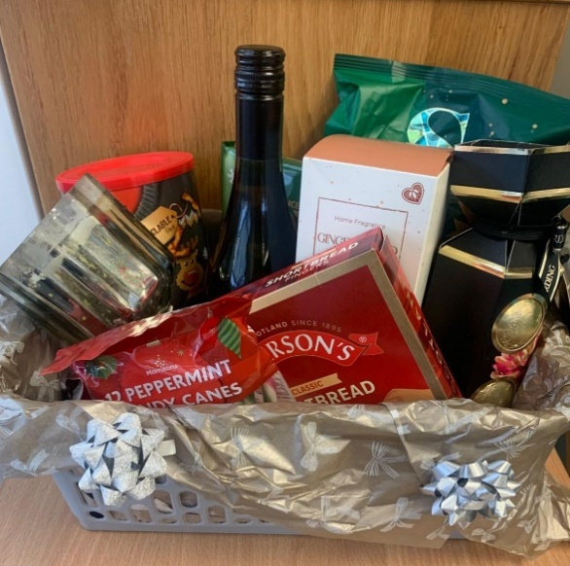

It's Christmas raffle time.....

With a chance to win one of our two Christmas hampers or a bottle of Baileys...

We are selling raffle tickets up until Monday 15th December.

Its £1 a strip...

Money can either be cash or BACs

Stratton Playgroup

TSB

30-91-41

00176633

Please ask a member of the team if you would like to buy some tickets ......

As a charity, your support is very much appreciated.

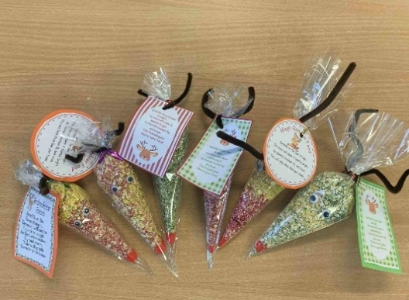
The children have made Magical Reindeer food which we are now selling........

£1.50 each.

Money can either be cash or BACs, as above.

Bags to school Collection

Thank you to everyone who supported this. We raised £20

Playgroups Christmas party

All children invited
All children will need to be collected at 12noon


Friday 19th December
@ Playgroup
9am – 12noon
Christmas partywear

Party food
Dancing
Face painting
Party games
Christmas songs
Please let us know if your child will be attending.
If your child normally does an early start, they can still attend this as normal.

Space/session availability
We are currently full for this academic year and have a waiting list for spaces.
Spaces are already filling up from September 2026 so if you or someone you know would like to reserve a space please:
Visit our website strattonplaygroupbude@co.uk
OR
Email strattonplaygroup@hotmail.co.uk

Lending library News
5 Book awards go to Ben, Bodhi, and Oscar
15 book awards to Ky

For children starting school in September 2026
Stratton school open sessions are offering their final Head Teacher School Tour of this year on: Tuesday 9th December 9:30-10:00

School applications
If your child was born between 1 September 2021 and 31 August 2022, you will need to apply for a school place for September 2026. The deadline for applications is 15 January 2026.
https://www.cornwall.gov.uk/education-and-learning/schools-and-colleges/school-admissions/

Reminder of Session Times
Early Start – drop off can be from 8.15am but no later than 8.30am.
Morning Session – drop off 9:00am.
End of morning session / lunch time - pickups or drop offs (12.00 or 12.30).
Afternoon pick up – from 3:15pm until 3.30pm.
Late fee charge of £8 per hour (minimum of £4) if you are later than 10 minutes collecting.

POLITE REMINDER Please ensure you pick your child up promptly at their allocated collection time. We do understand that on occasions you cannot help being late but we have had parents arriving 5-15 minutes late on several occasions. There is a late collection charge which we will start charging.

Updates
We are very proud of our website, where we display all our information; this will also be updated regularly with events and dates. This is available at: www.strattonplaygroup.uk.

We also have Facebook and Instagram - please find us as “Stratton Playgroup Bude”.
Monthly newsletters – these will be emailed to you each month.
At the end of each session a small description of the session will be written on the easel, outside – weather dependent.
Term Dates
Last Day Thurs 18th Dec
Christmas Party Fri 19th Dec
Start of Spring Term 2024 Mon 5th Jan
School Applications deadline Thurs 15th Jan
Half-Term Mon 16th Feb – Fri 20th Feb
Last Day Thurs 2nd April
Start of Summer Term 2024 Mon 20th April
Bank Holiday Mon 4th May
Half-Term Mon 25th May – Fri 29th May
Bags to school collection Tuesday 9th June
Last Day TBC
Leavers Party TBC

Other dates throughout the year will come up such as celebrations and events days.

Thank you for your time in reading this newsletter, if you have any questions please speak to a member of staff.

Kelly and all the team

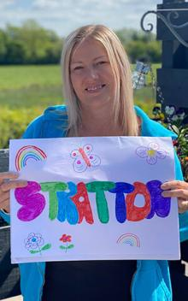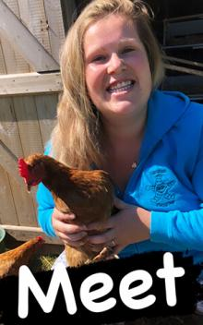
Kelly Anna Sam Harri Roxy Kayleigh Gemma

Liv Edwina

