**Stratton Playgroup**

New Road, Stratton, Bude, Cornwall EX23 9AP

**Telephone:** 01288 356135 **E-mail:**  strattonplaygroup@hotmail.co.uk

**Website:** www.strattonplaygroup.uk **Ofsted No.:** 102959 **Registered Charity No.:** 1038250

**February Newsletter**

The children have had a great few weeks back at playgroup, learning all about different climates, the environment and animals. We have been very impressed with the children’s listening skills during story times and their story recognition. We have also observed some lovely imaginative play and creative mark making.

**Dee Dee and Precious**

We were very lucky to have a visit from two Shetland ponies ‘Precious’ and ‘Dee Dee’. The children listened and followed the instructions they were given well. They were able to groom the ponies and take them around the garden for a walk.

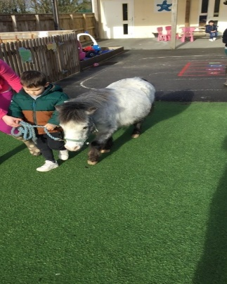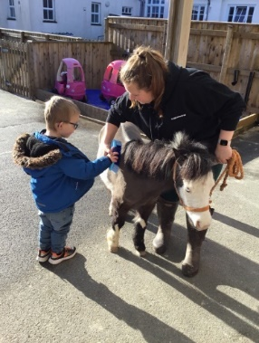 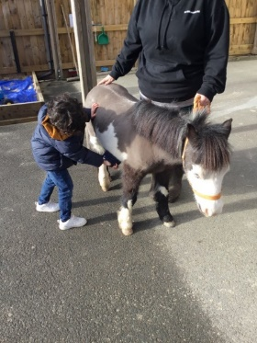 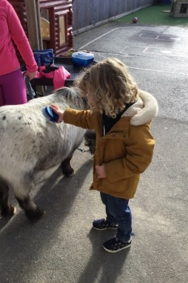

**Staff training**

All staff have refreshed their Safeguarding and Prevent training.

Anna has attended SENCO network meetings.

Kelly has completed several training courses including:

‘The importance of Physical activity’, high quality assessments, Managers Network Meeting, and a range of Safeguarding briefings.

**Key person meetings**

Thank you to everyone who has attended their key person meeting. We hope you found these beneficial. It was drawn to our attention during some meetings that parents were finding it difficult to access the reports on Tapestry.

Therefore, we would like to inform all parents that reports cannot be accessed via the Tapestry app. Please log in via the website, to view a report - click on the menu and then onto reports. Please do take time to read your child’s report and sign them.

If you need any support with this please ask a member of staff.

**Reminders**

**Suitable footwear**

It is important for the growth of children’s muscles in their feet that they wear **suitable, supportive and correctly fitting** shoes. Welly boots **are not** suitable for children to wear all day, as they do not support children’s feet correctly, they can also be heavy, which makes it more likely for children to fall over. Therefore, children should wear shoes when attending playgroup and have welly boots to change into for outdoor play where needed (If they wear welly boots to playgroup they must bring shoes to change into).

**Illness**

Please do not send your child to playgroup if they are unwell and need Calpol before attending. If children are unwell we will be asking you to come and collect them.

Your child should not attend playgroup if they have a stomach bug and they MUST NOT return until 48 hours have passed after the last loose movement or vomit.

**Drinks and lunches**

Children should only be having water in their water bottles. Children do not need to bring a drink in their lunch box, children are offered milk and water.

Lunch boxes should have at least one portion of fresh fruit or vegetables in their lunch boxes. All lunch boxes are stored in our fridge, so please ensure that they are cleaned regularly both inside and outside.

**Mobile Phones**

It is part of our Safeguarding policy that mobile phones should not be used on the playgroup premises. This includes coming down the pathway to drop and collect children.

**Staff roles and Responsibilities**

Kelly is our Designated Safeguarding lead (DSL)

Anna is our Deputy Safeguarding lead and Special Educational Needs Co-ordinator (SENCO)

Sam is our Health and Safety Officer

Kayleigh is our Behaviour lead

**A Kind Donations**

We would like to thanks Howdens at Bude, for a kind contribution they gave to playgroup, and to DT Construction who contributed some ‘play bark’ to our adventure area.

**Fundraising event**

The committee are currently in the process of organising another fund-raising event, more details to follow soon.

**Upcoming events in March**

World book day Thursday 2nd March

Red Nose Day – Friday 17th March

More details of how we will be joining in with their events nearer the time.

**Fees**

A polite reminder that any outstanding fees need to be paid by Friday 10th February. Thank you.

**Spaces in sessions**

We have a few spaces left in our sessions, if you would like to increase your child’s sessions please speak to your child’s key person.

We are also taking bookings for September 2023 onwards.

**Some useful websites we have been signposted to for parents**

[Community Energy Plus, Cornwall's Energy Advice Charity (cep.org.uk)](https://www.cep.org.uk/)

Provides information of support to help families with the increasing prices in energy.

[Children's language development and parenting advice - BBC Tiny Happy People](https://www.bbc.co.uk/tiny-happy-people)

Tiny Happy People is here to help you develop your child’s language skills, it offers simple activities and play ideas.

***Some photos of the children Playing and Learning***

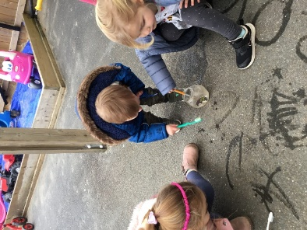 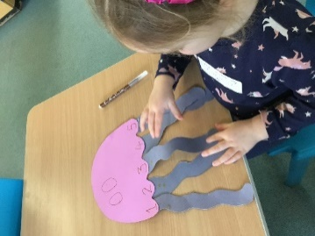 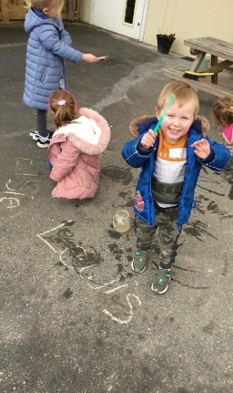 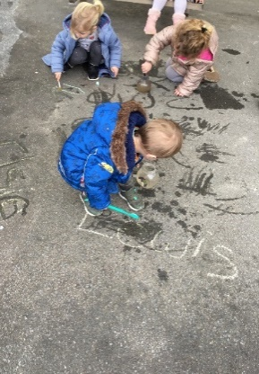

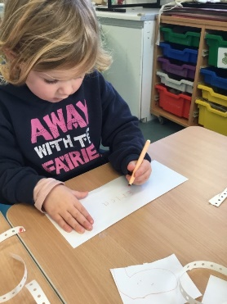 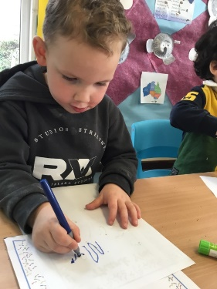 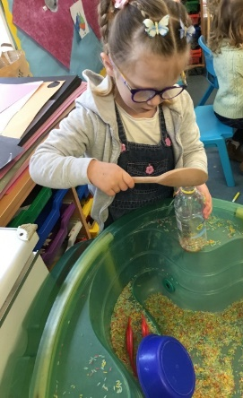

**Keeping yourself up to date**

Have a look at our website, follow the link www.strattonplaygroup.uk which is kindly supported by Budesolutions.uk.

“Like” and follow our Facebook page - please find us at “Stratton Playgroup Bude”

Monthly newsletters – emailed.

Letters in children’s drawers (we encourage children to check them at the end of each session).

Emails and text messages

**Term Dates**

Half-Term  Mon 13th- Fri 17th February

World Book Day Thurs March 2nd

Red Nose Day Fri 17th March

Last Day or term Fri 31st March

Start of Summer Term 2023 Mon 17th April

Bank Holiday Mon 1st May

**Extra Bank Holiday** Mon 9th May

Leavers photo Friday 12th May

Half-Term  Fri 26th May-Fri 2nd June

Long Weekend Fri 23rd-Mon 26th June

Last Day of term Thurs 20th July

Leavers Party Fri 21st July

Thank you for taking the time to read this month’s newsletter

Kelly and the team