**Stratton Playgroup**

New Road, Stratton, Bude, Cornwall EX23 9AP

**Telephone:** 01288 356135 **E-mail:**  strattonplaygroup@hotmail.co.uk

**Website:** www.strattonplaygroup.uk **Ofsted No.:** 102959 **Registered Charity No.:** 1038250



**Reminder Playgroup is closed For February half term from Friday 9th - 16th**



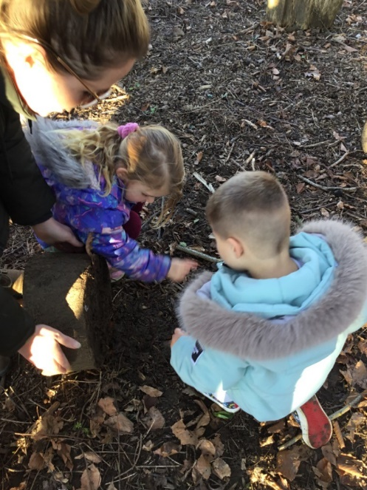

**In this month’s newsletter – February 2024!**

* Busy times at playgroup
* Lending Library News
* Childcare Choices
* Wrapping up warm / Labelled belongings and spare clothes
* Reminder – Fundraising £24 in the year 2024
* **Parents Information**
* Safer Internet
* EasyPeasy APP
* Chat Health
* Bude Food Bank
* Measles advice
* Upcoming event held by Mencap Society

**Dates**

* Key person meetings
* Term Dates

**Busy times at playgroup**

We have made really good use of the school woods and fields this month. The children have enjoyed walking, visiting the chickens and exploring in these environments.

The sand pit has been a busy place, and we have had lots of requests for dancing and musical instruments.

Our letters and sounds activities have provided some good learning time, developing children’s listening and communication skills.

It has been lovely welcoming lots of new children to playgroup 😊

Next week we will be learning all about Chinese New Year. The year of the Dragon.



**Lending Library News**

It is so lovely to see so many children enjoying our lending library.

**15 book awards are given to……….**

**Arlo, Paddy, Jackson, Amaya, Grace and Eli**

**Childcare Choices/Funding**

****

For all information about funding available to you, including the new 2-year funding coming into place in April, please use the link below:

[Childcare Choices | 30 Hours Childcare, Tax-Free Childcare and More | Help with Costs | GOV.UK](https://www.childcarechoices.gov.uk/)

**Wrapping up warm / Labelled belongings and spare clothes**

During this colder/wet month, please ensure children are sent to playgroup with a warm coat, and other warm clothes items such as hats, gloves, and scarfs.

**Please can all children’s belongings be clearly labelled** – such as all spare clothes, weather dependent clothing, packed lunch boxes and water bottles.

**REMINDER**

**Fundraising RAISING £24 In the year 2024 –**

**Everyone should have received a fundraising form.**

**Fundraising is an important part of playgroup.**

To celebrate the new year 2024, we would like our playgroup children /families to join in with fundraising by raising £24. The children can be sponsored to raise their £24 however they want.

Children are welcome to bring in their forms and money into playgroup at any time, we will celebrate all children’s achievements together. We would like to suggest that all children complete their fundraising by the end of the spring term - March 28th.

*We have loved hearing about some of the fundraising happening.*

*Bake and cake mornings with friends*

*Riding bikes, swimming yoga dancing.*

*We are so excited to share these achievements with everyone at playgroup.*

*Thank you*

 

|  |
| --- |
| Parent information  **Safer Internet day**  Safer Internet day is on **Tuesday 6th February.** Here are some useful websites to look at for internet with your child  .  [Keep Children Safe Online: Information, Advice, Support - Internet Matters](https://www.internetmatters.org/)  [Login | ParentZone](https://www.parentzone.me/login)  **A useful app to download is Easy-peasy Parenting Tips**  C:\Users\User\AppData\Local\Microsoft\Windows\INetCache\Content.MSO\26CDD02C.tmp  **Chat health**  Please see the poster below – this is not an emergency service but you can get advice on children’s health and wellbeing, behaviour, childhood illnesses and much more,  Budehaven Community School » New health advice messaging service launches  for families in Cornwall and the Isles of Scilly  **Bude Food Bank**  [Bude Food Bank | Essential Food & Care in Cornwall](https://budefoodbank.org.uk/)  C:\Users\User\AppData\Local\Microsoft\Windows\INetCache\Content.MSO\27C9A453.tmp  **Measles**  The Department of Health have asked us to share information with you about measles – This is because measles is circulating.  [Measles - NHS (www.nhs.uk)](https://www.nhs.uk/conditions/measles/)  **Up Coming event held by Royal Mencap Society**  C:\Users\User\AppData\Local\Packages\Microsoft.Windows.Photos_8wekyb3d8bbwe\TempState\ShareServiceTempFolder\Advert - Table booking.jpeg |

**Updates**

We are very proud of our website, where we display all our information; this will also be updated regularly with events and dates. This is available at: www.strattonplaygroup.uk.

We also have Facebook and Instagram - please find us as **“Stratton Playgroup Bude”.**

Monthly newsletters – these will be emailed to you each month.

At the end of each session a small description of the session will be written on the easel, outside – weather dependent.

**Dates**

**Key person meetings**

We are now offering key person meetings; your child’s key person will speak to you about arranging a convenient time.

**Term Dates**

Half-Term Fri 9th - Fri 16th February

Last Day Thurs 28th March

Start of Summer Term 2024 Mon 15th April

Bank Holiday Mon 6th May

Half-Term Fri 24th May - Fri 31st May

Long Weekend Fri 21st - Mon 24th June

Bags for school collection Thurs 13th June

Last Day Thurs 18th July

Leavers Party Fri 19th Jul

Thank you for your time in reading **this newsletter**, if you have any questions please speak to a member of staff.

Kelly and all the team 😊

