**Stratton Playgroup**

New Road, Stratton, Bude, Cornwall EX23 9AP

**Telephone:** 01288 356135 **E-mail:**  strattonplaygroup@hotmail.co.uk

**Website:** www.strattonplaygroup.uk **Ofsted No.:** 102959 **Registered Charity No.:** 1038250

**Newsletter – January 2023**



**What we are up to this half term……**

This half term our topic is **animals and the environment.** The children will be learning about sea turtles and their environment. We will then learn about the climate in Australia, as well as talking about Rainforests and the animals that live there.

The children will try different fruit that grows in the rainforest and will talk about the shape, colour and texture of them.

Activities this term include, making sea turtles from recycled objects, creating patterns on shells; making Boomerangs using aboriginal art techniques and making rainmakers and drums.

We will also be celebrating Chinese New Year, where we will enjoy some Chinese food, and Valentine’s day, where we will talk about all the people who are special to us.

**This half term learning intentions**

**Communication and Language**

Listens to other people’s talk with interest but can easily be distracted by other things – **0-3 years**

Understands simple questions about who, what and where – **0-3 years**

Use a wider range of vocabulary – **3-4 years**

Enjoys listening to longer stories and can remember much of what happened – **3-4 years**

**Understand the world**

Begin to understand the need to respect and care for the natural environment and all living things – **3-4 years**

Know that there are different countries in the world and talk about the differences they have experienced or seen in photos – **3-4 years**

Explore materials with different properties -**0-3 years**

**Mathematics**

Notice pattern and arrange things in a pattern – **0-3 years**

Talk about and identify the patterns around them – **3-4 years**

***This half term’s story focuses***

*‘Duffy’s lucky escape’*

*‘koala bear in Australia’*

*‘Buddy’s rainforest rescue’*

*‘Nelsons dangerous dive’*

**A few photos from our Christmas party**

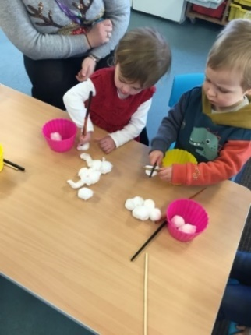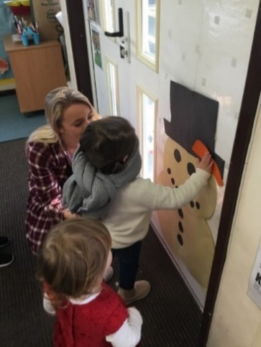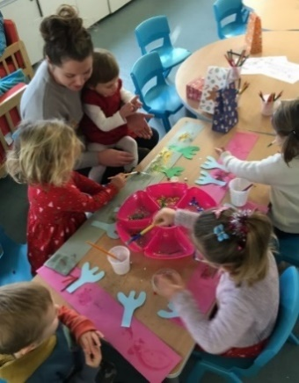

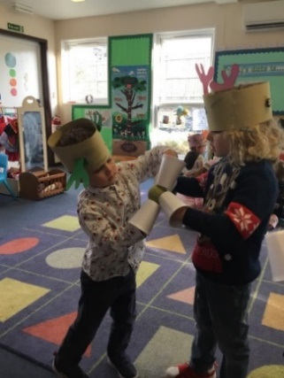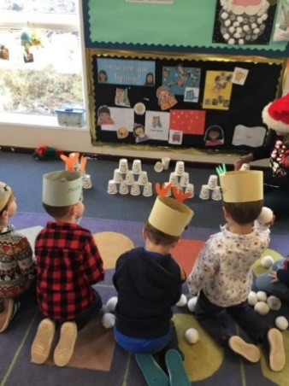

**Staffing**

I (Kelly) have now returned to work as playgroup manager after my maternity leave. I will be working at playgroup 3 days a week Monday, Wednesday and Thursday. Anna will now return to her role as deputy manager and Sam will return to her role as supervisor.

**Christmas Fayre**

Thank you to our committee for organising our Christmas fayre, not as many people attended as we would have hoped, for those that did attend it was a lovely evening and we raised over £300!!!

**Food bank donations**

Thanks to everyone who gave donations for the food bank.

**Kind donation**

Thank you to Pendeen car boot who generously donated £500 to playgroup.

**Healthy Movers Programme**

This week we will be starting our healthy movers activities again, you will be emailed some information of how this can be promoted at home.

**Fees**

All invoices will be sent out next week.

**Reminders**

As the colder and wetter weather continues, can we remind you that all children need to bring a waterproof coat and wellies with them every day they attend playgroup. We still spend time outdoors throughout the day and the children enjoy this time to explore and run around. We also visit the school grounds and woodland area frequently and take the children as a whole group, and weather appropriate clothing is essential for this. Spare clothes are also essential as children get wet and muddy.

**Illness**

It is always the case that children should be well enough to attend playgroup, and if they are not they should not attend, or if they come in and we feel they are unwell, we will send them home.

Please remember NO playgroup, if Calpol is needed for your child, as this could be masking other symptoms and illness.

Thank you for your understanding and support. This enables us to protect our playgroup community. As ever, if you have any specific concerns, please do get in touch.

**Pick up times**

Our end of day session times are from 3:15PM- 3:30PM, unless there is an individual arrangement. We will not bring children out to be collected before this time, as we are still having valuable learning time.

**School applications**

If your child was born between 1 September 2018 and 31 August 2019 you will need to apply for a school place for September 2023. **The deadline for applications is 15 January 2023.** <https://www.cornwall.gov.uk/education-and-learning/schools-and-colleges/school-admissions/>

**Parent meetings**

Over the next couple of weeks your child’s key person will be approaching you to arrange a convenient time for a meeting. This will be a chance for you to meet with your child’s key person and discuss your child’s development. Your child’s key person will arrange a convenient time and day with you in January.

**Keeping yourself up to date**

Have a look at our website, follow the link www.strattonplaygroup.uk which is kindly supported by Budesolutions.uk.

“Like” and follow our Facebook page - please find us at “Stratton Playgroup Bude”

Monthly newsletters – emailed.

Letters in children’s drawers (we encourage children to check them at the end of each session).

Emails and text messages

**Term Dates**

Half-Term  Mon 13th- Fri 17th February

Last Day or term Fri 31st March

Start of Summer Term 2023 Mon 17th April

Bank Holiday Mon 1st May

**Extra Bank Holiday** Mon 9th May

Leavers photo Friday 12th May

Half-Term  Fri 26th May-Fri 2nd June

Long Weekend Fri 23rd-Mon 26th June

Last Day of term Thurs 20th July

Leavers Party Fri 21st July

Thank you for taking the time to read this month’s newsletter

Kelly and the team