**Stratton Playgroup**

New Road, Stratton, Bude, Cornwall EX23 9AP

**Telephone:** 01288 356135 **E-mail:**  strattonplaygroup@hotmail.co.uk

**Website:** www.strattonplaygroup.uk **Ofsted No.:** 102959 **Registered Charity No.:** 1038250

**July Newsletter**



# 

# *We are in our final month of this academic year. We have had such a lovely start to this half term. We have spent lots of time outdoors, over at the school field, bike track and visitng the school chickens.*

This week we are making smoothies. We will then explore and take part in a range of different sports. We will look at different equipment used for each sport and compare the sizes and shapes of different balls. In our last week, we are *learning about staying safe at the beach, and exploring what we find on the beach, espeically in rock pools.*

# *Tapesty*

Please do take time to look at your child’s tapestry. There are observations on there, and end of term learning summaries. Tapestry is not a statutory requirement in Early Years, but we, as a setting, like to share your child’s learning and development with you. We aim to put at least one observation on every two weeks.

Our amazing Lifeboat runners

We are super proud of 3 of our playgroup children, Bertie, Cohen and Zara who ran the 1-mile Bude lifeboat run. This is an amazing achievement, WELL DONE!

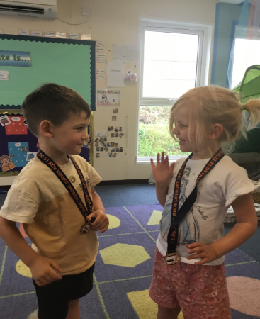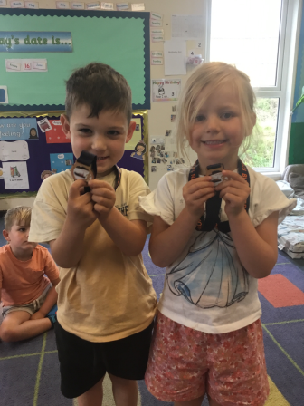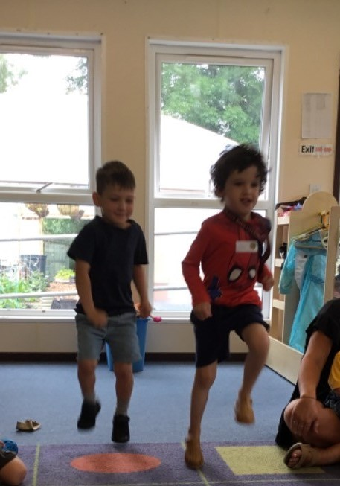

**40 YEARS**

WOW, this year playgroup is celebrating being open for 40 years. We all very really proud of this. Playgroup has changed, developed, and most certainly expanded in this time. As a setting we are constantly evaluating what we offer and from this we make positive changes. We are really excited that from September 2023, we will now be open to all 2-year olds all day, every day. ***Spread the word as we still have some spaces available for children to start in September.***

**REMINDERS**

**Sun cream and sun hats**

Please can children have sun cream applied before attending playgroup, and also bring in a **named** sunhat, and sun cream (unless you have paid to use playgroups sun cream).

**Sponsored walk and mini sports day –**

**An email with all the relevant information was sent to all parents on Friday afternoon. If you do have any questions please speak to a member of staff.**

Any money raised is going to be put towards developing improving our outdoor spaces.

Please ensure children come with a water bottle, hat and sun cream applied.

**Leavers party for school leavers**

Our school leavers party is on **Friday 21st July - in the morning** (invites will be sent to all our school leavers this week). Playgroup’s last day is **Thursday 20th July**.

**School leavers**

After a meeting with the reception teachers last week, here are some things to support your children with over the summer.

***Recognising their name***

***Self-regulation, talking about their emotions and how they are feeling and why they are feeling a certain way and how to deal with this.***

***Independence in self-care, toileting, washing hands, getting dressed, undressed, putting shoes on and taking off.***

***Talking about initial sounds of words/names – I spy games sounding out the sound of the first letter.***

**Keeping yourself up to date**

Have a look at our website, follow the link www.strattonplaygroup.uk which is kindly supported by Budesolutions.uk.

“Like” and follow our Facebook page - please find us at “Stratton Playgroup Bude”. We are now also on Instagram too!

Monthly newsletters – emailed.

Letters in children’s drawers (we encourage children to check them at the end of each session).

Emails and text messages

**Term dates**

Mini sports day/sponsored Thurs 6th July PM

Last Day of term Thurs 20th July

Leavers Party Fri 21st July

New children’s pre placements Tues 5th September and Weds 6th September

Playgroup first day back after summer Thurs 7th September

Thank you for taking the time to read this month’s newsletter

Kelly and the team

**Bude Animal Friends Awareness Day - Saturday 8th July 10am-4pm Bude Triangle**

**Fancy Dress:**

Any children aged 6 or below who come dressed in an animal costume will be given a pocket money prize donated by Banfords.

Come and learn more about the wonderful work on behalf of animals in Bude and surrounding areas.

Stall Holders:

1. Bude Animal Friends  
2. Born to be Wild  
3. Hilltop Animal Haven  
4. British Divers Marine Life Rescue  
5. Animal Free Research UK: Bude Group  
6. Paw's Stoat, Weasel and Polecat Rescue  
7. Shebbear Bat Care  
8. Sally's Animals in Need  
9. Donkey Haven

Information & chat, Tombola, Raffle, Bric-a-brac.