Stratton Playgroup
New Road, Stratton, Bude, Cornwall EX23 9AP
Telephone: 01288 356135 E-mail: strattonplaygroup@hotmail.co.uk
Website: www.strattonplaygroup.uk Ofsted No.: 102959 Registered Charity No.: 1038250
July 2026 Newsletter

I cannot believe this is our last newsletter of this academic year, time has gone so quickly. We have had a fantastic year with all the children.
I would like to wish the best of luck to all children who are starting school in September. We hope you all remember us in years to come.
We look forward to welcoming some of our families and children back in September, as well as welcoming some new children and their families.
I would also like to thank our amazing staff team for all their hard work and dedication to our setting.
I hope everyone has a lovely summer and the sun shines!
In this month’s Newsletter

What have we been up to

Lending library news

Sports day success

Sun cream

Summer clothing

Bags for school collection

Fundraising success

Bude Carnival

School starters party

Spaces in September

Remaining term dates

What have we been up to……
The children have been very busy over the last few weeks.
We have been learning about staying safe at the beach and in the sun. We have been practicing football and racket skills. The children have also been spending time on our slack line strengthening their core muscles and building on balancing skills.

Lending library news
15 book award to Oscar and Cathrerine
30 book award to Rory
50 book award to Olivia
60 book award to Ky
Please could we ask that all books are returned to playgroup by Monday 13th July.

Sports day success

Thank you everyone who came and supported our sports day.
We thought it was really successful morning especially considering how little the children are. We are very proud of all of them.

Sun cream
Please check the weather forecast before your child comes to their session. If hot, sunny weather is forecast, please apply sun cream.
If your child is here all day, we will reapply.
Please send your child to playgroup with a labelled bottle of sun cream which we will use for them. NHS Recommendations - a sun protection factor (SPF) of at least 30, to protect against UVB at least 4-star UVA protection.

Summer clothing
Please ensure children wear secure shoes preferably with a back.
We ask that where possible children wear tops that cover their shoulders.

Bags for school collection

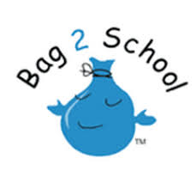
Thank you everyone who brought their bags in. We are unsure on the amount raised but we had 130kg.

Fundraising

Thank you to everyone who took part in our sponsored fundraising, to raise £26 in the year 2026. We have been sharing lots of the children’s sponsorships on Famly. We will have a presentation to celebrate all the children who have taken part. We will also let everyone know how much money we have raised towards developing our outdoor space.

Bude Carnival
Bude Carnival – Saturday 15th August 2026! 🎉
Stratton Little Learners will be taking part in Bude Carnival this year!
Tombola Donations 🎁
If you have any teddies, toys or books in good condition that you no longer need, we would be very grateful for donations for our tombola table. Please bring any donations into playgroup before the end of term.
Evening Parade 💃🕺
We will also be taking part in the carnival evening parade, walking and dancing along to Danny Go! music.
Children, siblings, and parents are all invited to join in by wearing their favourite sporting outfits. Please let us know if you and your child(ren) would like to take part. 🥳
Thank you for your support!

School starters party
An invitation has now been given to all the children starting school in September.
The invitation has also been uploaded to Famly.

Spaces in September
We do currently have some spaces available for children to join us from September. If you know any families that would like to join us please ask them to contact us via email or phone.

Remaining term dates
Last Day - Wednesday 15th July
Leavers Party (school starters only) - Thursday 16th July AM
Other dates throughout the year will come up, such as celebrations and events days.

Updates
We are very proud of our website, where we display all our information; this will also be updated regularly with events and dates. This is available at: www.strattonplaygroup.uk.

We also have Facebook and Instagram - please find us as “Stratton Playgroup Bude”.
Monthly newsletters – these will be emailed to you each month.
At the end of each session a small description of the session will be written on the easel, outside – weather dependent.

Thank you for your time in reading this newsletter, if you have any questions please speak to a member of staff.

Kelly and all the team

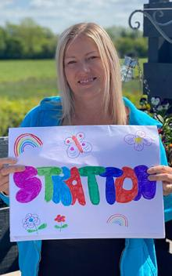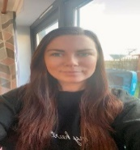
Kelly Anna Sam Roxy Kayleigh Gemma
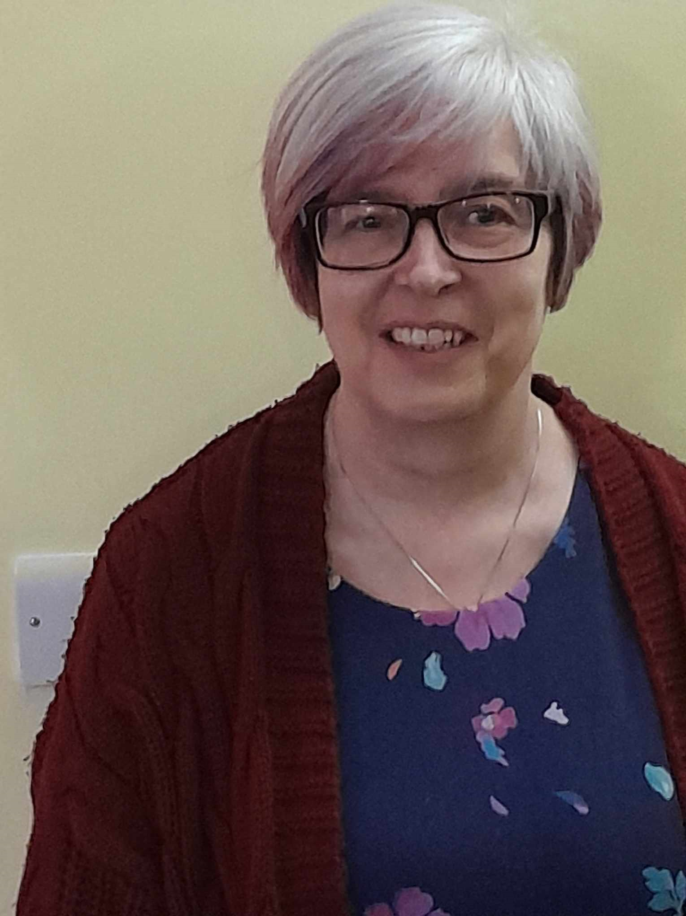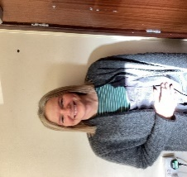
Liv Edwina Tracy

