**Stratton Playgroup**

New Road, Stratton, Bude, Cornwall EX23 9AP

**Telephone:** 01288 356135 **E-mail:**  strattonplaygroup@hotmail.co.uk

**Website:** www.strattonplaygroup.uk **Ofsted No.:** 102959 **Registered Charity No.:** 1038250

June Newsletter



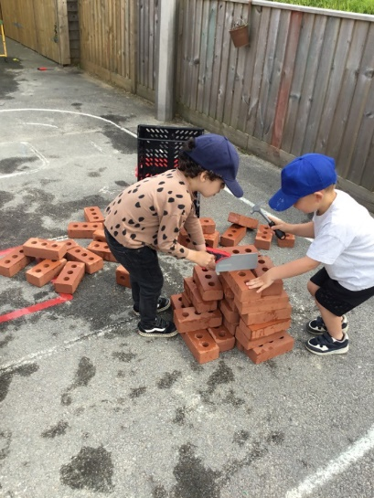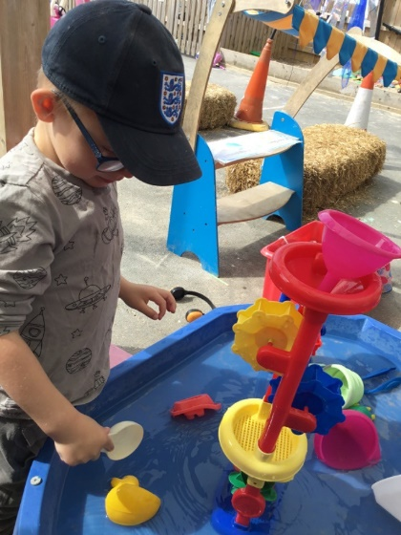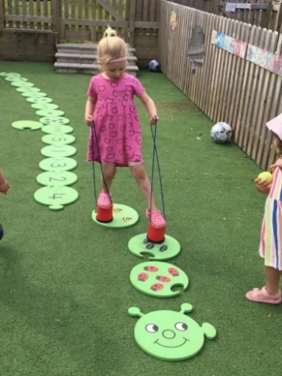

# *I cannot believe we are now in our final half term of this acedmeic year! This half term our Topic is ‘Summer Time’.*

This half term we will plant seeds to watch grow. We will learn about what seeds need to grow. The children will learn where our different foods come from. Outside the children will make patterns from flowers using sticky frames. We will use our senses to explore different herbs in the tuff spot outside.

We will then move on to explore mini beasts. We will take part in mini beast hunts. The children will help to make a wormery. At the craft table we will use bubble wrap to create patterns and make bee hives. We will learn how bees make honey. We will listen to the story “Super Worm”. The children will make tally charts of how many bugs they find.

We will also be making fathers day cards and medals out of clay, for our mini sports day.

**Some of our story focuses are -**

*Guess How Much I love you*

*Rainbow Fish*

*Tiddler*

**Our role plays this half term are -**

A ice cream shop – **Outside**

A farm shop – **Outside**

Puppet theatre – **Inside**

**Learning intentions for Summer term –**

**Communication and language**

· *Learning new words and use a wider range of vocabulary - 3 – 4 years*

*· Listens to simple stories and understand what is happening with the help of pictures – 0 – 3 years*

**Understanding the world**

*· Explore natural materials indoors and outdoors – 0 – 3 years*

*· Make connections between features of their family and other families 0 – 3 years*

**REMINDERS**

**Suitable clothing, footwear, sun cream and sun hats**

During the summer months please can children bring in a **named** sunhat.

Children can either bring in their own labelled sun cream to leave at playgroup, or for a £1 contribution they can use playgroups’. If you would like to use playgroups’ please either bring in £1 or BACS it over. We do ask that children have sun cream applied before attending their sessions, and we will reapply throughout the day if needed.

**We advise that sun cream used is a factor 50 and has a five-star UVA Rating.**

**Please can we request that thin strapped dresses/tops are not worn (shoulders covered where possible).**

**Please ensure that children wear summer shoes that have a secure back** (not flip flops).  **and that are the correct size for your child’s feet.**

**Lunch Boxes**

Grapes, cherry tomatoes, large blueberries and sausages should all be cut in half sideways. We also ask that children do not bring frubes in their lunch boxes, as children often attempt to open these themselves and often spill on their clothing.

**Library books**

A reminder for children to use our playgroup library system, bring their book back in their book bag and they can choose a new book to take home.

**Spaces in sessions**

We have a few spaces left in our sessions, if you would like to increase your child’s sessions please speak to your child’s key person.

We are also taking bookings for September 2023 onwards.

**Proposed date - for mini sports day & sponsored walk**

We are hoping to arrange a mini sports day and sponsored walk for Thursday 6th July, we are just waiting to hear back from school about use of the school field.

**Leavers party for school leavers**

Our School leavers party is on **Friday 21st July - in the morning** (invites will be sent to all our school leavers). Playgroup’s last day is **Thursday 20th July**.

**Keeping yourself up to date**

Have a look at our website, follow the link www.strattonplaygroup.uk which is kindly supported by Budesolutions.uk.

“Like” and follow our Facebook page - please find us at “Stratton Playgroup Bude”. We are now also on Instagram too!

Monthly newsletters – emailed.

Letters in children’s drawers (we encourage children to check them at the end of each session).

Emails and text messages

**Term dates**

Long Weekend Fri 23rd-Mon 26th June - playgroup closed

Last Day of term Thurs 20th July

Leavers Party Fri 21st July

Thank you for taking the time to read this month’s newsletter

Kelly and the team

