**Stratton Playgroup**

New Road, Stratton, Bude, Cornwall EX23 9AP

**Telephone:** 01288 356135 **E-mail:**  strattonplaygroup@hotmail.co.uk

**Website:** www.strattonplaygroup.uk **Ofsted No.:** 102959 **Registered Charity No.:** 1038250

**March Newsletter**

This half term our Topic is **‘Stories and Celebrations’**

We will have a different story focus each week with a range of learning activities built around these.

**Our Stories our -**

‘The Little Red Hen’

‘The Three Little Pigs’

‘The Hungry Caterpillar’

‘Keeping Healthy’

‘Mr Grumpy's Outing’

‘Kindness is my Superpower’

We will also be celebrating/ learning about St Pirans day, St David’s day, St Patricks day, National Science week, World book day, Red Nose day and Mother’s Day.

Our role play area this half term as voted for by the children is a **‘bakery’.**

**Our Learning intentions are -**

**Communication and language**

· Listens to simple stories and understand what is happening with the help of the pictures – 0 – 3 years

· Enjoys listening to longer stories and can remember much of what happens – 3 – 4 years

**Personal, social and emotional development**

· Develop friendships with other children – 0 – 3 years

· Build constructive and respectful relationships – 3 – 4 years

**Understanding the world**

· Explore materials with different properties – 0 – 3 years

· Explore how things work – 3 – 4 years

· Begin to understand the need to respect and care for the natural environment and all living things – 3 – 4 years.

· Understand the key features of the life cycle of a plant and an animal 3 – 4 years

· Continue developing positive attitudes about the differences between people – 3 – 4 years

· Show interest in different occupations 3 – 4 years – (role play and visits)

**Egg boxes**

If you have any empty egg boxes please could you bring them into playgroup for a craft activity we have planned.

**Dentist visit**

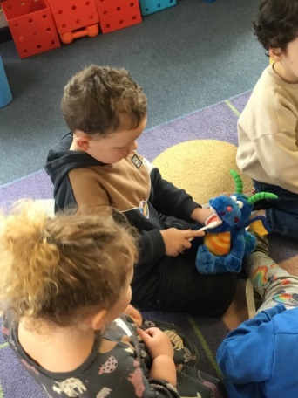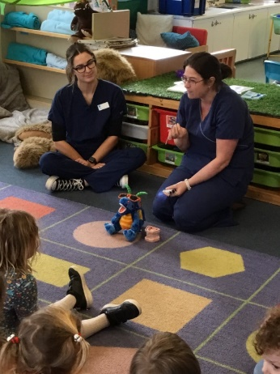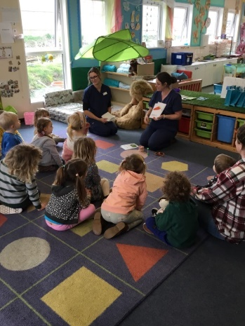

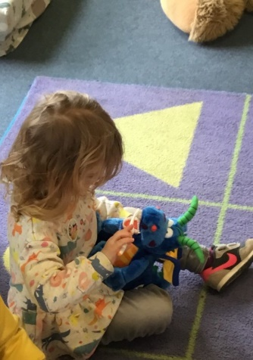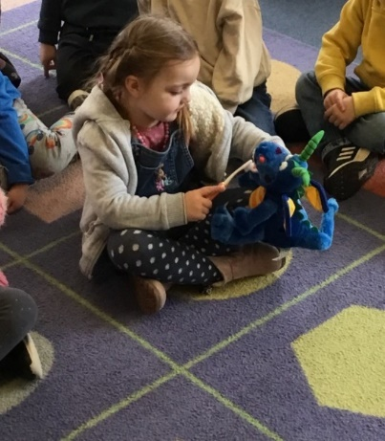

We were very lucky to have a visit from some dental nurses yesterday, they spoke to the children all about trips to the dentist and the importance of keeping our teeth clean.

**Reminders**

**Illness**

Unfortunately, there are lots of illnesses around at the moment, so please can we again ask that you do not sendyour child to playgroup if they are unwell and need Calpol before attending. If children are unwell we will be asking you to come and collect them.

Your child should not attend playgroup if they have a stomach bug and they MUST NOT return until 48 hours have passed after the last loose movement or vomit.

This is to protect our playgroup community.

**Drinks and lunches**

Children should ***only*** be having water in their water bottles, if they do come in with juice we will be replacing it with water. We often get comments from parents that children have not drunk much water. I would like to reassure you that we are always encouraging the children to drink and often children have their water bottles refilled.

Children do not need to bring a drink in their lunch box, children are offered milk and water.

Lunch boxes should have at least one portion of fresh fruit or vegetables in their lunch boxes. All lunch boxes are stored in our fridge, so please ensure that they are cleaned regularly both inside and outside.

**Mobile Phones**

**It is part of our Safeguarding policy that mobile phones should not be used on the playgroup premises. This includes coming down the pathway to drop and collect children.**

**Fundraising events –** As a charity, fund raising is very important for us, please support these events as much as you can.

**Donations month,** this month we are having a donations month there is a list of items attached to this email of items we would appreciate as a donation. If you are able to donate please bring you item(s) to playgroup, we will be extremely grateful.

**DISCO**

We are delighted to have sold lots of tickets for our playgroup disco, we are really looking forward to it, doors open at 5:30pm.

**Easter bucket and name the lamb fundraiser -**Available at playgroup from Monday March 6th

To win this Easter prize !!

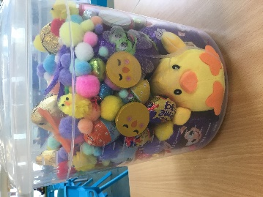

Guess how many chocolate **EGGS** are in the bucket?

**£1 a guess**

Everyone will find out how many eggs there are inside on Wednesday 29th March.

What’s my Name?

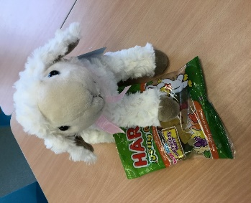

To win me and some sweeties, try and guess what I am called from a selection of names???

**50p a guess**

Everyone will find out my name on Wednesday 29th March.

*So, to have a go at wining, please make your guesses from a selection of names, and bring your pennies along to playgroup from Monday 6th March, or you can BACS money to playgroup.*

The committee are currently in the process of organising another fund-raising event, more details to follow soon.

**Spaces in sessions**

We have a few spaces left in our sessions, if you would like to increase your child’s sessions please speak to your child’s key person.

We are also taking bookings for September 2023 onwards.

How '**AMAZING'** is Ella one of our parents, who is running the London Marathon AGAIN!!!

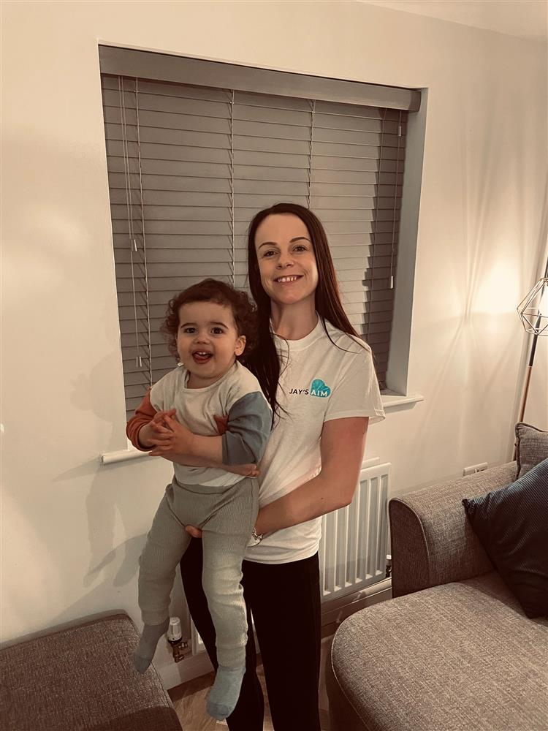

Ella is running for JaysAim, and she would like to be able to raise enough money for a defibrillator to be installed at playgroup, Bertie her eldest son already attends playgroup, and eventually Ted will too.

Please see Ella’s Fund raising page below and read all about Ella’s reason for this cause, and support her if you can 🙂

[https://www.justgiving.com/fundraising/ella-summers3...](https://www.justgiving.com/fundraising/ella-summers3?utm_source=facebook&utm_medium=fundraising&utm_content=ella-summers3&utm_campaign=pfp-share&utm_term=e808b55215b940fcbe6eb1a7d9e0006d&fbclid=IwAR21umNXJj54wz6qad4xe3mUTi4B-FddsoAes5wS16jKpK3aRcv1OlHetWo)

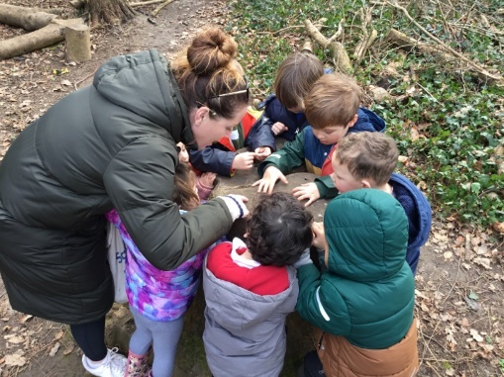 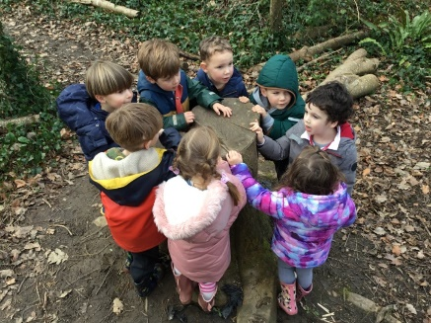 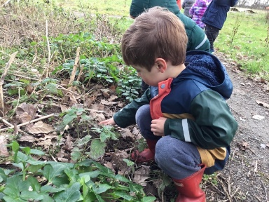

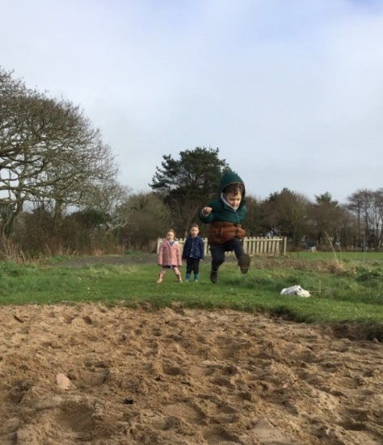 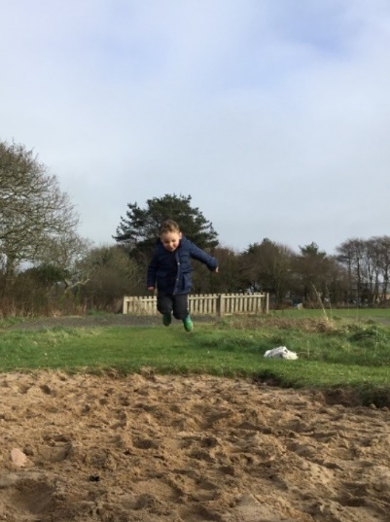 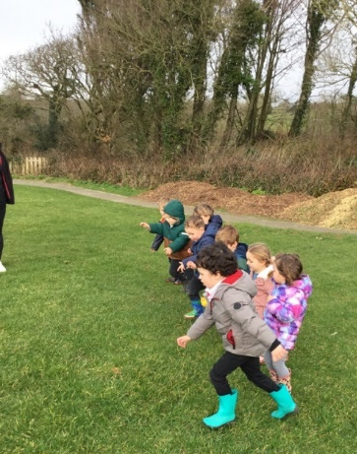

**Keeping yourself up to date**

Have a look at our website, follow the link www.strattonplaygroup.uk which is kindly supported by Budesolutions.uk.

“Like” and follow our Facebook page - please find us at “Stratton Playgroup Bude”

Monthly newsletters – emailed.

Letters in children’s drawers (we encourage children to check them at the end of each session).

Emails and text messages

**Term Dates**

DISCO Fri 3rd March

Red Nose Day Fri 17th March

Last Day or term Fri 31st March

Start of Summer Term 2023 Mon 17th April

Bank Holiday Mon 1st May

**Extra Bank Holiday** Mon 9th May

Leavers photo Friday 12th May

Half-Term  Fri 26th May-Fri 2nd June

Long Weekend Fri 23rd-Mon 26th June

Last Day of term Thurs 20th July

Leavers Party Fri 21st July

Thank you for taking the time to read this month’s newsletter

Kelly and the team