**Stratton Playgroup**

New Road, Stratton, Bude, Cornwall EX23 9AP

**Telephone:** 01288 356135 **E-mail:**  strattonplaygroup@hotmail.co.uk

**Website:** www.strattonplaygroup.uk **Ofsted No.:** 102959 **Registered Charity No.:** 1038250



We are continuing to learn all about **Transport- ‘Land, Air and Sea’.** The children have really engaged in this topic and over the next few weeks, we have many more activities planned.

Next week we will be learning all about different work vehicles such as: ambulance, police, fire engines and farm machinery. The children will be carrying out some transport surveys. We will also be looking at transport around the city, such as the underground train, buses, trains and bikes.

We will then be moving on to learn all about transport on the sea. The children will make their own sailing boats and we will race them, exploring different ways to make them move. We will be talking about lifeboats and how to stay safe on the beach.

We will read the story **‘Noah’s Ark’**

**OFSTED**

We had our OFSTED inspection on Wednesday. Having an OFSTED inspection is a really anxious time, I was extremely proud of all the staff. I would also like to say a BIG thank you to all the parents who emailed in with their feedback, I was overwhelmed by the postvie comments we received, they were so lovely to read, and I have shared your comments with the staff.

We will receive our report within the next 28 days.

**Walk to school week**

**15th – 19th May** is walk to school week, so if you can walk, scooter or cycle to playgroup that’s great, or even part of the way (parking at splash and walking up the lane). We do understand that not everyone can do this; therefore, we will be going for walks in the school grounds to join in.

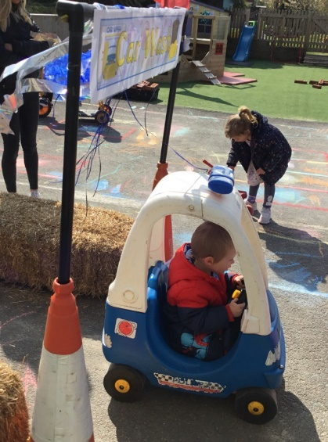 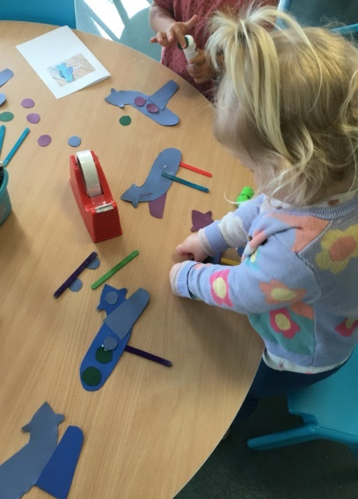 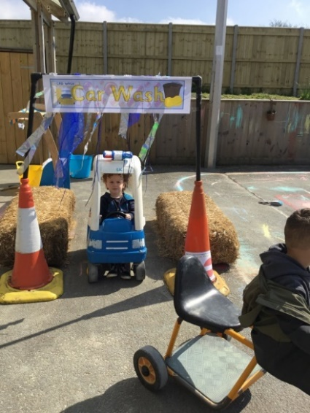

**REMINDERS**

**Suitable clothing**

**Footwear**

Please ensure that children wear suitable footwear to playgroup that they can be active in. We do ask that children do not wear wellies as a shoe all day. With hopefully the sunnier weather approaching, we ask that children wear footwear with a supportive back (not flip flops).

**Sun cream and sun hats**

During the summer months please can children bring in a named sunhat, for the hotter months. Children can either bring in their own labelled sun cream to leave at playgroup, or for a £1 contribution, they can use playgroups’. If you would like to use playgroups’ please either bring in £1 or BACS it over. We do ask that children have sun cream applied before attending their sessions, and we will reapply throughout the day if needed.

**Visits sharing skills and talents**

Throughout the next term we would like to invite in any parents/family members to come into playgroup and share a skill, talent or spent some time with us. This could be:

*Showing/talking to us about your occupation*

*Sharing a musical talent*

*Sport*

*Bringing in a pet*

*Sharing travel*

*Sharing/showing a collection*

*Or it could be coming in and reading a/some stories with the children*

*Or anything you would like to share with us*

**If you would like to arrange a time to come in, please speak to your child’s key person to arrange this.**

**Library books**

A reminder for children to use our playgroup library system, bring their book back in their book bag and they can choose a new book to take home.

**School leavers photo**

**Our School leavers group photo** will be on Friday 12th May from 8:30 am. If your child does not attend but would like to be included, please let a member of staff know.

**Spaces in sessions**

We have a few spaces left in our sessions, if you would like to increase your child’s sessions please speak to your child’s key person.

We are also taking bookings for September 2023 onwards.

**Keeping yourself up to date**

Have a look at our website, follow the link www.strattonplaygroup.uk which is kindly supported by Budesolutions.uk.

“Like” and follow our Facebook page - please find us at “Stratton Playgroup Bude”

Monthly newsletters – emailed.

Letters in children’s drawers (we encourage children to check them at the end of each session).

Emails and text messages

**Term dates**

**Extra Bank Holiday** Mon 8th May

Leavers photo Friday 12th May

Half-Term  Fri 26th May-Fri 2nd June

Long Weekend Fri 23rd-Mon 26th June

Last Day of term Thurs 20th July

Leavers Party Fri 21st July

Thank you for taking the time to read this month’s newsletter

Kelly and the team

