**Stratton Playgroup**

New Road, Stratton, Bude, Cornwall EX23 9AP

**Telephone:** 01288 356135 **E-mail:**  strattonplaygroup@hotmail.co.uk

**Website:** www.strattonplaygroup.uk **Ofsted No.:** 102959 **Registered Charity No.:** 1038250

**Newsletter - November 2022**

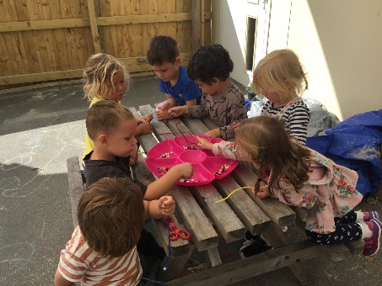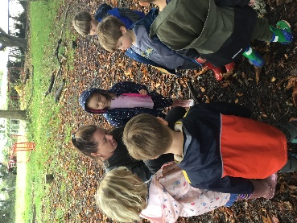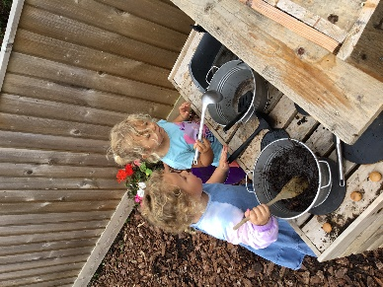

We are already in the second half of the Autumn term and we have lots of fun things planned!

Out topic for this half term is ‘The Night Sky’ and the children will be taking part in lots of fun activities around this theme.

During half term, Roxy and Charlotte set up a lovely new rocket role play area for the children to explore and enjoy.

This week the children have been enjoying creating fun firework pictures and we have been talking about safety when using sparklers and watching fireworks.

The children have also learnt about Diwali and made Rangoli patterns with chalk.

Next week the children will be learning about Remembrance Day and making some poppy craft.

We will be making telescopes and looking through binoculars to see how different objects look closer up, and compare distance and size. The children will use the iPad to learn about the different phases of the moon.

The children will learn about nocturnal animals and their habitats and learn how to care for the environment to help keep animals safe

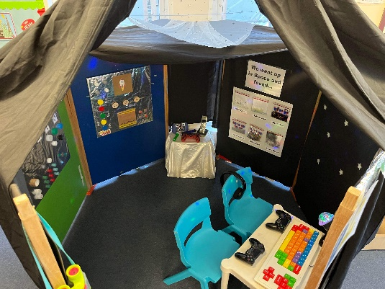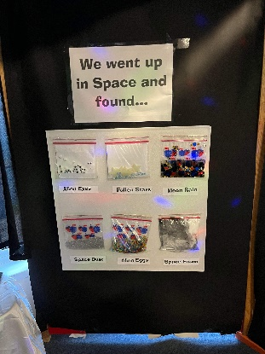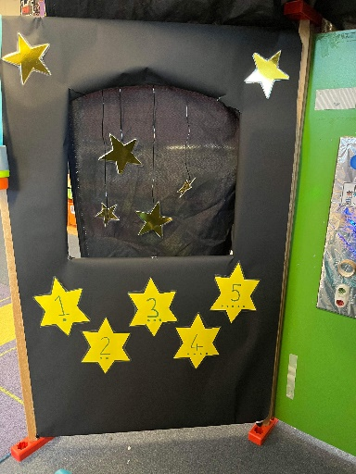

**Book focuses this term**

Whatever Next – baby bear travels into space

The Secret Forest – a look and see story

As well as some non-fiction books containing facts about our topic

**Christmas cards**

As Christmas approaches the children will be designing Christmas cards, this was really popular last year and helped to raise funds. Next week the children will be bringing home their fundraising Christmas cards designs and details of how to order the cards will be sent home but you can also see what other products are available with their design at www.fundraisinggallery.co.uk

**Photographs**

If you would like to purchase your child’s photo, please hand back the form to playgroup or reply direct to Jayne by the deadline stated on your order form.

**Christmas Fayre**

This will be held at Playgroup on Friday 9th December in the evening. More details to follow soon.

Your child will be making tea light candle holders which will be available to purchase at the Christmas Fayre.

**Bags 2 School**

Thank you to everyone that donated bags of clothes. Playgroup received £40 to go towards buying new equipment for the children.

**Reminders**

As the weather is growing colder and wetter could we ask that all children bring a waterproof coat and wellies with them. We still spend time outdoors throughout the day and the children enjoy playing in the puddles and exploring the school woods, walking through the fallen leaves and squelching in the mud.

**Children in Need**

This year’s theme is ‘spotacular’ and on Friday 18th November the children will be invited to wear spots and we will provide face paints and lots fun spotty activities.

**AGM**

Our AGM took place on Tuesday 1st November. If you were unable to attend but would like more information on joining our committee, please speak to a member of staff.

**Uniform**

Non-compulsory uniform t-shirts, can be purchased for your child, please speak to a member of staff to purchase one or have any questions.

**School applications**

If your child was born between 1 September 2018 and 31 August 2019 you will need to apply for a school place for September 2023. **The deadline for applications is 15 January 2023.**  <https://www.cornwall.gov.uk/education-and-learning/schools-and-colleges/school-admissions/>

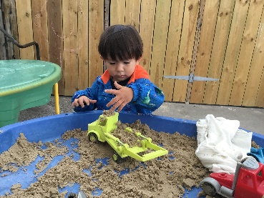

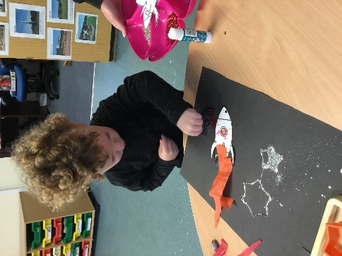

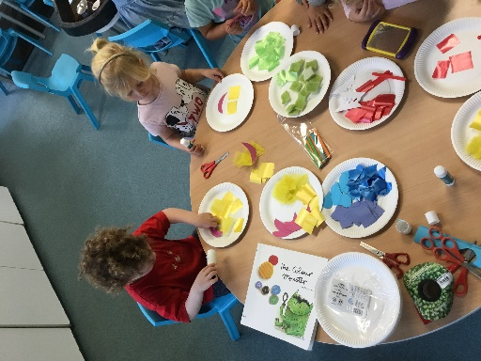

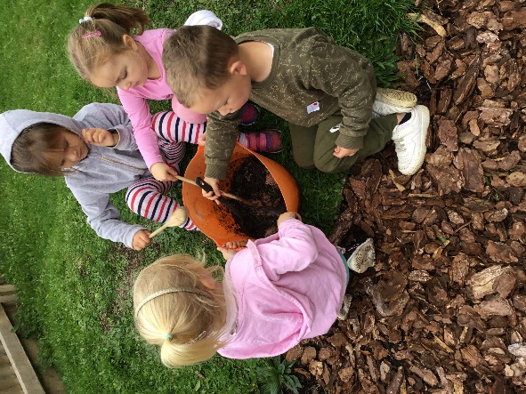

**Term Dates**

Children in Need Friday 18th November

Christmas card deadline Friday 18th November

Christmas Fayre Friday 9th December

Last Day of term Thurs 15th December

Christmas Party Fri 16th December

Start of Spring Term 2023 Weds 4th January

Half-Term  Mon 13th- Fri 17th February

Last Day or term Fri 31st March

Start of Summer Term 2023 Mon 17th April

Bank Holiday Mon 1st May

Leavers photo Friday 12th May

Half-Term  Fri 26th May-Fri 2nd June

Long Weekend Fri 23rd-Mon 26th June

Last Day of term Thurs 20th July

Leavers Party Fri 21st July