**Stratton Playgroup**

New Road, Stratton, Bude, Cornwall EX23 9AP

**Telephone:** 01288 356135 **E-mail:**  strattonplaygroup@hotmail.co.uk

**Website:** www.strattonplaygroup.uk **Ofsted No.:** 102959 **Registered Charity No.:** 1038250

**HELLO November**

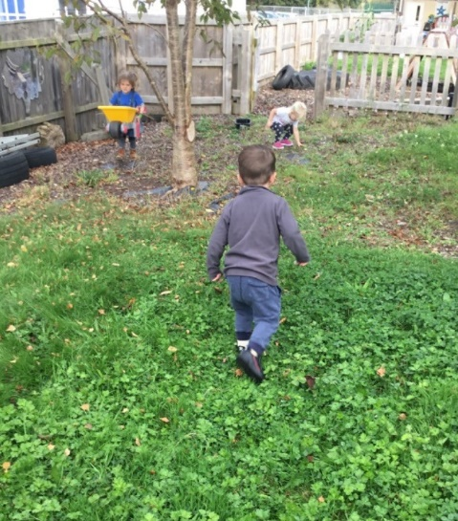

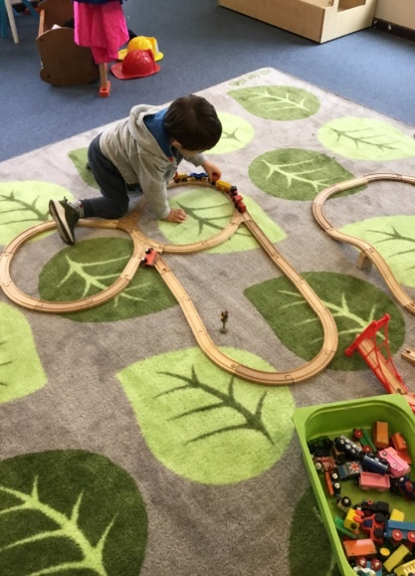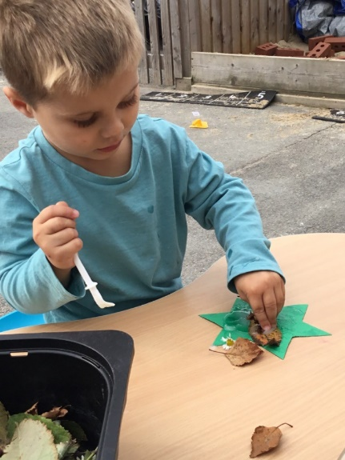

**In this month’s newsletter**

* Planning – what are we up to this half term?
* Book focuses
* Our learning intentions
* Role play
* Online safety, Poppy Playtime
* Gate safety, rules when coming down the path
* Tapestry
* Lending Library news
* Labelled Belongings and spare clothes
* Headlice
* Photos
* **Dates**
* All my own work Christmas
* Children in Need
* Christmas party Date change
* Bags for School collection
* School applications
* Watch this space for a Christmas fund raiser
* Updates
* Term dates

**Planning – What are we up to this half term?**

Our Topic this half term is ***Celebrations and Stories.***

We will begin the half term by learning about staying safe in different environments. We will practise our fire drills as well as learn about firework safety, and how important it is to listen to adults. The children will learn about road and car park safety, and we will go into the car park and practise crossing the car park safely.

We will then learn all about the Hindu festival of light – Diwali. The children will make diva lamps using their physical skills to manipulate clay into the small lamp shape. We will mark make with chalk outside to create Rangoli patterns. We will also try food from the Eastern world for snack time. Towards the end of the week, we will create poppy craft for Remembrance Day and watch clips on the iPad to find out why we wear our poppies.

Next, we will be reading the Stickman and creating crafts and activities around the story. Moving on to making reindeer food, singing Christmas songs and many more Christmas crafts.

**Book focuses**

-Stickman

-The Christmas Bear

-Mog’s Christmas

- Snow Bear

- The Gingerbread man

**Our learning intentions**

-How to keep myself safe

-The importance of listening to an adult

-Listening to instructions

-Learning about different celebrations

**Role play**

This half term our role play inside is a Stage, we are looking forward to seeing the children and their talents. We will later turn this area into a Christmas themed role play. Outside we will be developing our reading shed into a gingerbread reading house.

**Online safety and inappropriate material – POPPY PLAYTIME**

It has come to our attention that some of the children are watching clips on their tablets at home that are not appropriate for their age. There is a new online horror game which some children are talking about in playgroup. It is called Poppy’s playtime and is based on a toy named ‘huggy wuggy’ which chases you around a toy factory. There is not an official rating for the game! Children have told us they watch this on their tablets at home. Other characters in the game include kissy missy and candy cat.

Videos and versions of the game are becoming increasingly popular on YouTube, Roblox, and other platforms used by young children. It features frightening images and themes that are paired with child-friendly items. This disturbing content can have an effect on children’s personal wellbeing, the language they are using and how they play with others. It can create stress, fear, and intrusive thoughts.

We would ask that you check your parental controls on devices and keep a close eye on what your children are watching/playing on their tablets/devices.

**Gate safety, rules when coming down the path**

We have been informed that siblings of children attending playgroup, have been opening the gate down to playgroup, please ensure that only adults are opening and then closing the gate securely.

A staff member will always greet you at the side gate at both drop offs and collection times.

We do also advise that children do not climb along the wall or the railings as this can result in unwanted accidents.

**Tapestry**

It has been lovely to see lots being shared on Tapestry from home, we always share any uploads with the children at playgroup.

**Lending library news**

Some of our children have achieved their ‘5 books’ award this half term. The children love bringing their books back after sharing them at home with their families. They tell us all about the book and who they read it with. They have a stamp on their library card and work towards their certificates.

Awards this term go to:

Amaya-Lily

Paddy

Grace

Jackson

**Labelled Belongings and spare clothes**

Please can we ask that children bring a coat and bag to playgroup each day they attend. Along with spare clothes, including socks, weather dependent clothing, e.g. gloves, hats – **a labelled water bottle,** and for children that require toileting accessories; nappies, wipes and any other items needed. We suggest that children have a pair of wellies to leave at playgroup. **Please can all children’s belongings be clearly labelled**. If you borrow playgroup clothes, please return them.

**Headlice**

A text was sent out just before half term about headlice at playgroup. Please ensure you check your child’s hair regularly and treat if needed. Further information of treating headlice can be found here [Head lice and nits - NHS (www.nhs.uk)](https://www.nhs.uk/conditions/head-lice-and-nits/)

**Photos**

We hope everyone now has their photo proofs, and have been able to make their orders, if wanted, If you do have any problems with this, please speak to a member of staff.

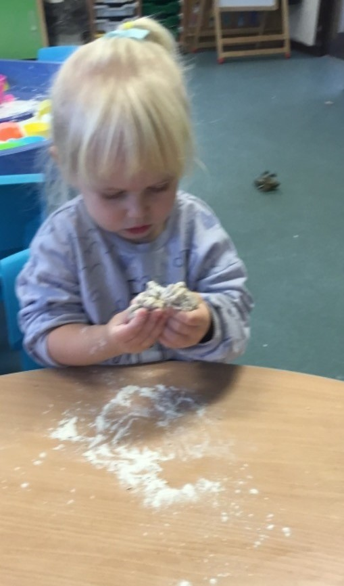 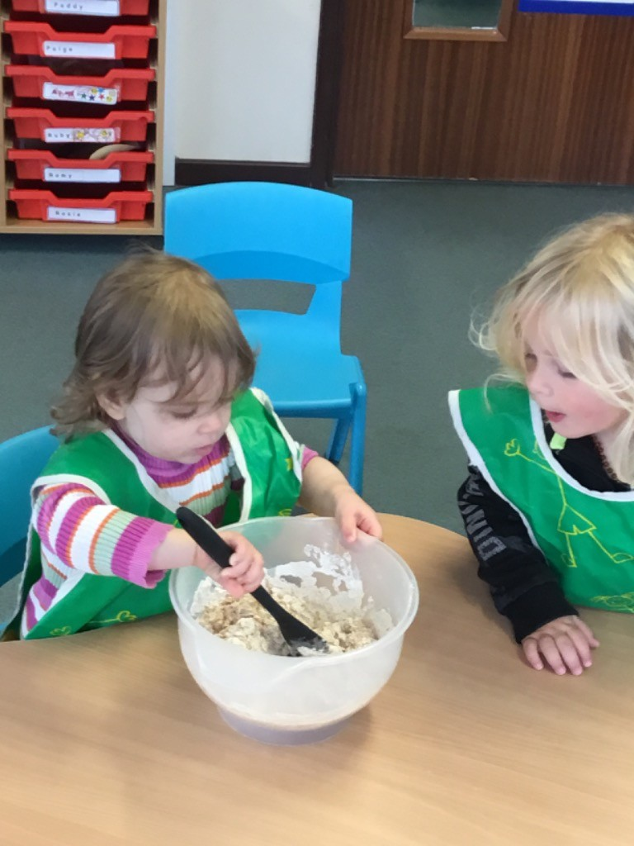 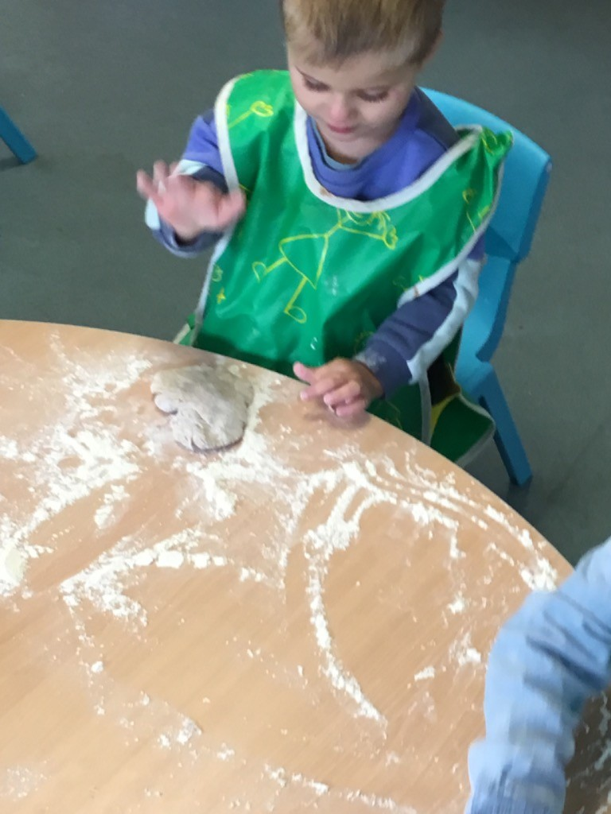

**Dates**

**‘All my own work’ Christmas**

All my own work Children’s Christmas card designs will be coming home the week of 30th October. All information about how and what you can order will be coming home with the designs. Please ensure your order is returned to playgroup by **Monday 13th November.** Payment must have been made with your order.

**Children in Need**

We will be joining in with ‘Children in Need’ which takes place on Friday 17th November. The theme this year is **SPOTacular**, therefore we are asking children to come to playgroup dressed in spots, the staff will be joining in too. We will be doing lots of exciting activities, suggested donation £1.



**Christmas party - Date change**

Our Christmas party will now take place on **Friday 15th December** in the afternoon (all children invited - more details will be sent out nearer the time). Playgroup’s session will run as normal in the morning. Playgroup will then close for the Christmas break, and we will re-open on Thursday 4th January.

**Bags for school**

Our next bags for school collection is on Wednesday 22nd November. Please see the link [What We Collect | Bag2School](https://bag2school.com/what-we-collect) to see what can be collected.

Please bring your bags to by Weds 22nd November, we can store bags before if needed.

**School applications**

If your child was born between 1 September 2019 and 31 August 2020, you will need to apply for a school place for September 2024. **The deadline for applications is 15 January 2024.**

<https://www.cornwall.gov.uk/education-and-learning/schools-and-colleges/school-admissions/>

**Watch this space for a Christmas fund raiser**

Details of our Christmas fund raiser will follow shortly.

**Updates**

We are very proud of our website, where we display all our information; this will also be updated regularly with events and dates. This is available at: www.strattonplaygroup.uk.

We also have Facebook and Instagram - please find us as **“Stratton Playgroup Bude”.**

Monthly newsletters – these will be emailed to you each month.

At the end of each session a small description of the session will be written on the easel, outside – weather dependent.

**Term Dates**

**Committee AGM 7pm Wednesday 1st November**

Bags for school collection Weds 22nd November

Christmas Party Friday 15th December PM

Last Day Friday 15th Dec After our Christmas party

Start of Spring Term 2024 Thurs 4th January

Half-Term Fri 9th - Fri 16th February

Last Day Thurs 28th March

Start of Summer Term 2024 Mon 15th April

Bank Holiday Mon 6th May

Half-Term Fri 24th May - Fri 31st May

Long Weekend Fri 21st - Mon 24th June

Bags for school collection Thurs 13th June

Last Day Thurs 18th July

Leavers Party Fri 19th July

Thank you for your time in reading **this very lengthy newsletter**, if you have any questions please speak to a member of staff.

Kelly and all the team 😊