**Stratton Playgroup**

New Road, Stratton, Bude, Cornwall EX23 9AP

**Telephone:** 01288 356135 **E-mail:**  strattonplaygroup@hotmail.co.uk

**Website:** www.strattonplaygroup.uk **Ofsted No.:** 102959 **Registered Charity No.:** 1038250

**Newsletter - October 2022**

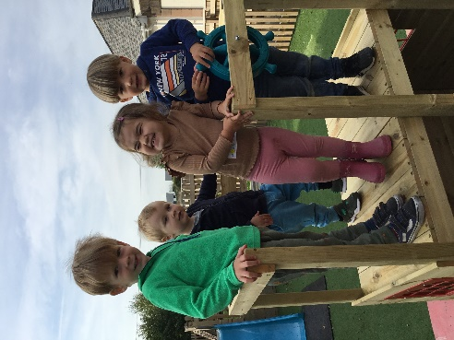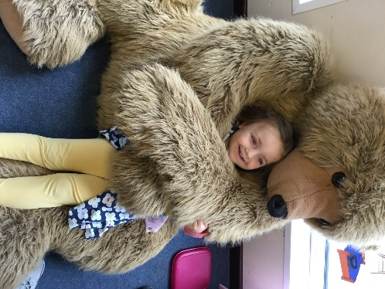

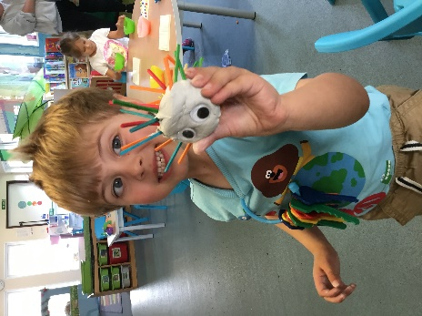

**Settling in**

The children have settled back really well and are following the playgroup routines really well too.

This month the children will be practicing fire drills and we will be talking about the importance of listening to the adults especially if the tambourine or whistle is heard and to stop and listen to the adult’s instructions on what to do next.

We are continuing with ‘learning about me and my friends’ and the children will be thinking about their favourite things and talk about the things they like and what they are good at.

The children will join in with a senses game, testing their senses to feel, smell, touch, see and taste.

We will be making craft mirrors to look at differences and similarities between us and make self-portraits.

**Lending library**

The children have loved taking time to choose a book to share at home this week. These can be exchanged for a new book as often as your child wants, just bring the bag and book back to playgroup and the children will be given the opportunity to find a new book that session.

**Photographer**

Our photographer, Jayne Poole will be at playgroup on Wednesday 12th October taking individual photos of the children. If your child does not attend on Wednesdays and you would like their photo taken or would like a photo taken with siblings please speak to a member of staff to arrange a time to bring your child in.

**Bags 2 School**

This was one of the ways we raised funds for playgroup last year and we will continue this for this year too. The next date is Tuesday 1st November and we ask you to bring in any bags of unwanted clothing. Playgroup then gets paid for the weight of the clothing. This is a good opportunity for a wardrobe clear out ready for the winter!

**New carpark layout**

The school have asked us to remind parents about the new car park layout and the importance of using the zebra crossings. This is to ensure the safety of all the children and parents using the carpark and accessing the school. The parents are asked to model the safe use of the crossings at all times to the children. This also forms a good habit for when your child starts school in the future. This also includes children attending breakfast club.

**Reminders**

We have a few reminders of things discussed at the parents meeting last month.

Please could parents refrain from using their mobile phones on playgroup premises, including the walkway into playgroup. This is part of our safeguarding policy.

Please could all items be clearly labelled with your child’s name including lunch boxes, water bottles, coats and wellies.

**Healthy eating and oral health**

At playgroup we promote and encourage healthy eating as part of the EYFS framework. This is because good oral health habits need to be formed from the earliest age. Tooth decay is largely preventable, but it’s still a serious problem among young children. Nearly a quarter of 5 year olds in England have tooth decay, with 3 or 4 teeth affected on average. Tooth extraction is one of the most common procedures for children under 6 in hospital. Extraction is also the most common reason for hospital admission for children aged 6 to 10. Children who have toothache, or need treatment, may have pain or infections. This can have a wider effect and lead to problems eating, sleeping, socialising and learning.

We aim to promote good oral health by discouraging the consumption of food and drink containing sugars at playgroup. We ask that children only have water in their bottles and have fresh fruit and vegetables in their lunch boxes (fruit winders, raisons, fruit flakes etc are not examples of fresh fruit) We support the children to be aware of what good oral health means – and helping them and their oral health is therefore an important aspect of a child’s overall health status and of their school readiness.

**Staff updates**

Sam has completed online safety training and FGM and county lines training as part of her role as Designated Safeguarding Lead.

Anna has attended and Special Educational Needs (SEN) service update, SEN network meeting and managers meeting.

Charlotte has started college and attends every Wednesday.

Roxy has completed her ‘Prevent’ training.

**Online Learning Journeys**

All new parents should have received an email with an activation code for tapestry. Please let a member of staff know if you experience any problems with this.

All children will have an observation with photos uploaded by their key person every few weeks. Please find time to read these and add comments if you wish. Also, we love hearing news and seeing photos from home and the children love sharing these with staff members and their friends.

**Session Fees**

All fees are due by Friday 21st October please.

**AGM**

The date for this year’s AGM is Tuesday 1st November at 19.30 at playgroup. Please speak to member of the committee for more information. Playgroup cannot remain open without a committee so your attendance at this meeting would be massively appreciated.

**WOW Board**

The children have already shared some wow moments including a visit to the dentist and a first swimming lesson, we would love to hear more, you can email us or tell a member staff at drop off.

**Session Times**

**Early Start** – drop off can be from 8.15am but no later than 8.30am.

**Morning Session – drop off** 9:00am

**End of morning session / lunch time pickups or drop offs** (12.00 or 12.30).

**Afternoon pick up –**is from 3:15pm until 3.30pm.

**Late fee charge** of £5 if you are later than 10 minutes.

**Uniform**

Non-compulsory uniform, t-shirts and sweatshirts, can be purchased for your child, please speak to a member of staff to purchase one or have any questions.

**School applications**

If your child was born between 1 September 2018 and 31 August 2019 you will need to apply for a school place for September 2023. **The deadline for applications is 15 January 2023.**  <https://www.cornwall.gov.uk/education-and-learning/schools-and-colleges/school-admissions/>

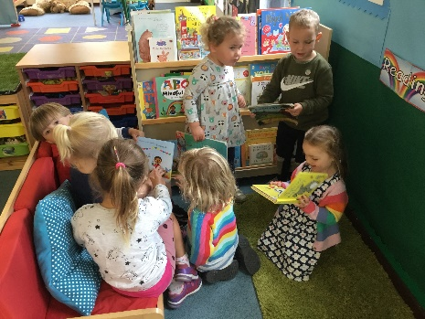

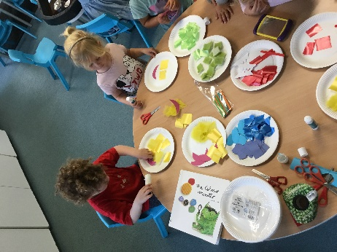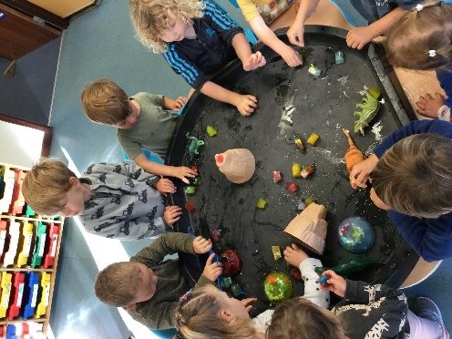

**Term Dates**

Individual photos Weds 12th October

Half-Term  Mon 24th- Fri 28th October

Bags to school Tues 1st November

AGM at playgroup Tuesday 1st November

Last Day Thurs 15th December

Christmas Party Fri 16th December

Start of Spring Term 2023 Weds 4th January

Half-Term  Mon 13th- Fri 17th February

Last Day Fri 31st March

Start of Summer Term 2023 Mon 17th April

Bank Holiday Mon 1st May

Half-Term  Fri 26th May-Fri 2nd June

Long Weekend Fri 23rd-Mon 26th June

Last Day Thurs 20th July

Leavers Party Fri 21st July