**Stratton Playgroup**

New Road, Stratton, Bude, Cornwall EX23 9AP

**Telephone:** 01288 356135 **E-mail:**  strattonplaygroup@hotmail.co.uk

**Website:** www.strattonplaygroup.uk **Ofsted No.:** 102959 **Registered Charity No.:** 1038250

**Newsletter - September 2022**

**Welcome**

We hope that you have had a lovely summer break. We would like to welcome everybody to the start of our autumn term. We are very excited to see our returning children and their families; and welcome our new children and families ☺.

**Planning**

Our topic this half term is **‘Learning about me and my friends’**. We have some fantastic activities planned. To begin, we will share our summer holiday news with our friends at circle time, and take part in some free-choice painting and sticking activities. The children will revisit/ learn our golden rules, and our new children will be introduced to ‘Mr Potato Head’. Further activities include making handprint family trees, name crafts, making mirrors and self-portraits.

Our role play this term is a home corner with the theme The three bears cottage.

**Book Focuses this term**

Starting Playgroup

You choose

Marvelous Me

Goldilocks and the Three Bears

**Learning intentions for this half term**

**Personal, Social and Emotional development**

-Becoming more outgoing with unfamiliar people in a safe context of their setting.

-Increasingly follows rules, understanding they are important.

-Develops friendships with other children.

-Finds ways of managing transitions, for examples from their parent to key person.

**Communication and Language**

-Use a wider range of vocabulary.

-Listens to simple stories and understands what is happening with the help of pictures.

**New Resources**

We held a few fundraising events last year including amazing hamper raffles, a toddle waddle and Easter fun day and have purchased new equipment for the children to enjoy outdoors including a pirate ship climbing frame, mud kitchen, gardening tools and new bark for the base of the climbing wall. The children have already been enjoying these.

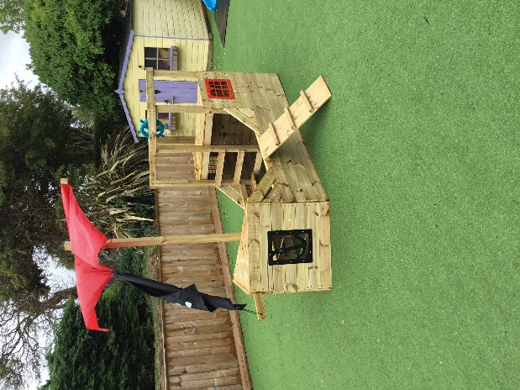 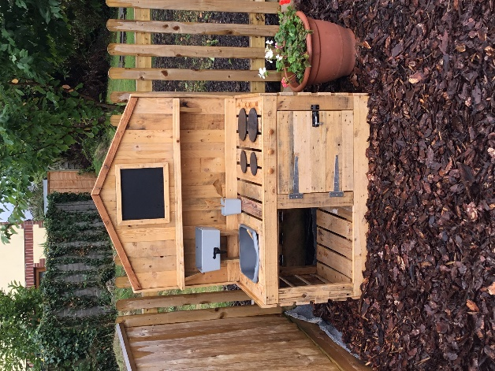 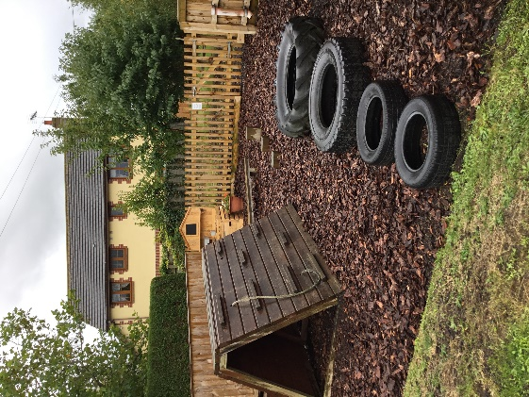

**Early starts, include breakfast option**

*The children will be offered -*

A range of fruits, cereals, yoghurts and toast (waffles, and pancakes may also be offered on occasions and we will take part in some voting with the children to see their preferences).

The early starts open from 8.15am and all children who are attending must be in the playgroup by 8.30am at the latest.

The session will cost £3.00 (the cost will be the same with or without breakfast), the cost of early starts can be covered by your funding - one early start will use ¾ hour of your funding.

We would appreciate it if these sessions can be booked in advance, but we do have some flexibility if you need to book in at the last minute.

**Lending library**

This was a huge hit last term and we are going to continue with it this term. Your child will have the opportunity to choose a book to bring home to share with siblings, parents and grandparents. We had some lovely feedback from the children and also some amazing art work which we displayed on the wall.

The books can be returned and exchanged for a new one as often as you want; some children chose to keep their books for several weeks whilst some changed theirs every session.

**Key Person**

Each child is allocated a key person; if you are starting with us this term, you will have received an email informing you of your child’s key person and met them at your child’s pre-placement. Returning parents, you were informed via email along with your re-confirming details documents – please can these be returned as soon as possible.

**Staff updates**

**Congratulations –** We are delighted to inform you that Gemma had her baby girl on 28th August, Layla Marshall-Hawkes weighed 7lbs 12oz, and doting big sister Lily is absolutely smitten with her.

Gemma will continue to be on maternity leave until May 2023



Kelly is on maternity leave until January 2023, during her time off Anna is Acting Manager and Sam Acting Deputy.

Congratulations to Roxy who has successfully completed her Level 3 Diploma for the Children’s Workforce.

Charlotte is starting her Level 3 childcare and education qualification.

**Each child has an online learning journey**

**Returning parents –** your tapestry activation is still valid and you should access tapestry in the same way, if you have forgotten your password - please let your key person know and a new one will be given to you. Remember, you can see your child’s learning journey at any time, please add comments to observations and also add your own photos and experiences.

**New parents**

In your welcome pack there is a permission slip for you to read and fill in, once we have received all of these back, we can send out an activation email to you, so you can activate your account. Once this has been done you can look at your child’s learning journey at any time, please add comments to observations and also add your own photos and experiences.

**Pegs**

We have pegs in the lobby for children to hang their belongings on. We will assign a peg to each child.

**Children’s Drawers**

Each child has a labelled drawer in the playroom. We encourage the children to use their drawers throughout their sessions; to put things in, such as their jumpers when they get warm, and their art work. We will also put letters, newsletters and other forms of written communication in their drawers. We will remind/support children to check their drawer at the end of each session.

**Labelled Belongings**

Please can we ask that children bring a coat and bag to playgroup each day they attend. To include -spare clothes, weather dependent clothing e.g. gloves, hats – **a labelled water bottle,** and for children that require toileting accessories; nappies, wipes and any other items needed. We suggest that children have a pair of wellies to leave at playgroup. **Please can all children’s belongings be clearly labelled.**

**Children bringing items into playgroup**.

We don’t encourage children to bring in items from home as these can become lost or damage and cause upset to the children. If your child has something special that they would to share could you please speak to your child’s key person before the session.

**Visits to the Stratton School’s - woods and playground track**

We are very lucky to be to have access to some of the outdoor space at Stratton School and we will often visit the bike track, woods, field and the poly tunnel, which are all very popular with the children.

**WOW Board**

We love to share and celebrate children’s WOW moments with them. We have a WOW board in the lobby. If your child has a WOW moment such as, learning to ride their bike, visiting the dentist, new haircut, please let a staff member know and we will fill this in and share it at circle time.

**Special Moment’s Wall**

We love to hear and share yours and your child’s special moments; these can be holiday travels - whether this is a day out, weekend away or a longer vacation. As well as visits to the dentist or meeting a new family member.

**Session Times**

**Early Start** – drop off can be from 8.15am but no later than 8.30am.

**Morning Session – drop off** 9:00am

**End of morning session / lunch time pickups or drop offs** (12.00 or 12.30).

**Afternoon pick up –**is from 3:15pm until 3.30pm.

**Late fee charge** of £5 if you are later than 10 minutes.

**Parking, Drop-off & Collection**

Please use the main car park. Vehicles MUST NOT drive down to playgroup (unless an agreement has been made) as children use this side of the school building for entering and departing.

**At drop off time** - please enter the playgroup premises down the playgroup pathway. A staff member will greet you at the side gate, to take your child/ren and their belongings into playgroup where a member of staff will meet them.

**At collection time –** please follow the same procedure as “drop-offs” and wait at the gate for a member of staff to bring your child to you.

**Lunch Times**

Please provide a packed lunch for your child/ren, and a LABELLED water bottle. We will also offer your child milk.

We would suggest that, where possible, all food is put in easy-open containers / packaging.

Don’t forget about cutting grapes, blueberries / cherry tomatoes, etc. lengthways; **NO frubes** please, as they are difficult for children to open; please remember that we have a **NO NUTS** policy.

**A Reasonable Amount in Lunch Boxes**

Please do not put too much food in your child’s lunch box, a nutritionally balanced packed lunch should include a savoury main and some fruit and/or vegetable choices (and no more than 5 items).

**Sun Cream**

Please check the weather forecast each morning and apply sun cream where you feel necessary.

**Birthdays**

At Playgroup we celebrate each child’s birthday, we provide a cake for the children to enjoy together.

**Uniform**

Non-compulsory uniform (t-shirts) can be purchased for your child, please speak to a member of staff to purchase one or have any questions.

T-shirts: £4.50

2-3 years (**BLUE** only) 3-4 years (**BLUE** / **PURPLE** / **AZURE**) 5-6 years (**BLUE** / **PURPLE** / **AZURE**)

We are also hoping to offer sweatshirts this term, we are waiting for samples and details will be sent soon.

**Medicine**

It is essential that we are informed if your child has had medicine before attending playgroup. If your child needs to have medicine while at playgroup you will be required to fill in a medicine form, the medicine will be checked by a staff member and it clearly needs to state, the child’s, name, dose and date. Your child should not attend playgroup for the first 24 hours on a new medication. Please do not send your child to playgroup if they are unwell and need Calpol. If your child has an inhaler this again will need to be clearly labelled.

**Attendance**

Please ring and let us know if your child will not be attending playgroup for any reason; otherwise, as part of our attendance policy we will have to ring you.

Please remember that children should not attend playgroup if they have a stomach bug and may not return until 48 hours have passed after the last loose movement or vomit.

**School applications**

If your child was born between 1 September 2018 and 31 August 2019 you will need to apply for a school place for September 2023. **The deadline for applications is 15 January 2023.**  <https://www.cornwall.gov.uk/education-and-learning/schools-and-colleges/school-admissions/>

**Updates**

We are very proud of our website, where we display all our information; this will also be updated regularly with events and dates. This is available at: www.strattonplaygroup.uk.

We also have a Facebook page - please find us at **“Stratton Playgroup Bude”.**

Monthly newsletters – these will be emailed to you each month

At the end of each session a small description of the session will be written on the easel, outside – weather dependent.

**Bank Holiday**

Everyone at playgroup is sorry to hear the sad news that Queen Elizabeth has died. Playgroup will be closed on Monday 19th September for the Bank Holiday.

**Term Dates**

Parents Evening Mon 5th September at 6.30pm until 7.30pm

Preplacement Days Tues 6th & Weds 7th September

Start of Autumn Term 2022 Thurs 8th September

Bank holiday – playgroup closed Mon 19th September

Half-Term  Mon 24th- Fri 28th October

Last Day Thurs 15th December

Christmas Party Fri 16th December

Start of Spring Term 2023 Weds 4th January

Half-Term  Mon 13th- Fri 17th February

Last Day Fri 31st March

Start of Summer Term 2023 Mon 17th April

Bank Holiday Mon 1st May

Half-Term  Fri 26th May-Fri 2nd June

Long Weekend Fri 23rd-Mon 26th June

Last Day Thurs 20th July

Leavers Party Fri 21st July

**Management Committee**

Stratton Playgroup is managed by a group of voluntary parents who form a Committee. This Committee is made up of Mums, Dads and Carers who have children attending playgroup; and who are willing to give up some of their time in order to assist with the running of the group.

We have been extremely fortunate over the last few years to have had several enthusiastic parents helping on the committee, which has meant that whilst lots more has been achieved, nobody has had to do more than their fair share. If you are interested in joining our committee please speak to Anna.

**Our current Committee**

Chairperson – Louisa Collidge

Secretary/vice chair – Gemma Skinner

Treasurer – Angela Hawkes

**Committee members**

Kelly Williams

Harriet Heard

Jess McCabe

Thank you for your time in reading **this very lengthy newsletter**, if you have any questions please speak to a member of staff.