Stratton Playgroup
New Road, Stratton, Bude, Cornwall EX23 9AP
Telephone: 01288 356135 E-mail: strattonplaygroup@hotmail.co.uk
Website: www.strattonplaygroup.uk Ofsted No.: 102959 Registered Charity No.: 1038250

Newsletter - September 2027

Stratton Playgroup is converting to a CIO – we are becoming Stratton Little Learners – all our documentation showing our name will gradually be changed over, we will also send you appropriate information as & when necessary.

Ofsted registration no. 2899166, Charity registration no. 1216995

Newsletters
Each month you will receive a newsletter via the Famly app, if you would prefer a paper copy, please let your child’s key person know.

We now have a new parents’ board at our gate entrance.
Displayed here is some information for you.
Each day we will display which staff are working.
Each month we will display dates to remember.

Welcome
We hope that you have had a lovely summer break. We would like to welcome everybody to the start of our autumn term. We are very excited to see our returning children and their families; and welcome our new children and families .

What we are learning about this half term
We will start our term by welcoming returning and new children. The children will get to know each other by playing collaboration games. We will listen to the story of the colour monster and make colour craft using our handprints. The children will make a friendship tree display.

Next, the children will take part in name craft. Recognising the initial letter in their names. This will be extended for older/more capable children to name craft. We will use mathematical equipment to measure our heights and compare to each other.

We will then make family trees, and we will talk about our different families. We will talk about people that are special to us and what different families look like.

Each week we have a number, sign and story of the week - we will share these with you on the Famly app.

Learning intentions for this half term
Personal, social and emotional development
- Develop friendships with other children
- Notice and asks questions about differences
- Develop their sense of responsibility and member of a community
- Increasingly follow rules and understand why they are important

Communication and Language
- Listen to simple stories and understand what is happening
- Use a wider range of vocabulary
- Learn new vocabulary

Understanding the world
- Make connections between the features of their family and other families
- Notice differences between people
- Use senses in hands on exploration of natural materials.
- Develop positive attitudes about the differences between people

Our Early Starts include breakfast
The children will be offered -
A range of fruits, cereals, yoghurts and toast (waffles and pancakes may also be offered on occasions, and we will take part in some voting with the children to see their preferences).

The early starts open from 8.15am and all children who are attending must be in the playgroup by 8.30am at the latest.

The session will cost £4.20 (the cost will be the same with or without breakfast), the cost of early starts can be covered by your funding - one early start will use ¾ hour of your funding.
We would appreciate it if these sessions can be booked in advance, but we do have some flexibility if you need to book in at the last minute.

Returning Parents – Reconfirm contact details
Next week you will be given a form to reconfirm all you contact details; please do ensure this is returned promptly to ensure we have all the correct up to date information.

Key Person
Each child is allocated a key person; if you are starting with us this term, you will have received an email informing you of your child’s key person, and met them at your child’s pre-placement visit. Returning parents, you were informed via email in July.

Famly
We use Famly to communicate with our families.
Returning Parents, you should still all have your log-in details. If you have any problems with this please speak to your child’s key person.
New parents you will receive a log-in request via email within the first couple of weeks of your child starting.

OUR TEAM
 Kelly – Manager and Designated Safeguarding Lead (DSL)

 Anna – Deputy Manager and Special Educational Needs Co-Ordinator (SENCO)

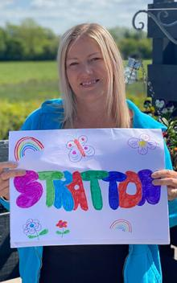 Sam – Early Years Supervisor and Health and Safety

 Kayleigh – Early Years Practitioner

 Gemma – Early Years Practitioner

 Roxy – Early Years Practitioner

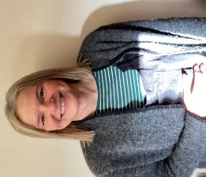 Tracy - Play & Engagement Support Worker

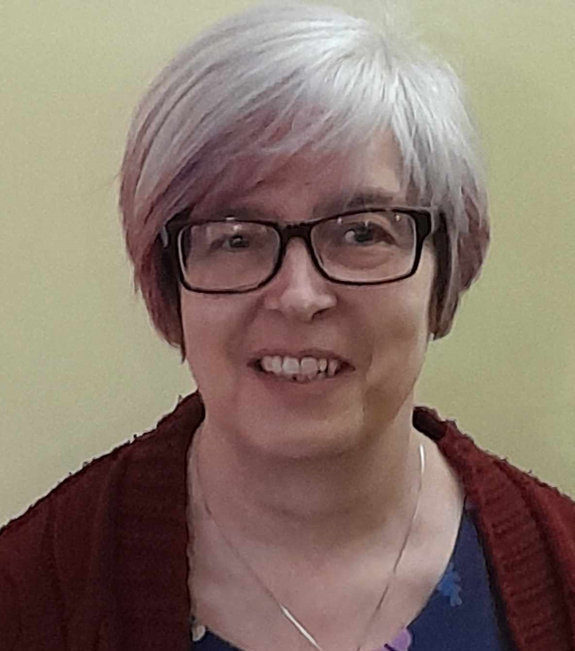 Edwina – Administrator and Healthy and Safety

Lending library
We have a successful library service at playgroup. Your child will have the opportunity to choose a book to bring home to share with siblings, parents and grandparents. We have had some lovely feedback from the children about the books they read with their families.
The books can be returned and exchanged for a new one as often as you want; some children chose to keep their books for a week or more, whilst some change theirs every session. Each child has a library card which is stamped with each book read and children receive certificates for their reading.

NHS Supervised teeth brushing programme
As a setting we will continue to take part in the NHS Supervised teeth brushing programme. Each morning for 2 minutes the children will brush their teeth as a group. Parents who signed a consent form last year will not need to complete a new one. New parents will have signed one at their child’s preplacement visit.

Individual Photos
On Wednesday 4th October Jayne Poole Photography will be in playgroup to take individual photos of the children; siblings/group photos can also be taken. If you child does not attend on this day but you would like to have a photo slot, your child’s key person will speak to you nearer the time to arrange a time slot.

Pegs
We have pegs in the playroom for children to hang their belongings on. On arrival to their session children will find their picture and choose a peg to stick it on for the day.

Children’s Drawers
Each child has a labelled drawer in the playroom. We encourage the children to use their drawers throughout their sessions; to put things in, such as their jumpers when they get warm, and their artwork. We will also put letters, newsletters, and other forms of written communication in their drawers. We will remind/support children to check their drawer at the end of each session.

Labelled Belongings
Please can we ask that children bring a coat and bag to playgroup each day they attend. To include -spare clothes, weather dependent clothing e.g. gloves, hats – a labelled water bottle, and for children that require toileting accessories; nappies, wipes and any other items needed. We suggest that children have a pair of wellies to leave at playgroup. Please can all children’s belongings be clearly labelled.

Children bringing items into playgroup.
We don’t encourage children to bring in items from home as these can become lost or damaged, and cause upset to the children. If your child has something special that they would like to share, could you please speak to your child’s key person before the session.

Visits to the Stratton School’s - woods and playground track
We are very lucky to be to have access to some of the outdoor space at Stratton School and we will often visit the bike track, woods, field, and the poly tunnel, which are all very popular with the children.

WOW Board
We love to share and celebrate children’s WOW moments with them. We display WOW moments in the playroom. If your child has a WOW moment such as, learning to ride their bike, visiting the dentist, new haircut, please let a staff member know and we will fill this in and share it at circle time.

Special Moment’s Wall
We love to hear and share yours and your child’s special moments; these can be holiday travels - whether this is a day out, weekend away or a longer vacation. As well as visits to the dentist or meeting a new family member.

Session Times
Early Start – drop off can be from 8.15am but no later than 8.30am.
Morning Session – drop off 9:00am.
End of morning session / lunch time - pickups or drop offs (12.00 or 12.30).
Afternoon pick up – from 3:15pm until 3.30pm.
Late fee charge of £8.40 per hour (minimum of £4.20) if you are later than 10 minutes collecting.

Parking, Drop-off & Collection
Please use the main car park. Vehicles MUST NOT drive down to playgroup (unless an agreement has been made) as children use this side of the school building for entering and departing.

At drop off time - please enter the playgroup premises down the playgroup pathway. A staff member will greet you at the side gate, to take your child/ren and their belongings into playgroup where another member of staff will meet them.

At collection time
Please follow the same procedure as “drop-offs” and wait at the gate for a member of staff to bring your child to you.

Lunch Times
Please provide a packed lunch for your child/ren, and a LABELLED water bottle. We will also offer your child milk.
We would suggest that, where possible, all food is put in easy-open containers / packaging.
Don’t forget about cutting grapes, blueberries / cherry tomatoes, etc. lengthways; NO frubes please, as they are difficult for children to open; please remember that we have a NO NUTS policy.

A Reasonable Amount in Lunch Boxes
Please do not put too much food in your child’s lunch box, a nutritionally balanced packed lunch should include a savoury main and some fruit and/or vegetable choices (and no more than 5-6items).

Labelled Water Bottle
Please ensure your child comes to every session with a labelled water bottle.

Sun Cream
Please check the weather forecast each morning and apply sun cream when you feel necessary.

Birthdays
At Playgroup we celebrate each child’s birthday, we provide a cake for the children to enjoy together.

Medicine
It is essential that we are informed if your child has had medicine before attending playgroup. If your child needs to have medicine while at playgroup you will be required to fill in a medicine form, the medicine will be checked by a staff member, and it needs to state clearly - the child’s, name, dose and date. Your child should not attend playgroup for the first 24 hours on a new medication. Please do not send your child to playgroup if they are unwell and need Calpol. If your child has an inhaler, this again will need to be clearly labelled.

Pre-Injury forms
If your child has had an injury before attending playgroup, we will ask you to fill in a pre-injury form on arrival to their session.

Attendance
Please ring or let us know via the famly app if your child will not be attending playgroup for any reason; otherwise, as part of our attendance policy we will have to ring you.
Please remember that children should not attend playgroup if they have a stomach bug and may not return until 48 hours have passed after the last loose movement or vomit.
We will share our attendance policy with you on the Famly app.

School applications
If your child was born between 1 September 2022 and 31 August 2023, you will need to apply for a school place for September 2027. The deadline for applications is 15 January 2027.
https://www.cornwall.gov.uk/education-and-learning/schools-and-colleges/school-admissions/

Updates
We are very proud of our website, where we display all our information; this will also be updated regularly with events and dates. This is available at: www.strattonplaygroup.uk.

We also have Facebook and Instagram - please find us as “Stratton Playgroup Bude”.

Monthly newsletters – these will be emailed to you each month.

At the end of each session a small description of the session will be written on the easel (outside – weather dependent).

Term dates
Half term (closed) - 26^{th -} 30th October
Insert days (closed) - 2nd and 3rd November
Last Day before Christmas Break - Thursday 17th December
Christmas Party - Friday 18th December AM (more details to follow)
Christmas Break (closed) – 21st December – 4th January
Reopen after Christmas - Tuesday 5th January
Half term (closed) - 15th – 19th February
Easter Break (closed) - 26th March – 9th April
Reopen after Easter – Monday 12th April
Bank Holiday (closed) - Monday 3rd May
Insert day (closed) - Tuesday 4th May
Half term (closed) 31st May – 4th June
Last day before Summer Break – Tuesday 20th July
School Starters Party – Wednesday 21st July am (more details to follow)

Other dates throughout the year will come up such as celebrations and events days.

Management Committee
Stratton Playgroup is managed by a group of voluntary parents who form a committee. This Committee is made up of Mums, Dads and Carers who have children attending playgroup; and who are willing to give up some of their time in order to assist with the running of the group.
We have been extremely fortunate over the last few years to have had several enthusiastic parents helping on the committee, which has meant that whilst lots more has been achieved, nobody has had to do more than their fair share. If you are interested in joining our committee, please speak to Kelly or Anna.

Our current Committee
Chairperson – Kerrianne Inch
Secretary – Edwina Williams
Treasurer – Angela Hawkes

Committee members
Roxy Wilkinson- Hardy
Kelly Swatton
Gemma Marshall
Amy Wise
Olivia James

Thank you for your time in reading this very lengthy newsletter, if you have any questions please speak to a member of staff.

Kelly and all the team

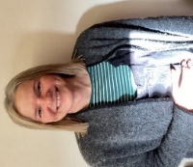
Kelly Anna Sam Roxy Kayleigh Gemma Tracy
Edwina

