**Stratton Playgroup**

New Road, Stratton, Bude, Cornwall EX23 9AP

**Telephone:** 01288 356135 **E-mail:**  strattonplaygroup@hotmail.co.uk

**Website:** www.strattonplaygroup.uk **Ofsted No.:** 102959 **Registered Charity No.:** 1038250



We hope everyone has had a lovely Easter break

**In this month’s newsletter – April 2024!**

* This half term the children are learning
* Our Learning intentions
* Story focuses
* Role play
* Thank you for supporting our fundraising
* **PARENT INFORMATION**
* Baby and Pet photos
* Kitchen tubes
* Clean lunch boxes
* Labelling water bottles
* Sunnier weather - Sun cream and summer clothing
* Brining in small snacks for our African snails
* Items from home
* Staff profiles – Harri and Sam
* New climbing frames and outdoor equipment
* Childcare choices
* Updates

**Term Dates**

Bank Holiday Mon 6th May

Half-Term Fri 24th May - Fri 31st May

Long Weekend Fri 21st - Mon 24th June

Bags for school collection Tues 25th June (DATE CHANGED)

Last Day Thurs 18th July

Leavers Party Fri 19th July

School Leavers photo – **Thursday 25th April** – If your child is due to start school in September but they do not attend on this date, if you would like them to be in the photo, please bring them to playgroup at 9am.

**This half term we are leaning all about………**

**Growth, spring, and our emotions**

To begin our half term, children will explore the new ‘Vets’ role play. We will learn about emotions and how to name the emotions we are feeling. We will use mirrors and the iPads to look at our faces and how they change when we feel different feelings.

The children will make emotion plates and emotions faces. We will listen to the story ‘the colour monster’ and use colour to describe emotions.

We will then listen to the story of the hungry caterpillar and begin to learn about life cycles and growth. The children will make hungry caterpillar and butterfly craft as well as taking part in a story sack.

We will look at the different food in the story and talk about which were the healthiest foods the caterpillar ate. The children will discuss size and how the caterpillar grew. We will compare to how the children have grown and changed since they were born.

This week the children will grow cress heads. They will decorate cups using a range of mixed media and make labels by looking at our name cards and copying the letters using writing tools. We will learn about what the seeds will need to grow. We will talk about the size of the seeds and think about where else we see seeds. The children will listen to the story ‘The tiny seed’.

**Our Learning intentions**

* Listen to simple stories and understand what is happening with the help of the pictures – Communication and language.
* Feel strong enough to express a range of emotions – personal, social and emotional development
* Talk about their feelings using words like ‘happy’, ‘sad’, ‘angry’ or ‘worried’ - personal, social and emotional development
* Explore the natural world around them – understanding the world
* Understand the key features of life cycles of plants and animals - understanding the world
* Begin to understand the need to respect and care for the natural environment and all living things - understanding the world
* Plant seeds and care for growing plants - understanding the world
* Notice patterns and rearrange things in patterns – Mathematics
* Compare sizes and weights, using gesture and language - Mathematics

Our Story Focuses

*The Colour Monster*

*The Hungry Caterpillar*

*The Tiny Seed*

*Jack and The Beanstalk*

**Role play**

This half term’s role play is VETS

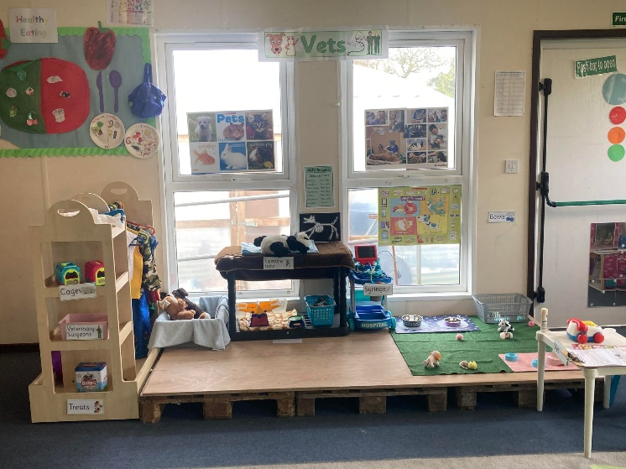

THANK YOU - Raising £24 in the year 2024

We would like to say a big thank you to all the children and families who supported our fundraiser, this means so much to us. We have enjoyed sharing photos of the children’s achievements. All the children who took part will receive a certificate. Once all the forms and money have been collected, I will let everyone know the total amount raised.

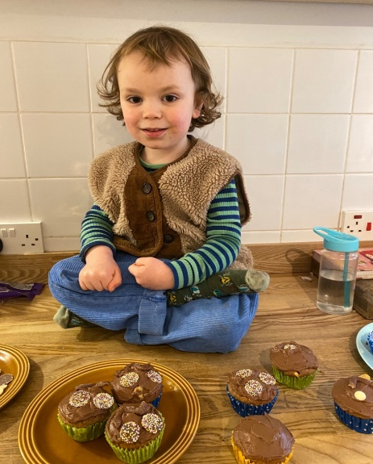 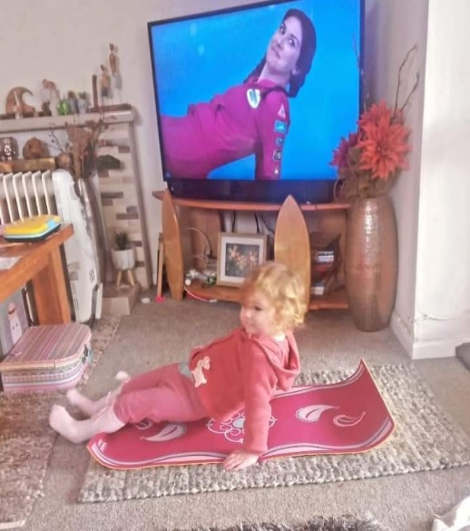 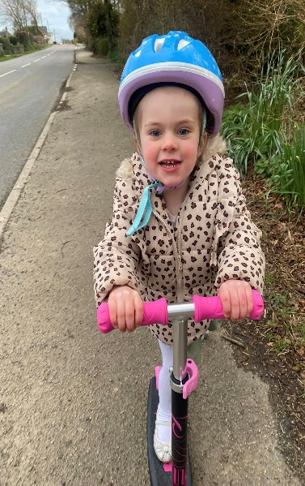

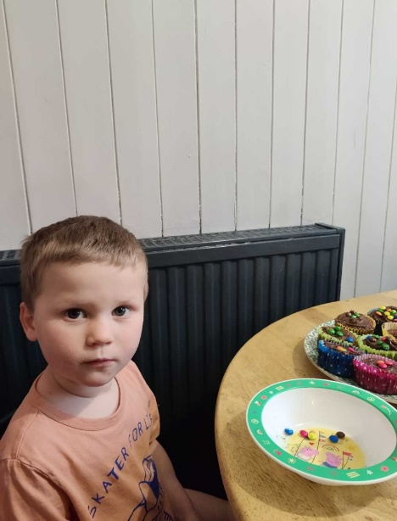

|  |
| --- |
| Parent Information  Baby and Pet photos  As we are learning all about growth and life cycles. We would like to invite children to either bring in, upload to Tapestry or email to playgroup, a photo of them as a baby and a photo of their pet so that we can share these together at playgroup.  Kitchen tubes  We will need some kitchen roll tubes next half term please if these can be brought in.  Clean lunch boxes  For good hygiene reasons please ensure your child’s lunchbox comes to playgroup clean.  **Labelled Water Bottles**  Please ensure children come to playgroup each day with a **Labelled** water bottle. We do encourage children to have WATER in their bottles.  C:\Users\User\AppData\Local\Microsoft\Windows\INetCache\Content.MSO\CF027810.tmp  Sunnier weather  We are hopeful sunnier and hotter weather will be coming this term. On days where hot weather is forecast, please send children in with appropriate clothing including labelled sun hats.  Sun cream  Children can either bring in their own labelled sun cream, or for a donation of £1 each half term use playgroups.  We advise a 50+ with a five-star UVA rating.  Clothing for the summer  All summer shoes must have a strip to support the heal  Shoulders to be covered  C:\Users\User\Pictures\m_o_31891_a63bf30g6n8y2ys4rfc88qzpfpd2bvx9.jpgSmall snacks for our African snails  Our African snails are growing away, and the children like to spend time giving them food and watching them move. We thought it may be nice if children had any small snacks, they could bring in for them, from home. Foods include… *lettuce, cabbage, spinach, watercress, courgettes, cucumbers, apples, melons and grapes* **(just a small amount).**  Bringing in items/toys form home  Where possible we do ask that children do not bring in items/ toys from home. We often find that these can get broken or lost. If children do want to show/ share something specific with us at playgroup, we of course welcome this, alternately you could upload a photo to Tapestry or email one to us. We do request that children do not bring in very small, large of precious things. |

**Getting to Know the Team**

As all our staff work different days and each child has a different key person. We thought it would be nice each month to introduce each staff member with some information about them.

This month it’s **Harri and Sam**

|  |
| --- |
| **Staff profile**  C:\Users\User\AppData\Local\Packages\Microsoft.Windows.Photos_8wekyb3d8bbwe\TempState\ShareServiceTempFolder\harri.jpeg  Name - Harri Bath  Roles and Responsibilities – Early Years Practitioner  About me - I love spending time in my garden. Growing vegetables with my children is something I really enjoy. I am also a farmer’s wife and enjoy all aspects of farming on our family farm.  Have long have you worked at playgroup? 10 years.  What is your Favourite thing about working with children?  Sharing the excitement in their individual achievements. I also love the laughter and happiness each child shares with us.  How would you like to see playgroup develop?  I would love to be involved in developing our garden to include more plants and flowers. |

|  |
| --- |
| **Staff Profile**    https://www.strattonplaygroupbude.uk/sites/strattonplaygroupbude.uk/files/styles/staff_photos/public/photos/sam.jpg?itok=vCtdzY5q  **Name -**Sam Piper  **Roles and Responsibilities -**Supervisor, health and safety officer  **About me -**I have four daughters; Natasha, Rebecca, Kylie and Sophie, a grandson, Harley and five granddaughters; Alicia, Indie, Nalah, Bodhi and Maizie, all of whom keep me very busy. We all enjoy walks with our dogs Lola and Loki, and days out exploring our beautiful local countryside and coastline.  **Have long have you worked at playgroup?**10 years.  **What is your Favourite thing about working with children?**  The smiles on their faces when they get excited to see their friends. I love how happy the children are at playgroup and how enthusiastic they are to try and explore new things, we really have an adventurous group of children attending playgroup and it is so lovely watching them grow in confidence.  I learn as much from them as they from me, their energy and curiosity is truly contagious.  **How would you like to see playgroup develop?**  To continue to be a place where the children really thrive. It would be lovely to develop our outdoor space, adding to our outdoor large-scale construction and role play toys to help the children expand their imagination, social and physical skills. |

**Lending Library News**

**It is so lovely to see so many children enjoying our lending library.**

**This month**

5 book awards go to

Paige

Nevaeh

10 book awards go to

Rosie

Keira

Luke

20 Book award goes to

Arlo

**New Outdoor resources**

We have recently purchased some new outdoor recourses. The children have enjoyed playing on these. We are looking forward to develop our outdoor space further.

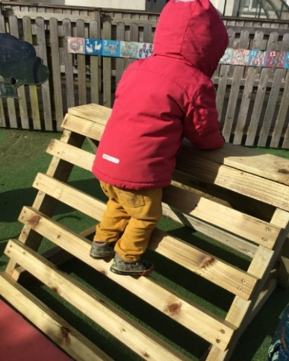 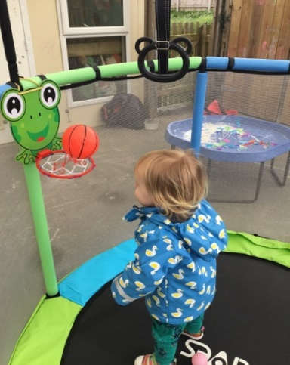 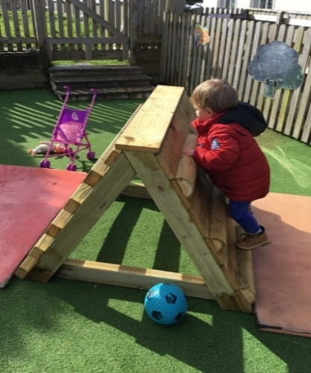

**Childcare Choices/Funding**

****

For all information about funding available to you, including the new 2-year funding coming into place in April, please use the link below:

[Childcare Choices | 30 Hours Childcare, Tax-Free Childcare and More | Help with Costs | GOV.UK](https://www.childcarechoices.gov.uk/)

**Updates**

We are very proud of our website, where we display all our information; this will also be updated regularly with events and dates. This is available at: www.strattonplaygroup.uk.

We also have Facebook and Instagram - please find us as **“Stratton Playgroup Bude”.**

Monthly newsletters – these will be emailed to you each month.

At the end of each session a small description of the session will be written on the easel, outside – weather dependent.

Thank you for your time in reading **this newsletter**, if you have any questions please speak to a member of staff.

Kelly and all the team 😊

 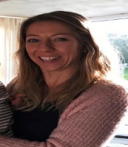 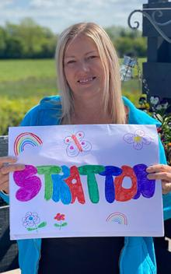 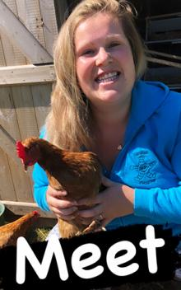   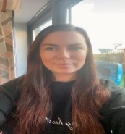

Kelly Anna Sam Harri Roxy Kayleigh Gemma Edwina