**Stratton Playgroup**

New Road, Stratton, Bude, Cornwall EX23 9AP

**Telephone:** 01288 356135 **E-mail:**  strattonplaygroup@hotmail.co.uk

**Website:** www.strattonplaygroup.uk **Ofsted No.:** 102959 **Registered Charity No.:** 1038250

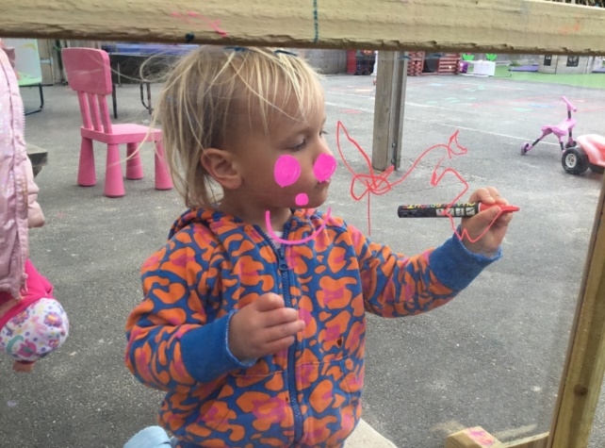

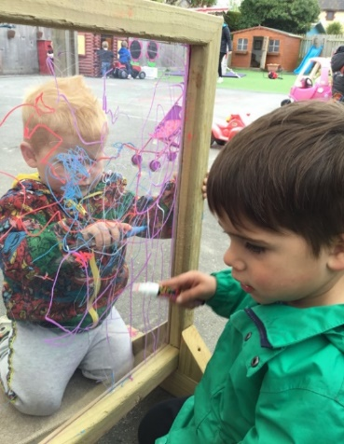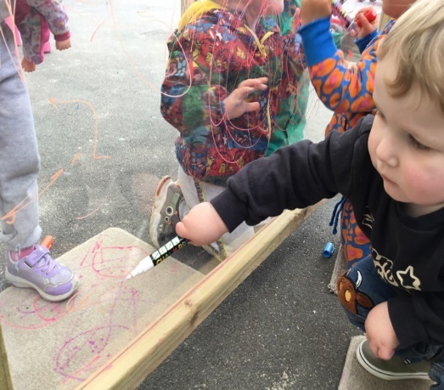 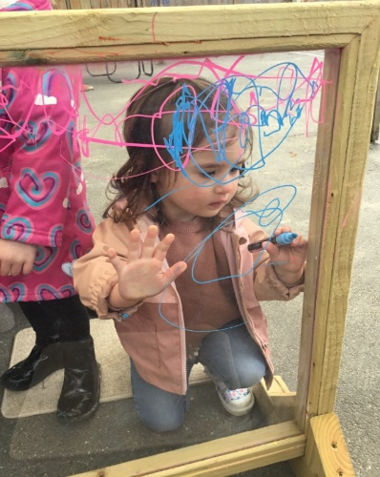

**In this month’s newsletter – May 2024!**

* This half term the children are learning
* Thank you for supporting our fundraising
* Ultra-marathon success
* Sickness Bug
* Sessions for September
* NHS Supervised Tooth Brushing Programme
* Children starting school
* **PARENT INFORMATION**
* Thank you - Baby and Pet photos
* **REMINDERS**
* Labelling water bottles
* Sunnier weather - Sun cream and summer clothing
* Provisional dates – Sports and Fun day
* **Staff profiles –** Kayleigh and Gemma
* Introducing Liv
* Childcare choices
* Updates

**Term Dates**

Bank Holiday Mon 6th May

Half-Term Fri 24th May - Fri 31st May

**Provisional Sports day date** Friday 7th June PM (More details to follow)

Long Weekend Fri 21st - Mon 24th June

Bags for school collection Tues 25th June (DATE CHANGED)

Last Day Thurs 18th July

Leavers Party Fri 19th July

Provisional Fun day date Sunday 21st July (More details to follow)

**This half term we are leaning all about………**

**Growth, spring, and our emotions**

**We have enjoyed the first couple of weeks back at playgroup since the Easter Break.**

Next week the children will explore and learn about mini beasts. We will go to the school woods and use our own outdoor space to go on mini beast hunts. The children will have mini beast surveys to tick off and learn the names of the mini beasts. We will make mini beast crafts and look at different patterns of mini beasts and take part in counting activities, counting spots, stripes, number of legs and wings ect.

This week the children will listen to the story ‘Jack and the beanstalk’. We will plant our own bean plants and talk about what the plants need to grow. We will experiment with growing the beans in different conditions and compare how they grow. We will measure our own heights and compare sizes. We will take part in imaginative stories about growth

**THANK YOU - Raising £24 in the year 2024**

I am still wanting for some monies raised from some children who took part. I will then inform every one of the total amounts raised.

Ultra-Marathon success

Anna and her daughter Holly successfully and amazingly ran an ultra-marathon.



***A message from Anna***

*Holly and I would like to say a massive thank you to everyone that has donated to our just giving page.*

*We completed the Ultra marathon on a lovely sunny day 😎.*

*It was a tough but absolutely beautiful route. 31.5 miles of challenging hills, steps, pebble beaches and cliff tops.*

*If you haven’t donated but would like to then please visit our JustGiving page.*

*All of your donations will go to towards creating a sensory and sleep room at playgroup.*

[*https://www.justgiving.com/.../anna...*](https://l.facebook.com/l.php?u=https%3A%2F%2Fwww.justgiving.com%2Fcrowdfunding%2Fanna-tannerultramarathonchallenge%3Futm_term%3DbDwGAWWEr%26fbclid%3DIwZXh0bgNhZW0CMTAAAR3qtFt0DxfO9s-6tAYkL48jmkRRfy6phyFJTDLKmMudVa5AjwWUleXsiVw_aem_ARCaksguR07NDT4-oW_uHRmvdnyXLSaTE55JGxzZxyba_rY2bqxxKe5wuHb9BX0AoHdLpPOc2Mbrz4ehhxGVDj8f&h=AT0Y169A_MkfFTImrieu6EDLWZMpG5KexYKzRlEce5TOoYWrBxQ7xdq6KBlf-z9s1Zg0P94UOX5hx1W7quRSlN9MjCn8YTsU738kP6rzSrokVrrtEIbCB2crfYNsxG1e5lRjfdjF6e4E6iyrqQ&__tn__=-UK-R&c%5b0%5d=AT39giRKpvDYDdtLMprzgv2OSUFuAISLjAI1HPpPK7kpbULa-crzo1O72OvmPJSZahJyOJO1eJmSmVrWKn-UBF4IJw-6fmpSuVPchnEYF-ogDdZWnrVYfJkFvCQ8OZnUNGUFSgmOH07BMi5DYUAg2RZooPWl4fvLgw2sGzERpKMevtCIovPHLplYcSWJaWGCVgM_MkZGl2k4aBa4LX-2gBNUx9HkrKuFfM07)

*Now for a rest…… or to plan our next challenge 🤔*

*Anna xx*

Sickness Bug

I sent a text out this week to inform you that we currently have a sickness bug circuiting at playgroup.

If your child becomes unwell with the bug, they **must be** symptom free for at least 48 hours before returning to playgroup.

**NHS Supervised Tooth Brushing Programme**

A letter will be going home with all children about a tooth brushing programme we will be taking part in. If you are happy for your child to take part please return the consent form to playgroup by Monday 20th May.

You can follow the programme on facebook/Instragram – The Big Brush Club

Sessions from September 2024

All Parents of children who will still be attending in for the next academic year have been sent an email about what sessions they would like for their child. Please do reply promptly if you have problems with filling the from in please just email with your session preferences.

Children starting school in September

You should have all now been informed of your child’s school place. We will be supporting children with this transition, by liaising with the school they will be attending.

|  |
| --- |
| Parent Information  *Thank you to everyone who has shared their children’s, baby/pet photos with us we have enjoyed looking and talking about these with the children.*  **REMINDERS**  **Labelled Water Bottles**  Please ensure children come to playgroup each day with a **Labelled** water bottle. We do encourage children to have WATER in their bottles.  C:\Users\User\AppData\Local\Microsoft\Windows\INetCache\Content.MSO\CF027810.tmp  Sunnier weather  We are hopeful sunnier and hotter weather will be coming this term. On days where hot weather is forecast, please send children in with appropriate clothing including labelled sun hats.  Sun cream  Children can either bring in their own labelled sun cream, or for a donation of £1 each half term use playgroups.  We advise a 50+ with a five-star UVA rating.  Clothing for the summer  All summer shoes must have a strip to support the heal  Shoulders to be covered  **Provisional Dates**  Sports day date **Friday 7th June**  We have a date provisional booked for our playgroup’s sports day (this will be in the afternoon) parents will be invited to come along. More details will be sent nearer the time.  Fun Day -  A fun day arranged by our committee. They are also arranging a raffle and there are some excellent prices to be won (more details to follow on both soon). |

**Getting to Know the Team**

As all our staff work different days and each child has a different key person. We thought it would be nice each month to introduce each staff member with some information about them.

This month it’s **Kayleigh and Gemma**

|  |
| --- |
| **Staff profile**  https://www.strattonplaygroupbude.uk/sites/strattonplaygroupbude.uk/files/styles/staff_photos/public/photos/Kayleigh.jpeg?itok=fq15ezYG  Name  Kayleigh  Roles and Responsibilities –  Early Years Practitioner and behaviour lead  About me -  I have two daughters Amilia and Eva and we live in our farm with 300 hundred cows, a dog called Doug, three cats two chickens and a pig named Dottie.  Have long have you worked at playgroup?  I have worked at playgroup for three years.  What is your Favourite thing about working with children?  I love working with children so it’s hard to pick one favourite thing. But if I had to it would be because I love seeing how children grow and develop in to fabulous people and being a part of that development.  How would you like to see playgroup develop?  Playgroup is always developing which is great. But I would love for us to be able to do more gardening with the children. |

|  |
| --- |
| **Staff Profile**  C:\Users\User\Pictures\428362348_1063934154859562_7537333876580038887_n (1).jpg  Name  Gemma Marshall  Roles and Responsibilities  Early years practitioner & Deputy SENDCO  About me –  I have 2 daughters Lily 9 and Layla who is nearly 2. Most of my time I spend with them going on adventures and making memories.  Have long have you worked at playgroup? 6 years.  What is your Favourite thing about working with children?  My favourite thing about working in childcare is watching each child develop and grow in their own ways and knowing that you were a part of their journey!  How would you like to see playgroup develop?  I would love to see some more outdoor resources to help the children explore their imagination more. I also can’t wait for the sensory room to be done as all of the children will benefit from it. |

|  |
| --- |
| We are also excited to have welcomed Liv Rowland to our team. Liv will be working as bank staff but also working two regular days a week.  C:\Users\User\Pictures\440409467_1629921361158405_1445780882643923330_n.jpg  Name Liv  Role and Responsibilities – Bank staff and Early years Practitioner  About me I enjoy being outside, travelling and being with friends and family.  I enjoy playing sports, surfing and going to the gym.  I love being in the sun and going to the beach  What’s your favourite thing about working with children  I love working with children and supporting their development in fun exciting ways. I enjoy listening to their funny stories and making each other’s day extra fun. |

**Lending Library News**

It is so lovely to see so many children enjoying our lending library.

**This month**

**5** book award goes to

**Ted**

15 book awards to

**Jenson**

25 book awards to

**Eli**

**Childcare Choices/Funding**

****

For all information about funding available to you, including the new 2-year funding coming into place in April, please use the link below:

[Childcare Choices | 30 Hours Childcare, Tax-Free Childcare and More | Help with Costs | GOV.UK](https://www.childcarechoices.gov.uk/)

**Updates**

We are very proud of our website, where we display all our information; this will also be updated regularly with events and dates. This is available at: www.strattonplaygroup.uk.

We also have Facebook and Instagram - please find us as **“Stratton Playgroup Bude”.**

Monthly newsletters – these will be emailed to you each month.

At the end of each session a small description of the session will be written on the easel, outside – weather dependent.

Thank you for your time in reading **this newsletter**, if you have any questions please speak to a member of staff.

Kelly and all the team 😊

  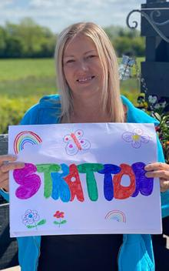 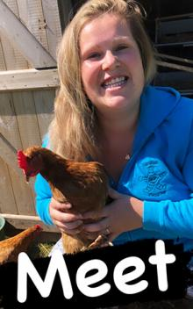

Kelly Anna Sam Harri Roxy Kayleigh Gemma Edwina