**Stratton Playgroup**

New Road, Stratton, Bude, Cornwall EX23 9AP

**Telephone:** 01288 356135 **E-mail:**  strattonplaygroup@hotmail.co.uk

**Website:** www.strattonplaygroup.uk **Ofsted No.:** 102959 **Registered Charity No.:** 1038250



Reminder Playgroup's last day before the Easter break is on **Thursday 28th March –** We are open for the summer term on **Monday 15th April**

**In this month’s newsletter – March 2024!**

* Busy Times at Playgroup
* Sandpit Fun
* Sensory play
* Labelled Water Bottles
* Fees Increased
* Getting to Know the Team
* Staff Profiles
* Staff Training Updates
* Lending Library News
* Childcare Choices

**Parent Information and Dates**

* World Book Day
* Red Nose Day
* Reminder – Fundraising £24 in the Year 2024
* Mencap Day
* Updates
* Dates
* Term dates

**Busy Times at Playgroup**

What a Wet month it has been! The children have still been able to spend time outside, playing parachute games, in the sandpit and building with large scale construction.

Sandpit Fun

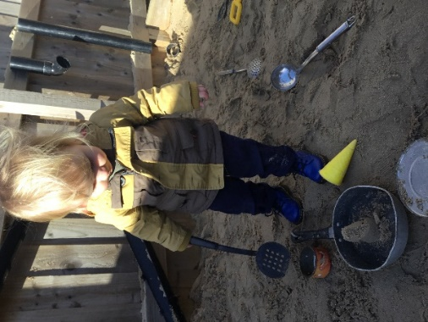 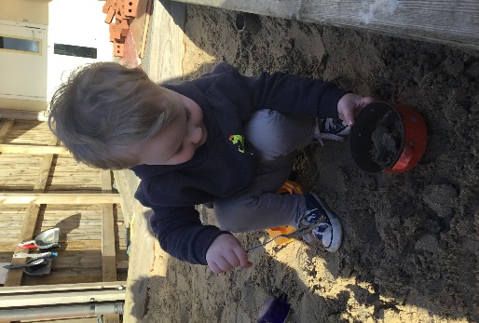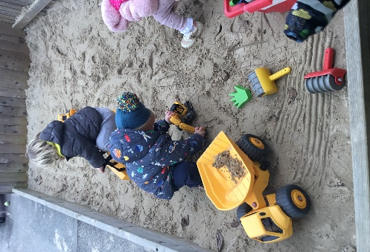

Sensory and Messy play is always on offer at playgroup

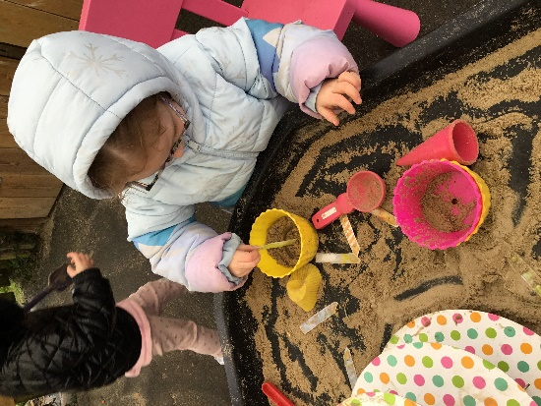 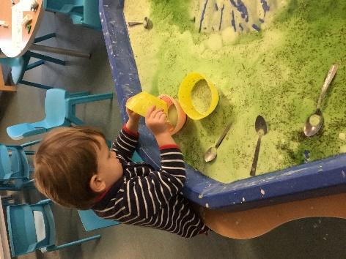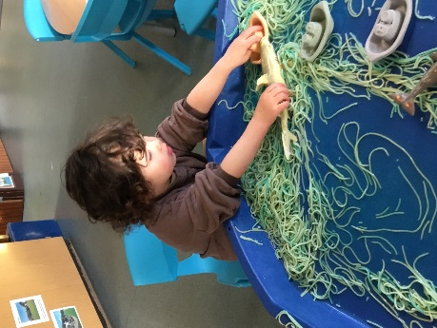 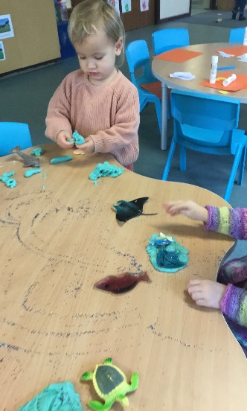

 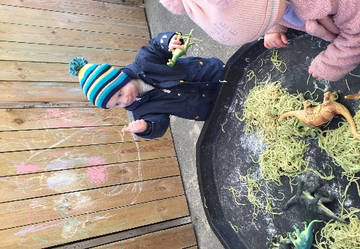 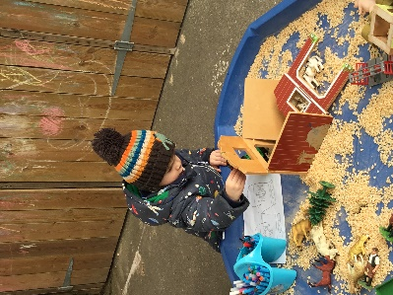

**Labelled Water Bottles**

Please ensure children come to playgroup each day with a **Labelled** water bottle.

**Increase in Fees**

You should have received an email about our increase in Fees from April 2024.

**Getting to Know the Team**

As all our staff work different days and each child has a different key person. We thought it would be nice each month to introduce each staff member with some information about them.

This month it’s **Kelly and Anna.**

*Kelly and Anna have worked together in their leadership role at playgroup for 13 years. Previously to this they worked together in another local early years setting for many years. We really enjoy working together and feel we make a good team 😊*

|  |
| --- |
| **Staff profile**  C:\Users\User\Pictures\166452553_10159000526760675_4805057017291548122_n.jpg  **Name -** Kelly Swatton  **Roles and Responsibilities -** Manager and Designated Safeguarding lead (DSL).  **About me -** I have four children Harrison 17, Tilly-Paige 13, Lottie-rose 8 and Otto who is nearly 2.  I enjoy being active, playing and watching sport. My weekends involve swimming with my younger children, watching Harrison play football and Tilly play Rugby. I LOVE traveling with my family, seeing different places and cultures.  **Have long have you worked at playgroup?** 13 years.  **What is your Favourite thing about working with children?**  Watching children grow and develop, seeing children from their starting point to when they leave us for their next educational journey. I often take a step back at playgroup and enjoy seeing our children happily playing and learning 😊  **How would you like to see playgroup develop?**  I really want to see playgroup’s outdoor space grow and expand. I would like more climbing apparatus and to create both a mathematical and literacy area. |

|  |
| --- |
| **Staff Profile**  C:\Users\User\Pictures\423472062_419769053941267_912508108087475725_n.jpg  Name - Anna Tanner  Roles and responsibilities - Deputy manager and SENDCO (Special Educational Needs Co-ordinator), Key person and deputy DSL.  About me: I have 3 children; Holly who is 22, Sophie 20 and Ben 13. I love keeping active and enjoy swimming, running, and going to the gym. I love spending time with my family and watching Ben play football on the weekends. I love to set myself challenges and in April I am running an ultra- marathon.  How long have you worked at playgroup? 13 years.  What is your favourite thing about working with children?  I love seeing progression and being part of a child’s learning journey. Seeing characters and personalities develop through a child’s time with us. Progression looks very different for each child, and I am committed to making sure all children get the same opportunities to be able to reach their full potential.  How would you like to see playgroup develop?  I am excited to be part of developing our new sensory and quiet room, this is going to be a huge asset to our setting. I love seeing the changes to our outdoor space through the seasons and can’t wait to get some veggies growing in our garden again this year. |

**Staff Training Updates**

**Kelly** has completed a course *‘Getting it Right at Group times’*

Attended a ‘*Managers network meeting’*

**Anna** has a attended a ‘*SENCO Network meeting’.*

111

**Sam** has updated her training in

*‘Health and Safety in Education’*

*‘The Prevent Duty in Early Years’*

*‘Effective Safeguarding Practice’*

Lending Library News

Anna recently attended a literacy course and was given a £100 book voucher to spend. Playgroup have purchased some lovely new books which the children have been listening to at groups story times.

**It is so lovely to see so many children enjoying our lending library.**

**This month**

A 5-book award goes to Rosie

A 10-book Award goes to Jenson

20-book awards go to Elias, Amaya, Grace, Jackson and Paddy

**Childcare Choices/Funding**

****

For all information about funding available to you, including the new 2-year funding coming into place in April, please use the link below:

[Childcare Choices | 30 Hours Childcare, Tax-Free Childcare and More | Help with Costs | GOV.UK](https://www.childcarechoices.gov.uk/)

|  |
| --- |
| Parent Information and Dates  **C:\Users\User\AppData\Local\Microsoft\Windows\INetCache\Content.MSO\C21C4DB6.tmp**  **Next Thursday 7th March** we will be celebrating world book day. We are inviting children to bring in their favourite book and dress as a book character.  **C:\Users\User\AppData\Local\Microsoft\Windows\INetCache\Content.MSO\BFBA19A5.tmp**  **On Friday 15th March** we will be joining in with raising money by doing lots of fun things at playgroup. If children want to, they can come into playgroup dressed a bit silly (e.g, odd socks, funny hair styles, lots of colour)  **Fundraising - RAISING £24 in the Year 2024 –**  **Everyone should have received a fundraising form.**  **Fundraising is an important part of playgroup.**  To celebrate the new year 2024, we would like our playgroup children /families to join in with fundraising by raising £24. The children can be sponsored to raise their £24 however they want.  Children are welcome to bring in their forms and money into playgroup at any time, we will celebrate all children’s achievements together. We would like to suggest that all children complete their fundraising by the end of the spring term - March 28th.  **Up Coming event held by Royal Mencap Society**  C:\Users\User\AppData\Local\Packages\Microsoft.Windows.Photos_8wekyb3d8bbwe\TempState\ShareServiceTempFolder\Advert - Table booking.jpeg |

**Updates**

We are very proud of our website, where we display all our information; this will also be updated regularly with events and dates. This is available at: www.strattonplaygroup.uk.

We also have Facebook and Instagram - please find us as **“Stratton Playgroup Bude”.**

Monthly newsletters – these will be emailed to you each month.

At the end of each session a small description of the session will be written on the easel, outside – weather dependent.

**Dates**

World Book Day

Red Nose Day

Thursday 28th March – end date for raising £24 in the Year 2024.

**Term Dates**

Last Day Thurs 28th March

Start of Summer Term 2024 Mon 15th April

Bank Holiday Mon 6th May

Half-Term Fri 24th May - Fri 31st May

Long Weekend Fri 21st - Mon 24th June

Bags for school collection Tues 25th June (DATE CHANGED)

Last Day Thurs 18th July

Leavers Party Fri 19th Jul

Thank you for your time in reading **this newsletter**, if you have any questions please speak to a member of staff.

Kelly and all the team 😊

Kelly Anna Sam Harri Roxy Kayleigh Gemma Edwina