Playgroups Outdoor Rules

Sweep the sand up when it goes on the floor 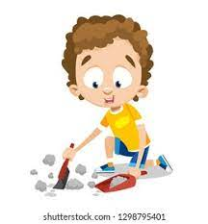
Walking legs on the Concrete
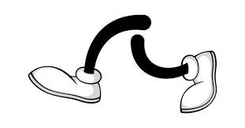
Only 2 children on top of the Pirate ship
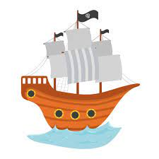
The Pirate ship is only open when the red mats are out
-

Down the slide only - feet first
Make sure the slide is clear at the bottom before going down
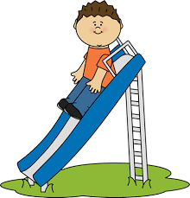

Only drive/scoot one way around the road
