**Stratton Playgroup**

New Road, Stratton, Bude, Cornwall EX23 9AP

**Telephone:** 01288 356135 **E-mail:**  strattonplaygroup@hotmail.co.uk

**Website:** www.strattonplaygroup.uk **Ofsted No.:** 102959 **Registered Charity No.:** 1038250

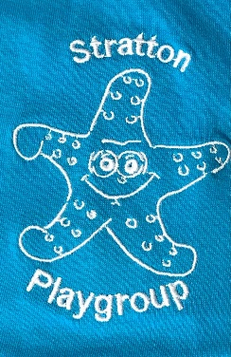**Stratton Playgroup T-shirts & Sweaters**

As you will be aware, children do get messy at playgroup. To save their favourite clothes from getting too messy, we have embroidered uniform available to buy:

**T-shirts**

We have a range of t-shirts available:

All Polo Shirts **(YELLOW)** **£2.50**

T-shirts: **All £4.50**

2-3 years - 25” (**ROYAL BLUE** only)

3-4 years – 26” & 5-6 years – 28” (**ROYAL BLUE** / **PURPLE** / **AZURE**)

All of the above are stock items – if you wish to purchase at the above fantastic prices, please get your order in promptly, whilst stocks last.

We have been informed that on our next order, the prices will rise to **£6.50**, but we will have a larger range of colours available:

2-3 years (**ROYAL BLUE** / **SKY** / **SUNFLOWER**)

3-4 years & 5-6 years (**ROYAL BLUE** / **SKY** / **SUNFLOWER** / **PURPLE** / **AZURE**)

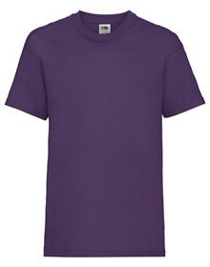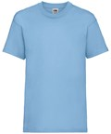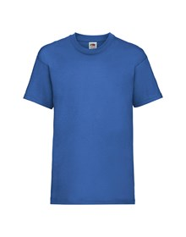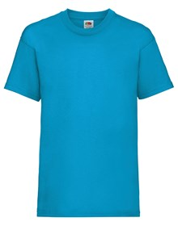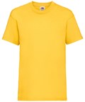

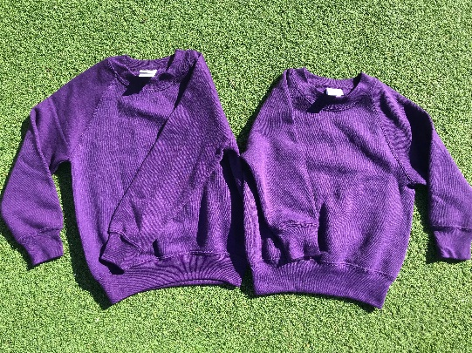**Sweaters**

If we get enough interest, we would like to offer a range of sweaters, as these can be more practical in the colder months, at **£13.50**:

3-4 years – 22/25” & 5-6 years – 25/28” (**ROYAL BLUE** / **SKY** / **PURPLE** / **WINTER EMERALD**)

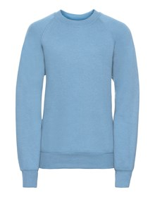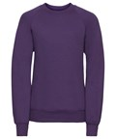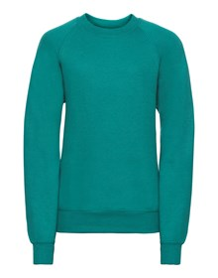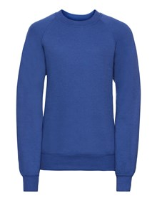

Please feel free to try the t-shirts / sweaters on for sizing; and if you would like to purchase, or have any questions - please speak to a member of staff.

Many thanks for your continued support

From the Staff & Committee of Stratton Playgroup