
Stratton Playgroup
We have exciting news……
We are changing our name – soon we will be known as
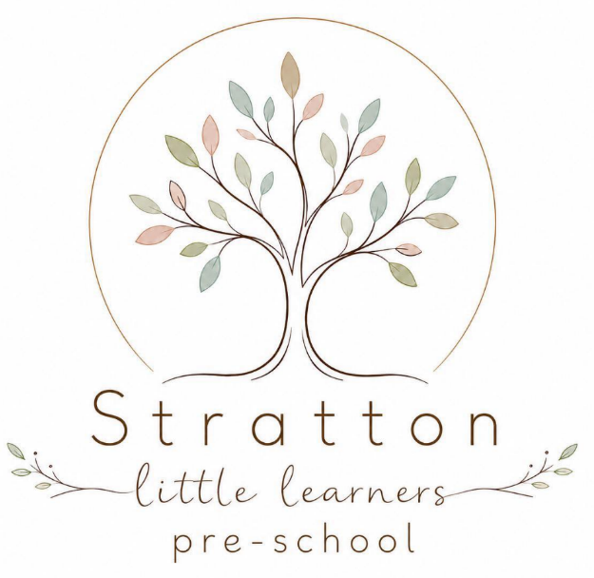
Stratton Little Learners
(A Charitable Incorporated Organisation)

We will be the same staff / same location, just a rebranding!

Why come to Stratton Playgroup?
- We have a large indoor space
- We have an extensive outdoor space
- We have a sensory room for small groups / quiet time.
- We have spaces available for September – book now to avoid disappointment.
- We take children from the term before they turn 2.
- We are open from 8.15 for Early drop offs (includes breakfast).

We have flexible session times available
Early Start Breakfast Club 8:15 to 9:00
AM Sessions 9:00 to 12:00
Lunch Club 12:00 to 12:30
PM Sessions 12:30 to 15:30
(These can be combined for all day childcare 8:15 to 15:30)


Please contact us to discuss your requirements:


01288 356135 strattonplaygroup@hotmail.co.uk
New Road, Stratton, Bude, Cornwall EX23 9AP

We are on Facebook & Instagram, find us as “Stratton Playgroup Bude”
Serving the Community for over 40 years

