**Stratton Playgroup**

New Road, Stratton, Bude, Cornwall EX23 9AP

**Telephone:** 01288 356135 **E-mail:**  strattonplaygroup@hotmail.co.uk

**Website:** www.strattonplaygroup.uk **Ofsted No.:** 102959 **Registered Charity No.:** 1038250

**Newsletter - December 2022**

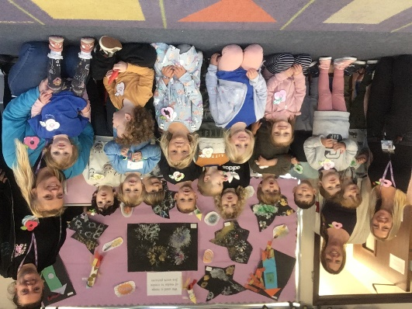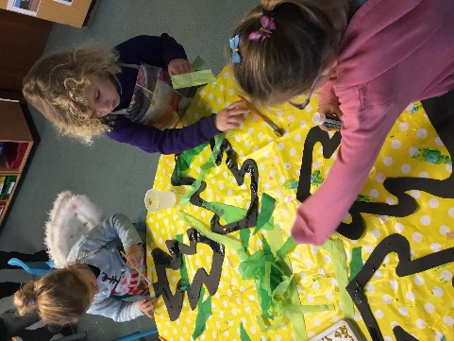

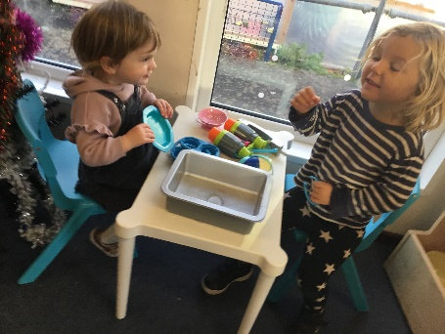

The end of term is fast approaching us and we are getting into the Christmas spirit, making lots of decorations and learning Christmas songs.

The children have thoroughly enjoyed learning about the moon and stars and making their own telescopes.

We will continue with different Christmas crafts and will be making calendars and talking about the months of the year and days of the week.

**Christmas Fayre**

Our committee are holding a Christmas shopping event at playgroup on Friday 9th December in the evening from 6pm. Please come along and support this event and enjoy a mulled wine and mince pie. There will be various stalls selling Christmas crafts, gifts, books, and Christmas jumpers.

Your child will be making tea light candle holders, reindeer food and hot chocolate cones which will be available to purchase at the Christmas Fayre.

Raffle tickets will be on sale prior to this event at £1 a strip, please ask a member of staff if you would like to purchase some.

**Playgroup Christmas Party**

This will be on Friday 16th December from 9 – 11.30, all children will need to be dropped off at 9 (No breakfast club) and collected at 11:30 as **Playgroup is closed for Christmas from the Thursday 15th December**. The new term will resume Wednesday 4th January 2023.

Please use the slip on the invitation to let us know if your child will be attending.

**Food bank donations**

If you had something to donate to our food bank collection, could these please be brought into playgroup and placed into the donations box by Friday 9th December.

**Reminders**

As the weather is growing colder and wetter could we ask that all children please bring a waterproof coat and wellies with them every day they attend playgroup. We still spend time outdoors throughout the day and the children enjoy this time to explore and run around. We also visit the school grounds and woodland area frequently and take the children as a whole group and weather appropriate clothing is essential for this. Spare clothes are also essential as children get wet and muddy.

**School applications**

If your child was born between 1 September 2018 and 31 August 2019 you will need to apply for a school place for September 2023. **The deadline for applications is 15 January 2023.**  <https://www.cornwall.gov.uk/education-and-learning/schools-and-colleges/school-admissions/>

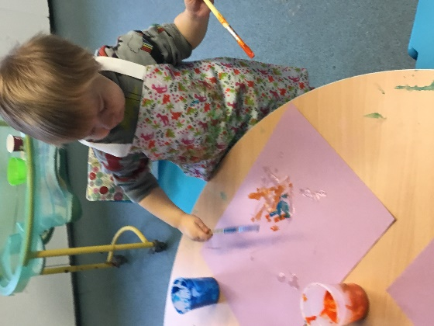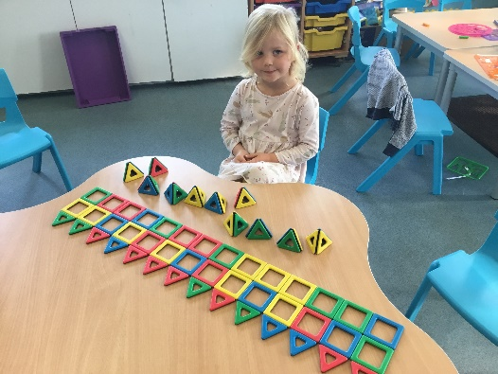

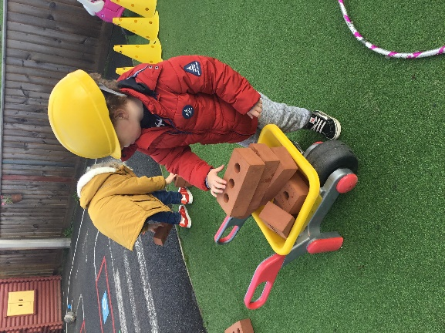

**Fees**

A polite reminder that any outstanding fees need to be paid by Friday 9th December. Thank you.

**Parent meetings**

We will be holding key person meetings in the new year. This will be a chance for you to meet with your child’s key person and discuss your child’s development. Your child’s key person will arrange a convenient time and day with you in January.

**Term Dates**

Christmas Fayre Friday 9th December

Last Day of term Thurs 15th December

Christmas Party Fri 16th December 9.00am – 11.30am

Start of Spring Term 2023 Weds 4th January

Half-Term  Mon 13th- Fri 17th February

Last Day or term Fri 31st March

Start of Summer Term 2023 Mon 17th April

Bank Holiday Mon 1st May

Leavers photo Friday 12th May

Half-Term  Fri 26th May-Fri 2nd June

Long Weekend Fri 23rd-Mon 26th June

Last Day of term Thurs 20th July

Leavers Party Fri 21st July